

Samsung Data Platform User’s Guide

MAY 2022

# Legal Information

INFORMATION IN THIS DOCUMENT IS PROVIDED IN CONNECTION WITH THE SAMSUNG DATA PLATFORM (SDP) AND ALL RELATED PRODUCTS, UPDATES, AND DOCUMENTATION (HEREINAFTER "SAMSUNG DATA PLATFORM"). NO LICENSE, EXPRESS OR IMPLIED, BY ESTOPPEL OR OTHERWISE, TO ANY INTELLECTUAL PROPERTY RIGHTS IS GRANTED BY THIS DOCUMENT. THIS DOCUMENTATION IS PROVIDED FOR REFERENCE PURPOSES ONLY, AND ALL INFORMATION DISCUSSED HEREIN IS PROVIDED ON AN "AS-IS" BASIS, WITHOUT WARRANTIES OF ANY KIND. SDP TECHNOLOGIES AND ITS AFFILIATES (COLLECTIVELY, "SAMSUNG DATA PLATFORM") ASSUMES NO LIABILITY WHATSOEVER, INCLUDING WITHOUT LIMITATION CONSEQUENTIAL OR INCIDENTAL DAMAGES, AND SAMSUNG DISCLAIMS ANY EXPRESS OR IMPLIED WARRANTY, ARISING OUT OF OR RELATED TO YOUR APPLICATION AND/OR USE OF THIS DOCUMENT OR THE SDP PRODUCTS INCLUDING LIABILITY OR WARRANTIES RELATED TO FITNESS FOR A PARTICULAR PURPOSE, MERCHANTABILITY, OR INFRINGEMENT OF ANY PATENT, COPYRIGHT, OR OTHER INTELLECTUAL PROPERTY RIGHT.

SAMSUNG DATA PLATFORM RESERVES THE RIGHT TO CHANGE PRODUCTS, INFORMATION, DOCUMENTATION AND SPECIFICATIONS WITHOUT NOTICE. THIS INCLUDES MAKING CHANGES TO THIS DOCUMENTATION AT ANY TIME WITHOUT PRIOR NOTICE. SDP ASSUMES NO RESPONSIBILITY FOR POSSIBLE ERRORS OR OMISSIONS, OR FOR ANY CONSEQUENCES FROM THE USE OF THE DOCUMENTATION CONTAINED HEREIN.

Unless otherwise agreed to between the parties, SDP Products are not intended for use in medical, life support, critical care, safety equipment, or similar applications where product failure could result in loss of life or personal or physical harm, or any military or defense application, or any governmental procure- ment to which special terms or provisions may apply.

This document and all information discussed herein remain the sole and exclusive property of SDP. All brand names, trademarks and registered trademarks belong to their respective owners. Unless specifically identified as such, SDPs use of third-party trademarks does not indicate any relationship, sponsor- ship, or endorsement between SDP and the owners of these trademarks. Any references by SDP to third-party trademarks is to identify the corresponding third party goods and/or services and shall be considered nominative fair use under the trademark law.

All rights reserved. No part of this publication may be reproduced, stored in a retrieval system, or transmitted in any form or by any means, electric or mechanical, by photocopying, recording, or otherwise, without the prior written consent of Samsung Data Platform.

Samsung Data Platform and the SDP logo are among the trademarks of Samsung Data Platform and/or its affiliates in the United States, certain other countries and/or the EU. Any other trademarks or trade names mentioned are the property of their respective owners.

**Table of Contents**

Contents

Legal Information 2

1 Document purpose 5

2 Samsung Data Platform design 6

2.1 High-level architecture 6

2.1.1 Data Managers 6

2.1.2 Key-Value Stores 6

2.2 Cluster server system Virtual Machines 7

3 The Samsung Data Platform Cluster from a user’s perspective 8

3.1 vStores and datasets 8

3.2 User groups 8

4 Accessing an Samsung Data Platform cluster 10

4.1 Using the GUI 10

4.2 Using the CLI 11

5 Managing SDP Security and System Administration 20

5.1 Samsung Data Platform cluster security administration 20

5.1.1 Setting up the authentication server for user login 20

5.1.2 Using the GUI to set up the authentication server 20

5.1.3 Using the CLI to set up the authentication server 24

5.1.4 Setting up the password policy 24

5.1.5 Using the GUI to set up password policy 24

5.1.6 Using the CLI to set up password policy 25

*5.2* Adding a new user group 25

5.2.1 Adding a new user group 25

5.2.2 Using the CLI to add a new user group 26

5.2.3 Editing an existing user group’s cluster and vStore privileges 27

5.2.4 Using the CLI to edit an existing user group 27

5.2.5 Adding a user to one or more user groups 28

5.2.6 Using the CLI to add a new user 30

5.2.7 Unlocking a user and optionally requiring a change of password 30

5.2.8 Using the CLI to unlock a user or change a password 30

5.3 Samsung Data Platform cluster system administration 30

5.3.1 Managing system IP addresses and domain names 31

5.3.2 Using the CLI to manage system IP addresses and domain names 33

5.3.3 Viewing or changing the time zone 33

5.3.4 Using the CLI to view or change time zones 34

5.3.5 Setting the storage capacity expansion policy and capacity warning threshold 34

5.3.6 Running or scheduling specific tasks 35

5.3.7 Updating the software from the GUI 35

5.3.8 Using the CLI to update the software 36

5.3.9 Creating a support bundle 37

5.3.10 Using the CLI to create a support bundle 37

5.3.11 Viewing active and completed tasks in the GUI 38

5.3.12 Using the CLI to view task status 39

5.3.13 Selecting the time period for running maintenance background tasks 41

5.3.14 Configuring the email server for sending system event notifications 43

5.3.15 Using the CLI to configure the email server for sending system event notifications 43

5.3.16 Enabling remote monitoring of the Samsung Data Platform cluster 44

5.3.17 Using the CLI to Enable remote monitoring of the Samsung Data Platform cluster 44

5.3.18 Viewing the audit trail of events on the Samsung Data Platform cluster 45

5.3.19 Using the CLI to View the audit trail of events on the Samsung Data Platform cluster 45

6.3 Managing your user profile 46

6.3.1 Change the email address for receiving automated notifications from the Samsung Data Platform cluster 47

6.3.2 Select the type and severity of system notifications to receive in your email 48

6.3.3 Change your Samsung Data Platform cluster login password 49

6 Managing vStores 50

6.1 Creating an additional data set 50

Procedure using the GUI 50

• Equivalent CLI commands 54

6.2 Changing or viewing vStore configuration settings 55

• Procedure using the GUI 55

• Equivalent CLI commands 59

6.3 Changing or viewing data set settings 61

• Procedure using the GUI 61

• Equivalent CLI commands 63

8 Viewing Node Status 72

8.1 Procedure using the GUI 72

8.2 Equivalent CLI commands 79

8.2.1 Viewing node status and network summaries 79

8.2.2 View KVS drive status 80

9 Reboot or shut down the Samsung Data Platform cluster 82

9.1 Procedure using the GUI 82

9.2 Equivalent CLI commands 83

10 Monitor the Samsung Data Platform cluster capacity, performance, and health 84

10.1 View the cluster capacity using the GUI 84

10.1.1 View changes in used capacity and percentage utilization 85

10.2 View vStore and dataset capacity 85

10.2.1 Procedure using the GUI 85

10.2.2 CLI commands 86

10.3 Monitor cluster performance 90

10.4 Data protection status 92

10.5 View system-health alarms 92

10.5.1 Procedure using the GUI 92

10.5.2 Equivalent CLI command 93

11 Opening an SSH remote-access gateway 96

11.1 Initiating the tunnel 96

11.1.1 Using the GUI 96

11.1.2 Using the CLI 97

11.2 Disabling the tunnel 97

11.2.1 Using the GUI: 98

11.2.2 Using the CLI: 98

11.3 Connecting to the tunnel as Samsung Support 98

11.3.1 View customer clusters with a remote-access tunnel enabled 98

11.3.2 Connecting to the customer cluster via the CLI (1.0.2+) 101

11.3.3 Connecting to the customer cluster manually (1.0.1+) 103

Glossary 104

# Document purpose

This document provides a high-level architectural overview of the Samsung Data Platform and describes the following procedures:

* + How to view or change the configuration of a Samsung Data Platform, and perform system administration, such as adding users, groups, accessing permissions, and setting up email alerts.
  + How to manage a Samsung Data Platform over time, such as creating vStores and datasets.
  + How to schedule and monitor background tasks.
  + How to monitor the system performance and health.

**Note**: This document was originally written for a bare metal cluster solution, referred to as the “Stellus Data Platform”. That solution has been ported to run within Microsoft Azure cloud environment and is now known as the “Samsung Data Platform”. There may be sections in this document that refer to “Stellus” or that refer to features that existed in the bare metal solution. Efforts have been made to reduce and avoid any confusion or misinformation.

# Samsung Data Platform design

This section describes the components that comprise a Samsung Data Platform cluster.

## High-level architecture

A Samsung Data Platform consists of at least six (6) Data Managers (DMs) and fifteen (15) Key-Value Stores (KVSs). Figure 2-1 shows the high-level functional blocks, which are explained below and in more detail in the sections that follow.

### Data Managers

While a DM serves many functions, the most important ones are as follows:

* + - * Protocol Server—Accepts IO requests from client systems through protocols such as NFS.
      * Key Value Data Services—Converts the protocol data structures and payload into objects, which are later written to and read from the KVSs.
      * Cluster Management—Tracks and manages the state of the DMs and KVSs in the Samsung Data Platform (also known as a cluster) and manages additions and removals of nodes in the cluster.
      * I/O Request Initiators—Uses Non-Volatile Memory Express (NVMe) over Remote Direct Memory Access (RDMA), DMs communicate with KVSs, to process incoming I/O requests received from clients over a protocol such as NFS.

### Key-Value Stores

The main functions of a KVS are as follows:

* + - * NVMe RDMA Targets—Uses NVMe over RDMA, KVSs communicate with DMs, to pro- cess incoming I/O requests received from clients over a protocol such as NFS.
      * Media Management—What goes here?
      * Key-value Persistent Services—Manages Key-Value objects across three data stores, called Staging Store, Immutable Data Store, and the Atomic Data Store.
      * Cluster Management—Tracks and manages the state of the DMs and KVSs in the clus- ter and manages additions and removals of nodes in the cluster.

**Figure 2-1 Samsung Data Platform Cluster Overview**

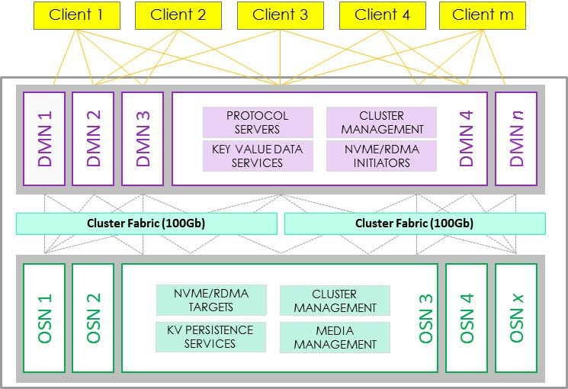

## Cluster server system Virtual Machines

Each KVS and DM is a node based on the following Azure Virtual Machine sizes:

* Data Manager Node: D32 v3
  + 32 vCPU
  + 128 GB RAM
* Key Value Store Node: L16s v2
  + 16 vCPU
  + 128 GB RAM
  + Two (2) 1.92 TB NVMe SSD’s

# The Samsung Data Platform Cluster from a user’s perspective

## vStores and datasets

The Samsung Data Platform Cluster is comprised of a vStore, which in turn is comprised of one or more datasets. A vStore performs a similar function to virtual machines on a server. Since an organization is divided into groups of users that have data requirements that are isolated from other groups, a vStore users and their data are isolated from the users and data in other vStores. Currently each cluster has a single vStore. (Previous version of SDP had multiple vStores, such that there may be still language that refers to multiple.)

## User groups

By default, the software provides two user groups:

* + - vstore_administrators
    - vstore_operators

Administrators get full control over the system or vStores. Operators can view the settings but, in general, cannot change them.

# Accessing an Samsung Data Platform cluster

A Samsung Data Platform cluster or one of its DMs can be accessed and controlled through a Graphical User Interface (GUI) or a Command Line Interface (CLI).

## Using the GUI

Use secure HTTP (HTTPS) protocol to gain access to the GUI, enter the hostname of the cluster or one of its DMs by typing its address in the following format:

**https://<cluster ip address>:8443/login**

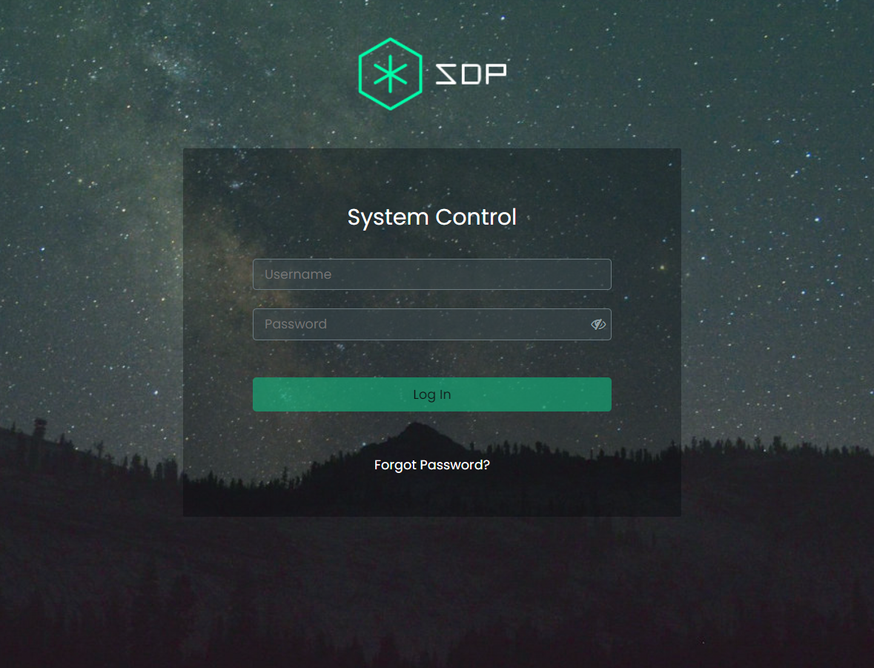

After entering the user name and password, and clicking the Log In button, the browser will display the main Samsung Data Platform cluster dashboard, which will appear similar to the following:

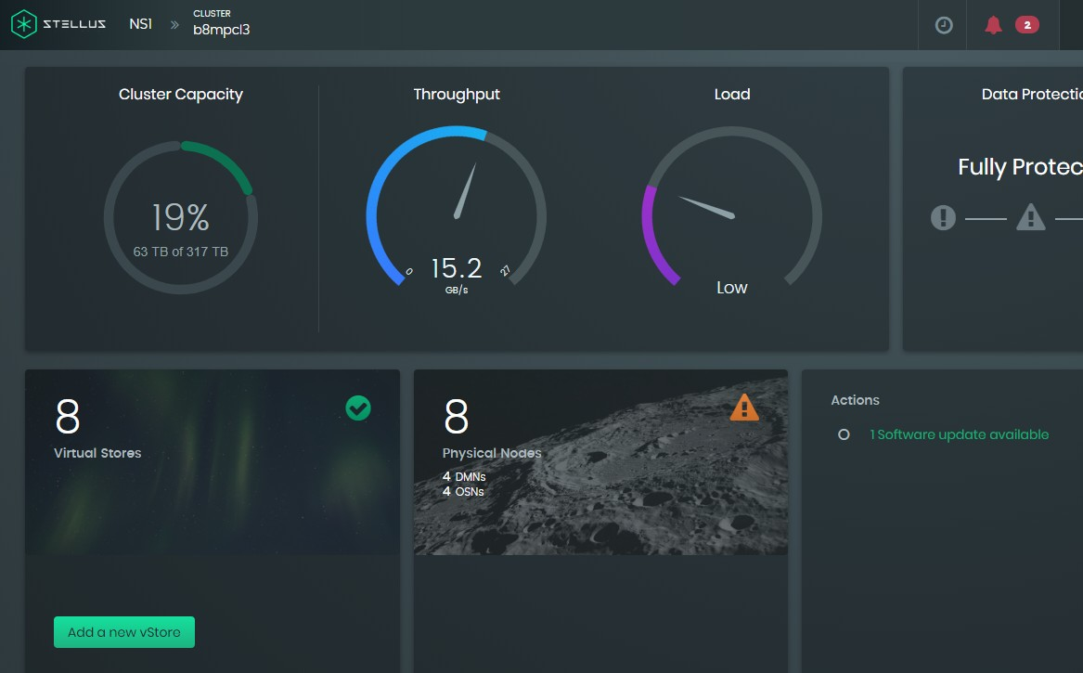

## Using the CLI

Use the Secure Shell (SSH) protocol to connect to the CLI by entering the cluster or DM hostname as the remote host. For example, if you are connecting with MobaXterm, enter the cluster or DM hostname in the **Remote host \*** text box, and optionally add the user name used to log into the GUI, as shown in the highlighted fields below:

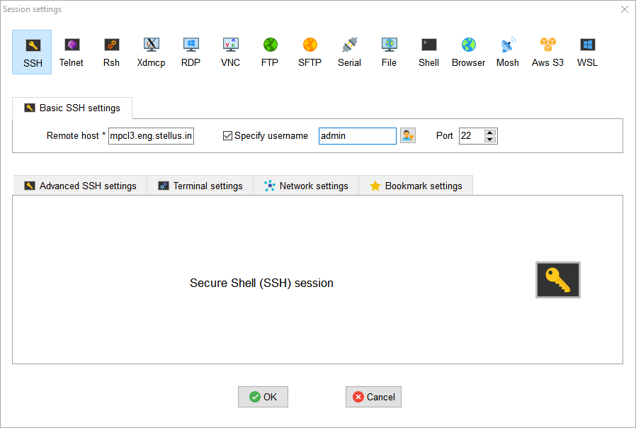

After clicking OK, and entering the same password as used in the GUI, the Samsung Data Platform CLI prompt will be displayed as follows:

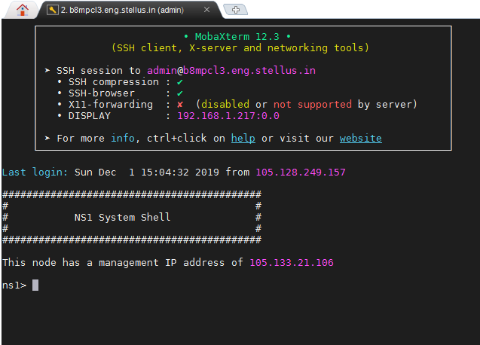

To list all the available commands and a summary of each, type **?** and press the **Enter** key.

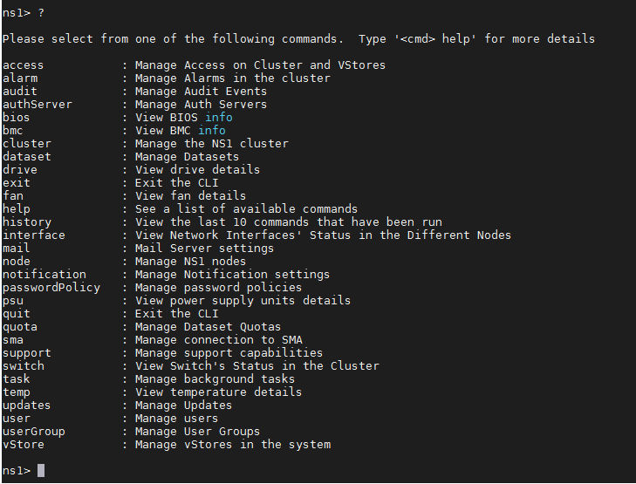

To view the syntax and options for each command, type the command name followed by **help**. For example, to view details about the node command, type **node help** and press **Enter**.

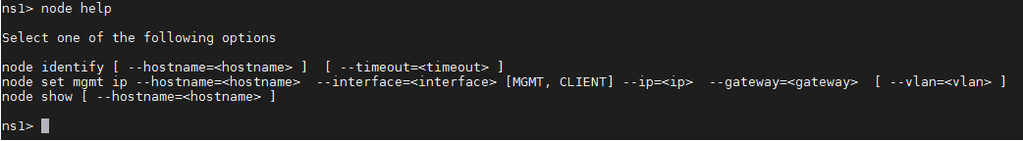

# Managing SDP Security and System Administration

This section is divided into two subsections:

* Samsung Data Platform cluster security administration
* Samsung Data Platform cluster system administration

## Samsung Data Platform cluster security administration

This subsection details how to perform the following operations:

* Set up the authentication server for user login
* Set up the password policy, which defines password rules for local users
* Add a new user group
* Edit an existing user group’s cluster and vStore privileges
* Add a user to one or more user groups
* Unlock a user and optionally require a change of password

### Setting up the authentication server for user login

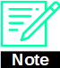Once the authentication server is set up, the user will gain access to the user login screen using the domain name of the authentication server instead of the IP address of a DM in the cluster.

To perform this task you will need to provide the following information:

* + - * Select between Lightweight Directory Access Protocol (LDAP) and Active Directory (AD) protocol. For user authentication, you would normally use LDAP protocol.
      * Provide a host name for the authentication server, provide a port number if you do not want to use the default, and to decide whether or not the connection will use Secure Sockets Layer (SSL).
      * Specify the administrator user name and password.
      * Select which user groups are allowed to log in.

### Using the GUI to set up the authentication server

The step-by-step procedure for setting up the authentication server is as follows:

* + - * 1. Select **Settings** from the user drop-down menu at the top-right of the Samsung Data Plat- form cluster dashboard window.

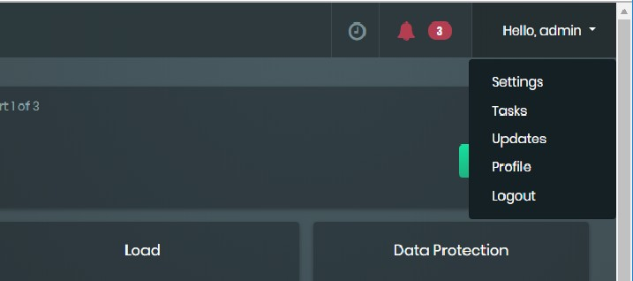

* + - * 1. On the **Settings** page, select the **Security** tab and then select the **Authentication** sub-tab.

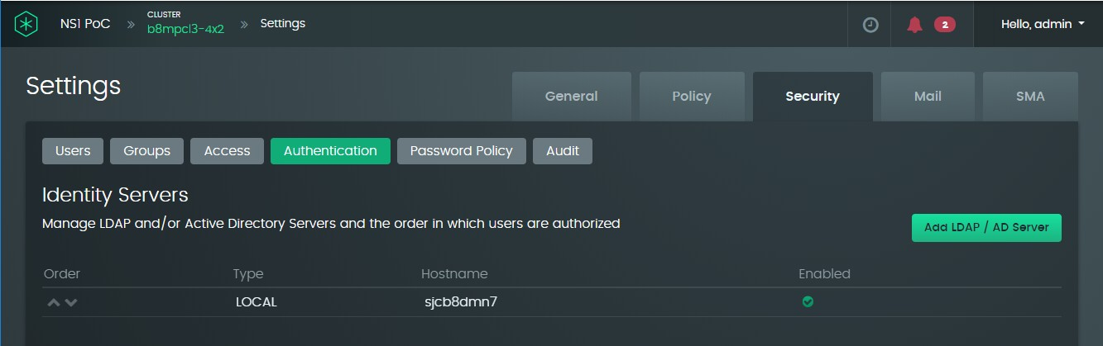

* + - * 1. Click the **Add LDAP / AD Server** button to display a **Create Identity Server** window. The **Create Identity Server** dialog displays withthe **General** tab selected.

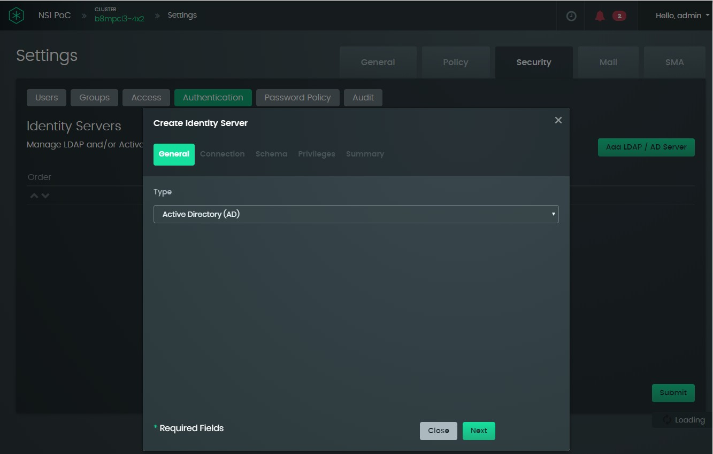

* + - * 1. Select between **Lightweight Directory Access Protocol (LDAP)** and **Active Directory(AD)** and click the **Next** button. The **Connection** dialog displays.

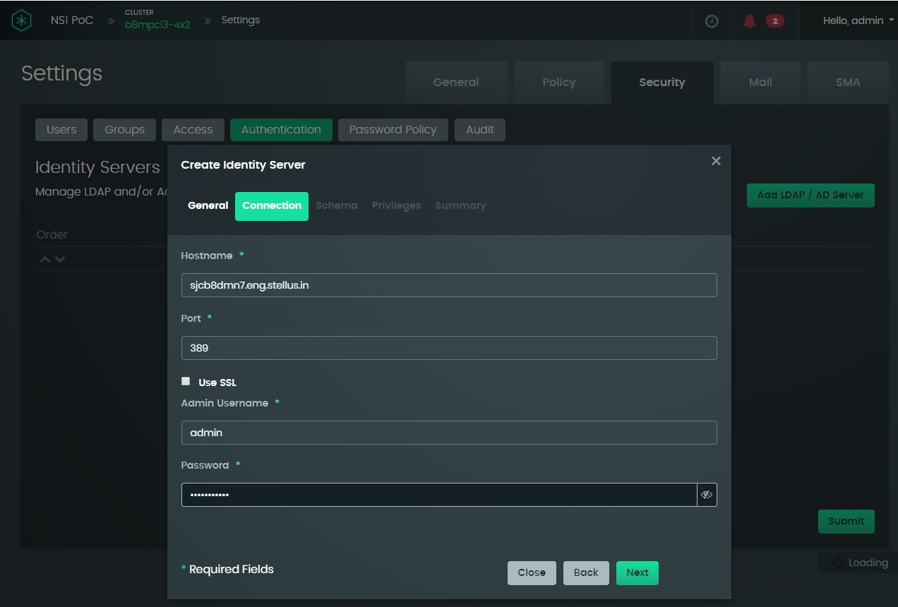

* + - * 1. Enter the **Hostname**, **Admin Username**, and (administrator) **Password**.

Optionally, you can choose to select SSL. If you do this, the port number should be changed to 636.

* + - * 1. Click the **Next** button. The **Schema** dialog displays.

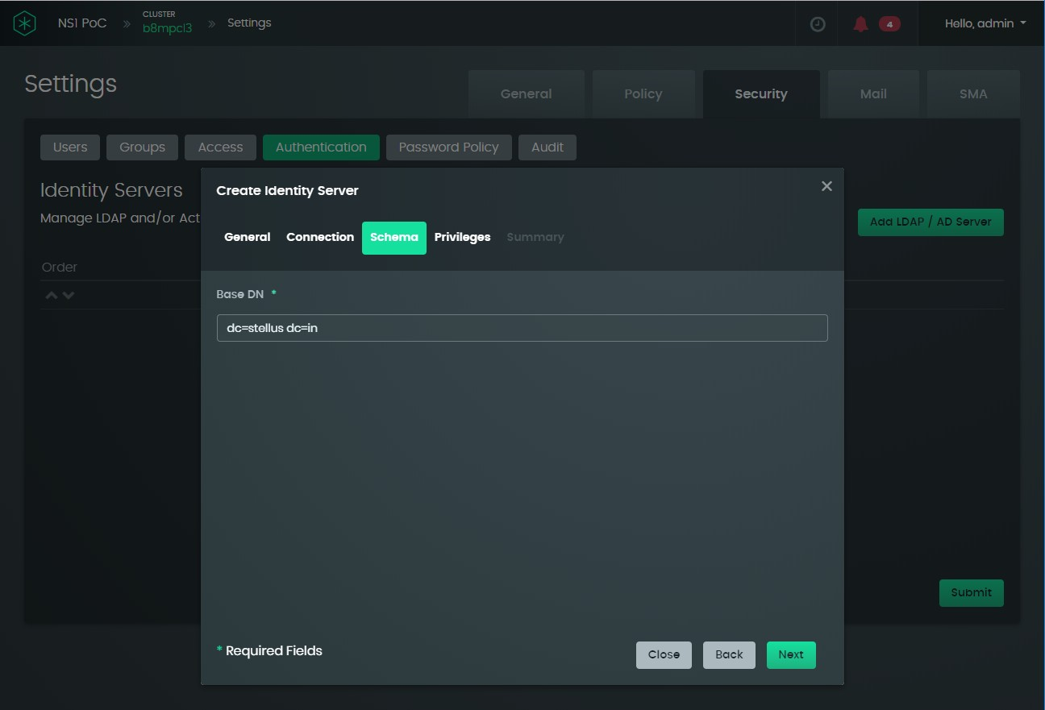

* + - * 1. Type in the base distinguished name (DN) of the identity server. Click the **Next button.** The **Privileges** dialog window displays.

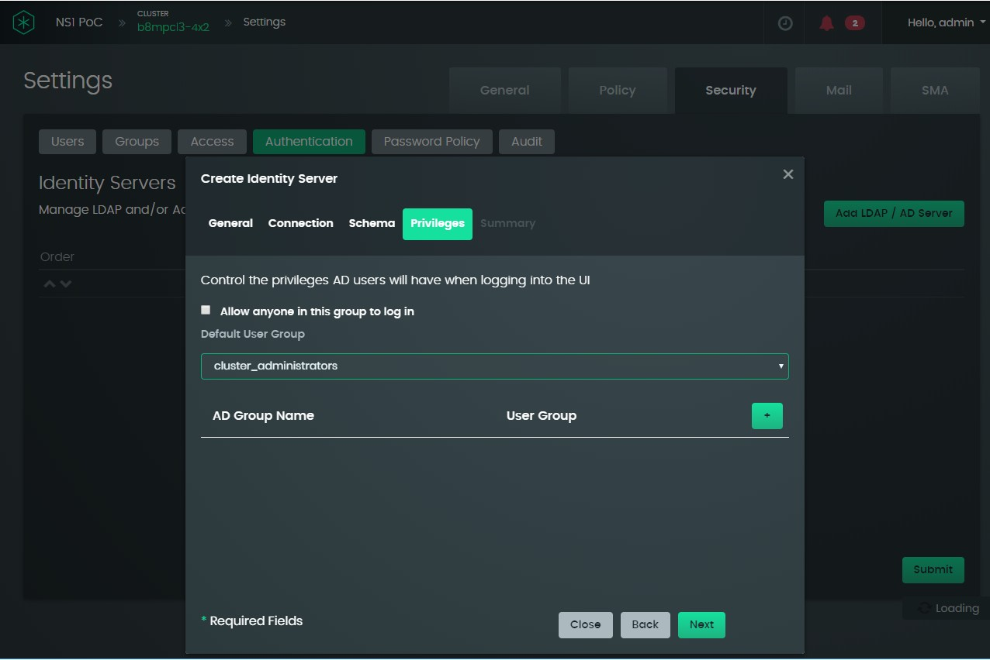

2

1

3

* + - * 1. Select a **Default User Group** (1) from the drop-down list. These are the user groups that will be able to log in to the Samsung Data Platform cluster dashboard.

Select the **Allow anyone in this group to log in** (2) checkbox to allow anyone access to the cluster user interface. Click the **+** button (3) to map an LDAP/AD user group name to the cluster user group.

* + - * 1. Click the **Next** button. The **Summary** window displays.

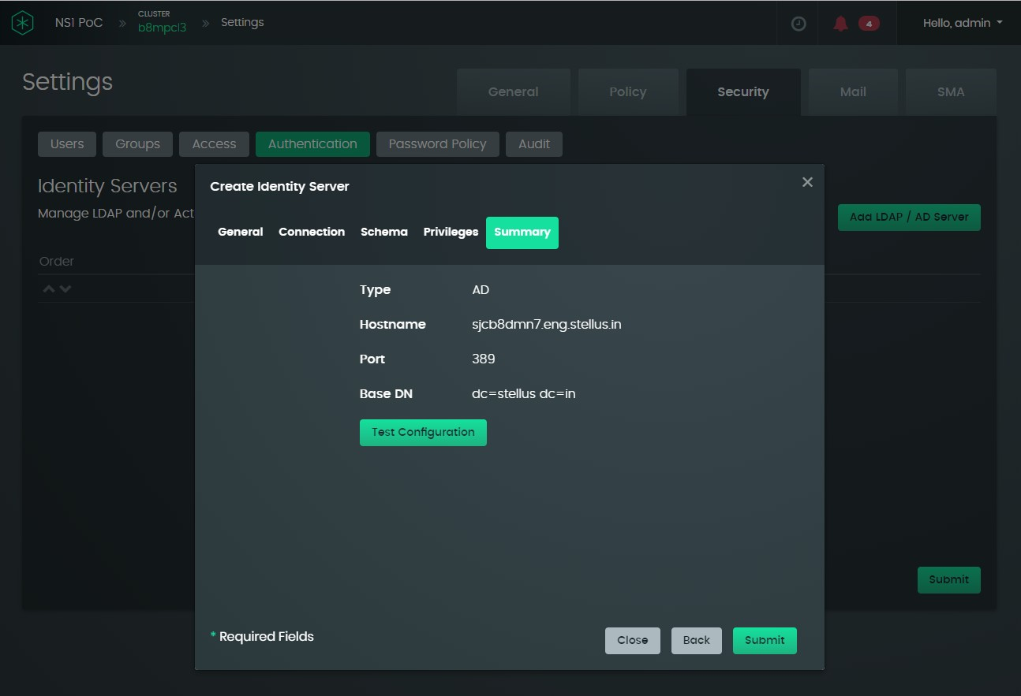

* + - * 1. Click the **Test Configuration** button. If the results are satisfactory, click the **Submit** button to finish the set-up operation.

### Using the CLI to set up the authentication server

**authServer create --level=<level> [CLUSTER, VSTORE] [ --vStore=<vStore> ]**

**--hostname=<hostname> --type=<type> [LOCAL, LDAP, AD] [ --port=<port> ]**

**--adminAccount=<adminAccount> --password=<password> --baseDn=<baseDn> [ --ssl ] [ --enabled ] [ --userAttribute=<userAttribute> ]**

**[ --groupAttribute=<groupAttribute> ] [ --userGroup=<userGroup> ]**

### Setting up the password policy

The password policy allows you to define the password rules for local users, such as minimum password length, the types of characters that must be included, password duration, and lockout rules. Logging in over the Internet is disabled.

### Using the GUI to set up password policy

To set up the policy:

* + - * 1. Select **Settings** from the user drop-down menu at the top-right of the Samsung Data Platform cluster dashboard window.
        2. On the **Settings** page, select the **Security** tab and then select the **Password Policy** tab.

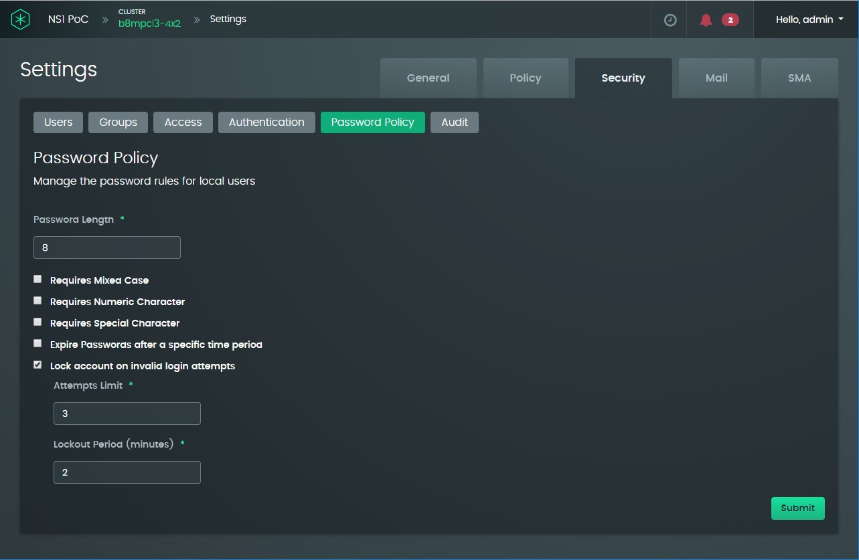

* + - * 1. Specify the criteria for the password policy in the dialog window. The following can be specified:

password length (default eight characters)

Whether or not the password requires mixed case alphabetic characters, numeric characters, special non-alphanumeric characters

Whether or not the password needs to be renewed periodically and, if so, what the renewal period is

Whether or not the account will be locked after a number of invalid log-in attempts and, if so, the maximum number of attempts before lockout and the lockout period. Or to lock the user out until the password is reset by the system administrator, set the lockout period to a very large value.

* + - * 1. Click the **Submit** button to put the password policy into effect.

### Using the CLI to set up password policy

**passwordPolicy update --level=<level> [CLUSTER, VSTORE] [ --vStore=<vStore> ] [ --minPasswordLength=<minPasswordLength> ]**

**[ --requireMixedCase=<requireMixedCase> ]**

**[ --requireNumericChars=<requireNumericChars> ] [ --requireSpecialChars=<requireSpecialChars> ] [ --passwordExpires=<passwordExpires> ]**

**[ --maxPasswordAge=<maxPasswordAge> ] [ --lockOnFailed=<lockOnFailed> ]**

**[ --lockAfterFailedAttempts=<lockAfterFailedAttempts> ] [ --lockPeriod=<lockPeriod> ]**

## Adding new user groups

To add a new user group, you will need to provide the following information:

* A group name
* A numeric group ID (GID)
* Specify whether the group has cluster privileges and, if so whether the group has full control or just read-only access
* Specify whether the group has vStore privileges and, if so whether the group has full control or just read-only access
* Whether or not the group will be made visible to all vStores

The user groups “cluster_administrators” and “cluster_operators” are already pro- vided by default.

### Adding a new user group

The step-by-step procedure for adding a user group is as follows:

* + - * 1. Select **Settings** from the user drop-down menu at the top-right of the Samsung Data Plat- form cluster dashboard window.
        2. On the **Settings** page, select the **Security** tab and the **Groups** sub-tab.

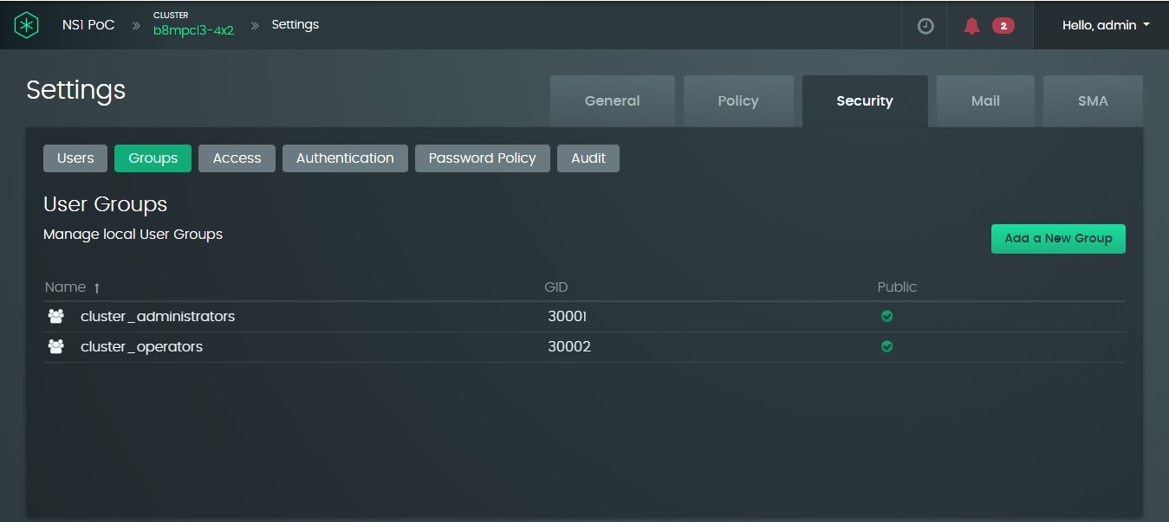

* + - * 1. Click the **Add a New Group** button.

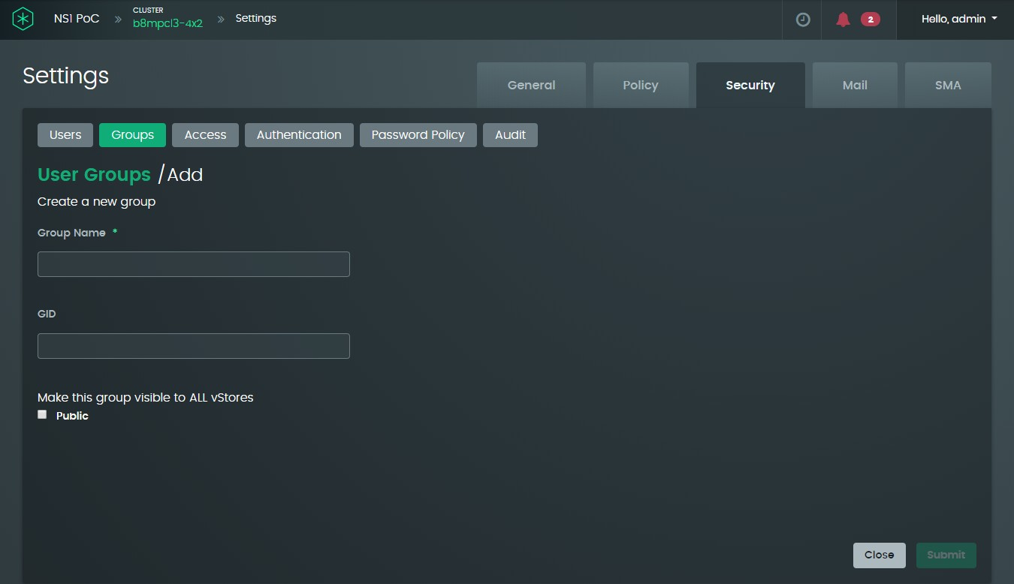

* + - * 1. Fill in the **Group Name** and **GID** and select the checkboxes to set up visibility to vStores as required, and then click the **Submit** button.

### Using the CLI to add a new user group

**userGroup create --level=<level> [CLUSTER, VSTORE]**

**--name=<name>**

**[ --vStore=<vStore> ] [ --public=<public> ] [ --gid=<gid> ]**

### Editing an existing user group’s cluster and vStore privileges

*Procedure using the GUI*

* + - * 1. Select Settings from the user drop-down menu at the top-right of the Samsung Data Plat- form cluster dashboard window.
        2. To view the existing user groups, select the **Security** tab and the **Groups** sub-tab.



* + - * 1. To edit a group, double-click on the group name.

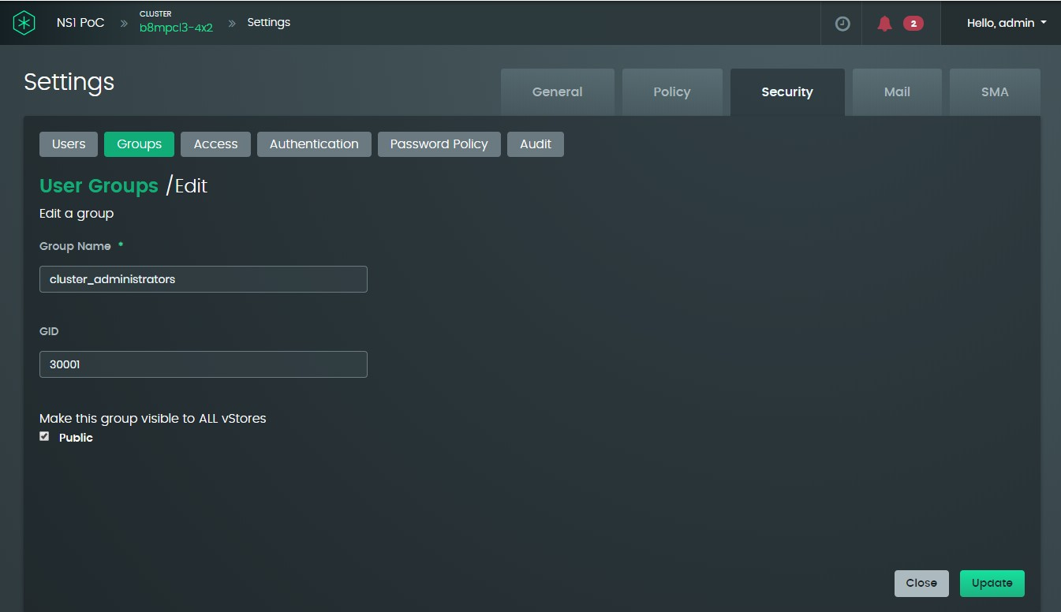

* + - * 1. Set or clear the visibility checkbox as desired and click the **Update** button.

### Using the CLI to edit an existing user group

To view the existing user groups:

**userGroup show --level=<level> [CLUSTER, VSTORE] [ --vStore=<vStore> ]**

**[ --name=<name> ]**

To edit a user group:

**userGroup update --level=<level> [CLUSTER, VSTORE]**

**--name=<name>**

**[ --newName=<newName> ] [ --vStore=<vStore> ]**

**[ --public=<public> ] [ --gid=<gid> ]**

### Adding a user to one or more user groups

*Procedure using the GUI*

* + - * 1. Select **Settings** from the user drop-down menu at the top-right of the Samsung Data Plat- form cluster dashboard window.
        2. On the **Settings** page, select the **Security** tab and the **Users** sub-tab.

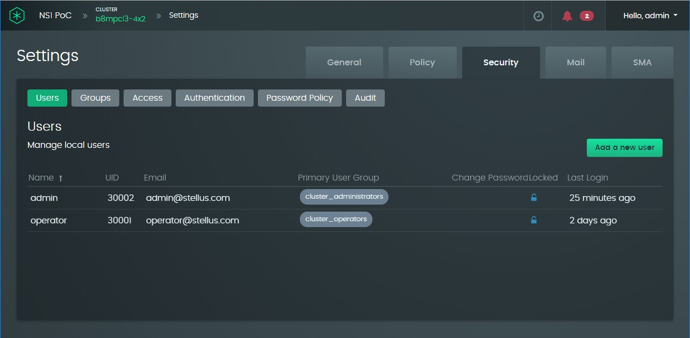

* + - * 1. Click the **Add a new user** button or double-click on an existing user that you want to add to a user group.

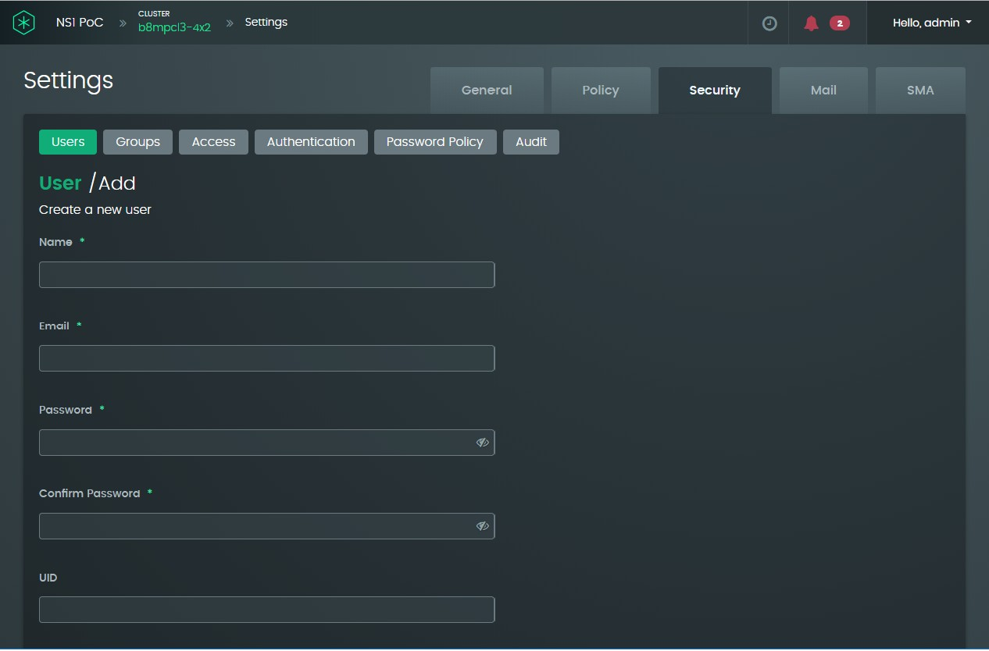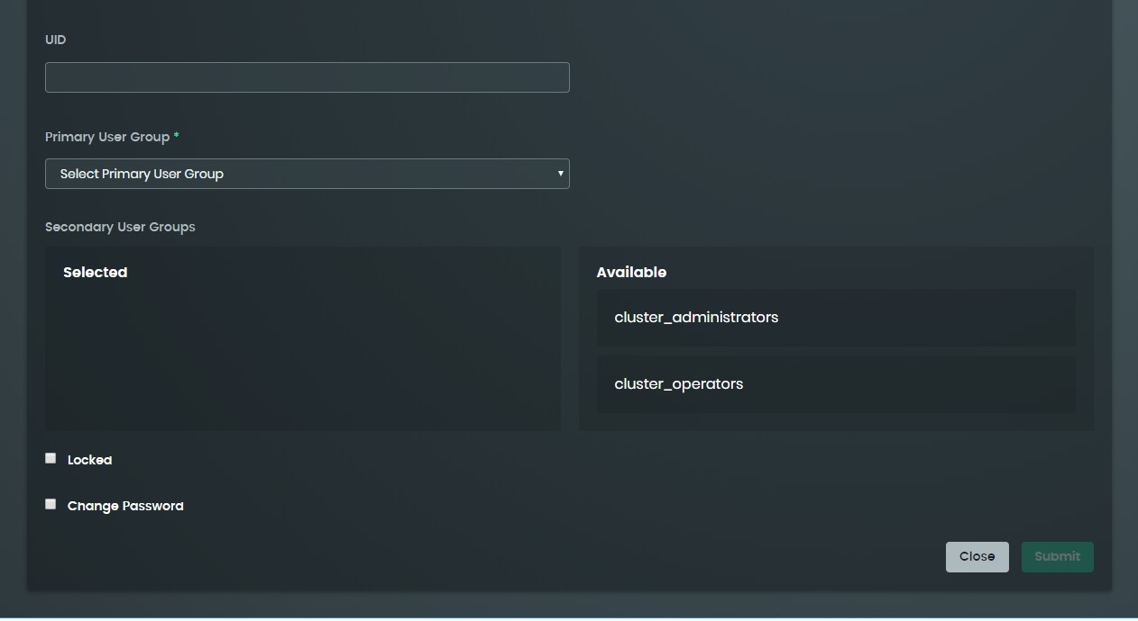

* + - * 1. If you created a new user, provide a name, a numeric user ID (UID), email address for receiving event notifications from this cluster, and initial password for logging in to the Samsung Data Platform cluster.

Once set up, if granted cluster privileges, the user can change the email address and password by selecting Profile options from the user drop-down menu at the top-right of the Samsung Data Platform cluster dashboard win- dow; see Section 6.3, “Managing your user profile”.

* + - * 1. Select a user group from the **Primary User Group** drop-down menu
        2. If the user needs to be a member of one or more other user groups, select them as **Secondary User Groups** from the list of available groups on the right by clicking on the **Available** group name.

### Using the CLI to add a new user

**user create --level=<level> [CLUSTER, VSTORE]**

**--username=<username>**

**--password=<password>**

**--emailAddress=<emailAddress>**

**[ --changepw=<changepw> ] [ --locked ] [ --vStore=<vStore> ]**

**--primaryUserGroup=<primaryUserGroup> [ --userGroups=<userGroups> ]**

**[ --uid=<uid> ]**

In the above command, valid values of <changepw> are **true** and **false**.

### Unlocking a user and optionally requiring a change of password

By default, a user account is only locked out for 2 minutes. This procedure is only likely to be used if the administrator changes the timeout for the lockout period to a much longer period, such as an hour or more.

*Procedure using the GUI*

If a user’s account is locked due to exceeding the threshold of failed login attempts:

* + - * 1. Perform steps 1 and 2 as described in Section 6.1.5, “Add a user to one or more user groups”.
        2. Double-click the user’s name or UID from the list of users.
        3. Uncheck the **Locked** password at the bottom left of the window.
        4. If you require the user to change his or her password, set the **Change Password** checkbox and enter a temporary password in the **Password** and **Confirm Password** text boxes.

### Using the CLI to unlock a user or change a password

Use the **--password**, **--changepw**, and **--locked** options in the user update command:

**user update --level=<level> [CLUSTER, VSTORE]**

**--username=<username> [ --newusername=<newusername> ] [ --password=<password> ]**

**[ --emailAddress=<emailAddress> ] [ --changepw=<changepw> ]**

**[ --locked=<locked> ] [ --vStore=<vStore> ]**

**[ --primaryUserGroup=<primaryUserGroup> ] [ --userGroups=<userGroups> ]**

**[ --uid=<uid> ]**

In the above command, valid values for <changepw> and <locked> are **true** and **false**.

## Samsung Data Platform cluster system administration

This subsection details how to perform the following operations:

* + - Manage system IP addresses and domain names—view the Samsung Data Platform cluster and DNS server IP addresses, and view or change the domain name of the Samsung Data Platform cluster.
    - View or change the time zone
    - Set the storage capacity expansion policy and capacity warning threshold
    - Run or schedule specific tasks
    - Configure the email server for sending system event notifications
    - Enable remote monitoring of the Samsung Data Platform cluster
    - View the audit trail of events on the Samsung Data Platform cluster, such as alarms and login session timeouts

### Managing system IP addresses and domain names

*Procedure using the GUI*

To view the Samsung Data Platform cluster root domain name and IP addresses:

* + - * 1. Select **Settings** from the from the user drop-down menu at the top-right of the Samsung Data Platform cluster dashboard window.

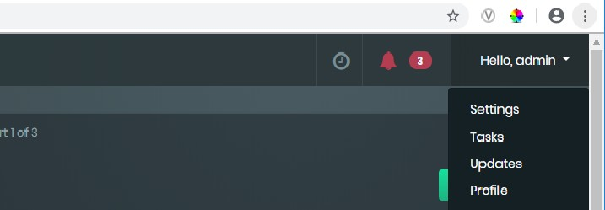

* + - * 1. The panel associated with the **General** tab displays the name of the Samsung Data Platform cluster, its IP address, and the IP addresses of the DNS servers.

The cluster name is an arbitrary label and is not be the same as the domain name.

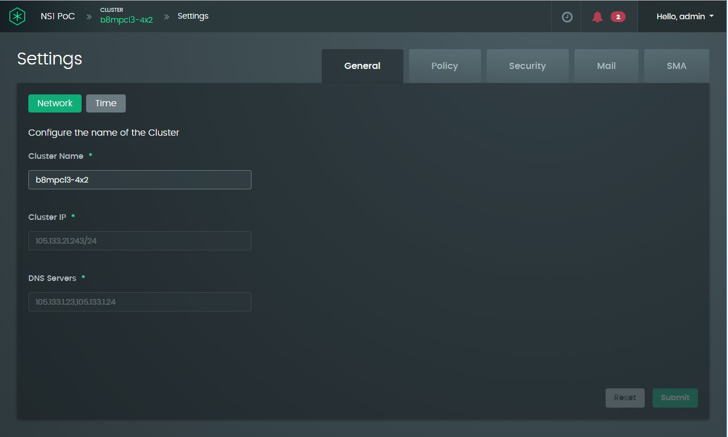

* + - * 1. If desired, change one or more of the values in the **Cluster Name**, **Cluster IP**, and

**DNS Servers** fields, and click the **Submit** button to complete the operation.

### Using the CLI to manage system IP addresses and domain names

Use the **cluster show** command to retrieve the cluster name, cluster IP, DNS servers, and other cluster information. For example:

**ns1> cluster show**

Name : b8mpcl8x8

State : ACTIVE

Time Zone : America/Los_Angeles

Cluster IP : 105.133.21.243/24

DNS Servers : 105.133.1.23

: 105.133.1.24

Capacity Status : READ_WRITE

Capacity Used : 141.4 TB of 633.2 TB Storage State : ACTIVE_HA

+---------------------+-----------+----------------+----------------+

| Hostname | Type | State | Health |

+---------------------+-----------+----------------+----------------+

|  |  |  |  |  |  |  |  |  |
| --- | --- | --- | --- | --- | --- | --- | --- | --- |
| | | sjcb8dmn10 | | | DMN | | | ONLINE | | | MAJOR | | |
| | | sjcb8dmn11 | | | DMN | | | ONLINE | | | MAJOR | | |
| | | sjcb8osn4 | | | OSN | | | ONLINE | | | MAJOR | | |
| | | sjcb8osn3 | | | OSN | | | ONLINE | | | MAJOR | | |
| | | sjcb8osn8 | | | OSN | | | ONLINE | | | MAJOR | | |
| | | sjcb8dmn5 | | | DMN | | | ONLINE | | | MAJOR | | |
| | | sjcb8osn1 | | | OSN | | | ONLINE | | | MAJOR | | |
| | | sjcb8osn7 | | | OSN | | | ONLINE | | | MAJOR | | |
| | | sjcb8osn5 | | | OSN | | | ONLINE | | | MAJOR | | |
| | | sjcb8dmn9 | | | DMN | | | ONLINE | | | MAJOR | | |

+---------------------+-----------+----------------+----------------+

Hit [enter] to retrieve more items. [Ctrl-C] to exit

+---------------------+-----------+----------------+----------------+

| Hostname | Type | State | Health |

+---------------------+-----------+----------------+----------------+

| sjcb8osn2 | OSN | ONLINE | MAJOR |

| sjcb8dmn8 | DMN | ONLINE | MAJOR |

| sjcb8osn6 | OSN | ONLINE | MAJOR |

| sjcb8dmn7 | DMN | ONLINE | MAJOR |

| sjcb8dmn6 | DMN | ONLINE | MAJOR |

| sjcb8dmn12 | DMN | ONLINE | MAJOR |

+---------------------+-----------+----------------+----------------+

**ns1>**

The software refers to a Data Manager as a DMN and a Key-Value Store as an OSN.

### Viewing or changing the time zone

*Procedure using the GUI*

* + - * 1. Select **Settings** from the from the user drop-down menu at the top-right of the Samsung Data Platform cluster dashboard window.
        2. Check that the application is set to the **General** tab and then click on the **Time**

button. The application will show the following screen:

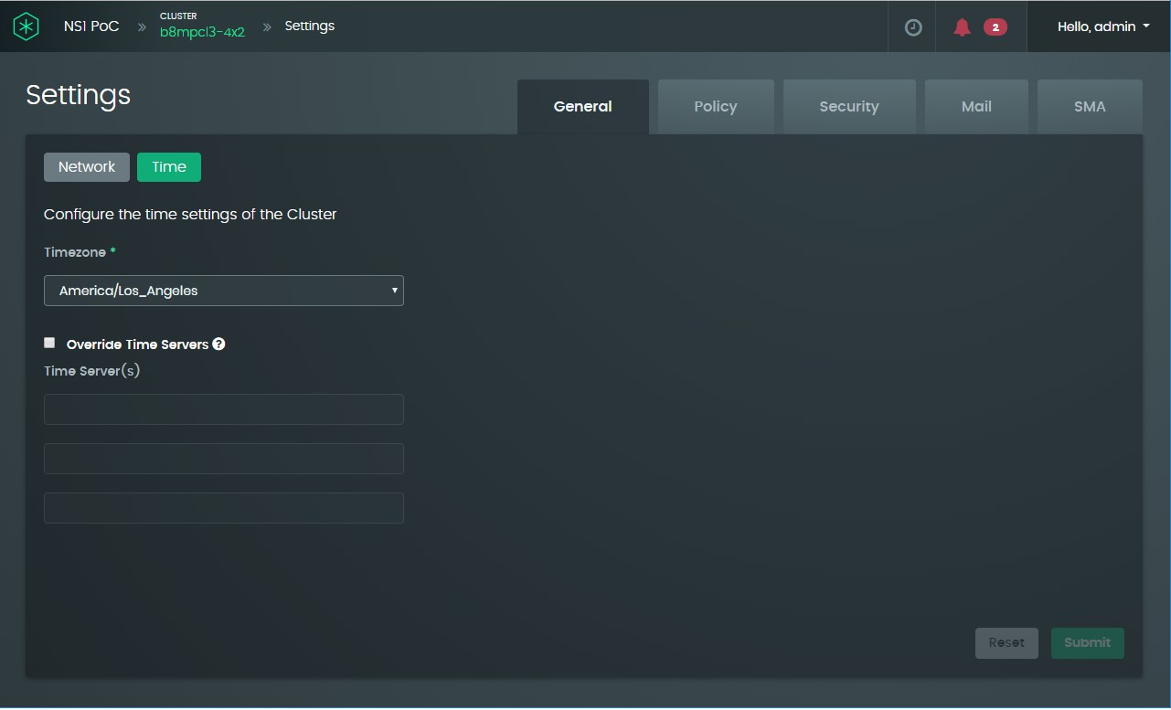

* + - * 1. If you have Internet access and you want to change the time zone, click on the **Timezone** drop-down menu and select a different time zone from one of the options provided.
        2. If you do not have Internet access, provide a fully qualified domain name of the time server on your local network.
        3. If you made any changes in step 3 or 4, click the **Submit** button to complete the operation.

### Using the CLI to view or change time zones

To view the current time zone settings, enter the **cluster show time** command. For example:

**ns1> cluster show time**

Time Zone : America/Los_Angeles Use Local Time Servers : false

To change the time zone:

**cluster update time --timeZone=<timeZone>**

**--useLocalTimeServers=<useLocalTimeServers> [ --timeServers=<timeServers> ]**

In the above command, the options for <useLocalTimeServers> are **true** and **false**.

### Setting the storage capacity expansion policy and capacity warning threshold

The capacity expansion policy allows you to decide on the degree of automation when the cluster is approaching maximum capacity.

To change the expansion policy:

1. Select **Settings** from the user drop-down menu and click the **Policy** tab. Check that the **Policy** button in the top-left of the panel is active (green).

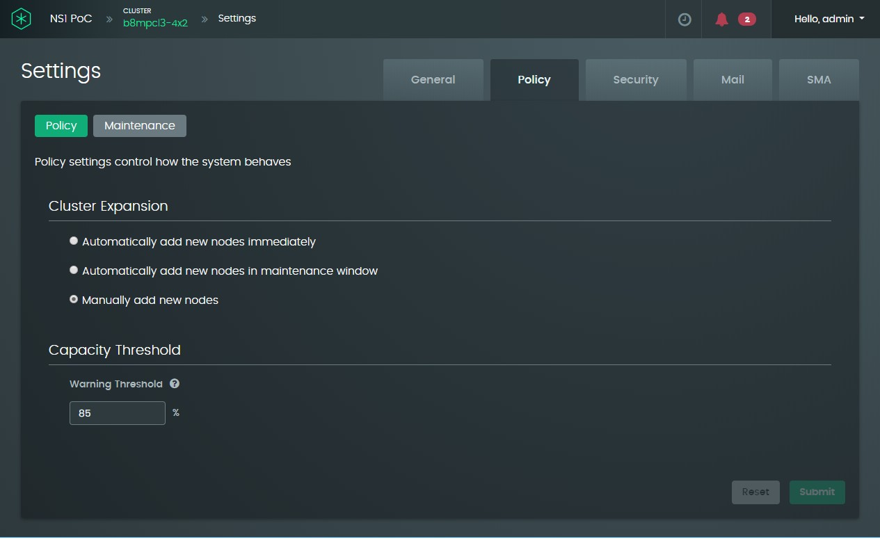

1. To change the expansion policy, select the radio button corresponding to one of the following options:
   * Automatically add new capacity immediately
   * Automatically add new capacity as a background task in a maintenance window; see Section 6.2.4.7, “Select the time period for running maintenance background tasks”.
   * Manually add new capacity by increasing the number of nodes in the cluster.
2. If desired, change the capacity threshold when the system a warning notification that the system is approaching full capacity. This option is particularly important if you elect to expand capacity manually, and may need to be tuned if you elect to add capacity during the next maintenance window.
3. If you made any changes in step 2 or 3, click the Submit button to complete the operation.

### Running or scheduling specific tasks

Tasks that can be performed immediately or as a background task during the maintenance window are as follows:

* Adding extra capacity to the Samsung Data Platform cluster
* Update Samsung Data Platform cluster software
* Create a support bundle

### Updating the software from the GUI

Samsung automatically pushes notifications that there are updates available. To determine whether or not there are any updates to install:

* + - * 1. Select Updates from the user menu. If updates are available, you will see a brief sum-

mary describing the update and an option to Install.

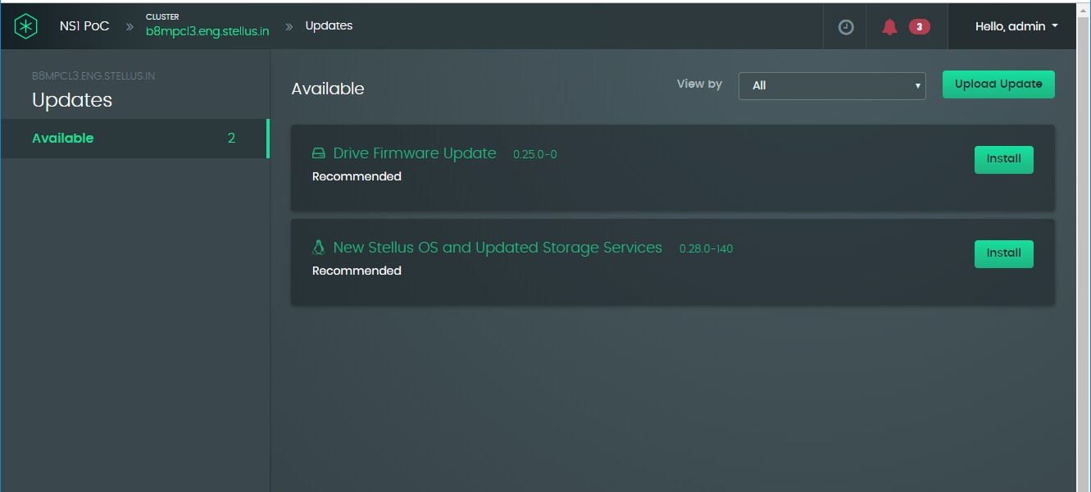

* + - * 1. When you click an **Install** button, the update is scheduled as a background task; see Section 6.2.4.7, “Select the time period for running maintenance background tasks”.

Also, note that if an update is available, a link to the update is available from the lower-right panel on the main cluster dashboard:

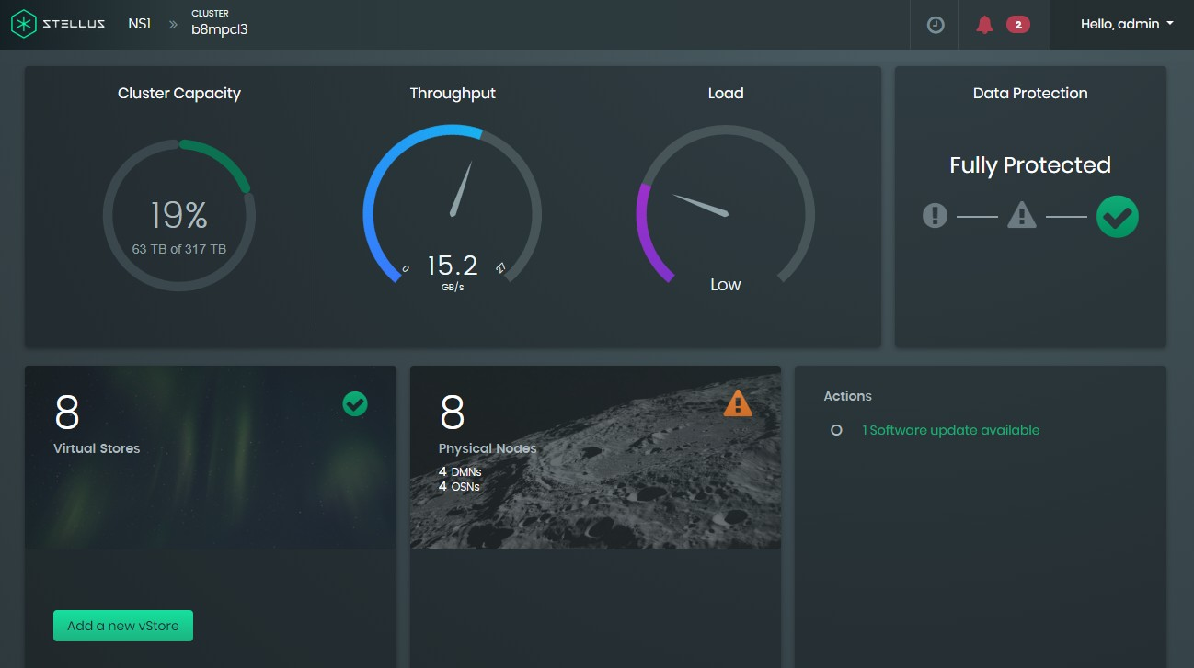

### Using the CLI to update the software

To view whether or not there are any updates to install:

**updates show [ --history ] [ --type=<type> ] [DRIVE, SWITCH, SYSTEM]**

For example:

**ns1> updates show**

+-----------------------+----------+------------------------------+----------------+----------------+----------+

| Title | Version | Release Date | Update Type | Severity | State |

+-----------------------+----------+------------------------------+----------------+----------------+----------+

| Drive Firmware Update | 0.26.0-0 | Sat May 25 06:43:39 PDT 2019 | DRIVE | RECOMMENDED | AVAILABLE|

+-----------------------+----------+------------------------------+----------------+----------------+----------+

To install an update:

**updates install --type=<type> [DRIVE, SWITCH, SYSTEM] --version=<version>**

For example:

**ns1> updates install --type=DRIVE --version=0.26.0-0**

Update Initiated

### Creating a support bundle

If your system has hardware or software issues that require support from Samsung Technologies, create a support bundle from the GUI as follows:

* + - * 1. Select **Support** from the user drop-down menu.

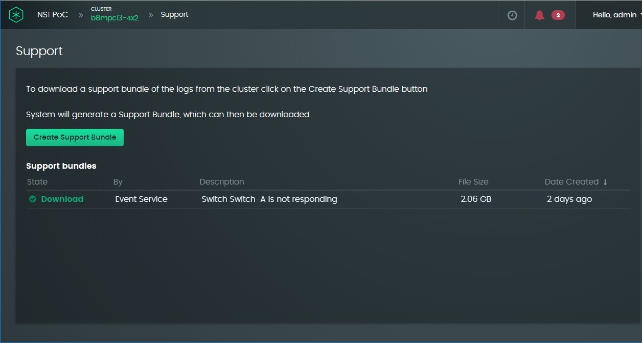

* + - * 1. When you click the **Create Support Bundle** button, the task is scheduled as a background task; see Section 6.2.4.7, “Select the time period for running maintenance background tasks”. To enable support packages to be forwarded to the SMA for monitoring over the Cloud, see Section 6.2.6, “Enable remote monitoring of the Samsung Data Platform cluster”.

### Using the CLI to create a support bundle

**support bundle create --destination=<destination>**

**--destinationPath=<destinationPath>**

**--username=<username>**

**--password=<password>**

**[ --description=<description> ]**

The system automatically generates a support bundle once per day.

### Viewing active and completed tasks in the GUI

The number of tasks scheduled or actively in progress is displayed in blue as a number next to a blue clock icon at the top-right of the dashboard:

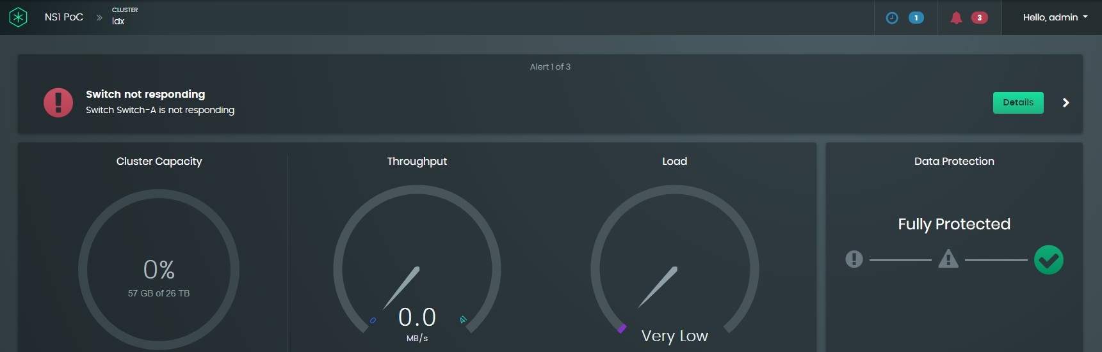

If there are no active or scheduled tasks, the clock icon will be gray and there will be no number next to it.

To view details about tasks in progress:

* + - * 1. Click in the area shown highlighted in the preceding screenshot.

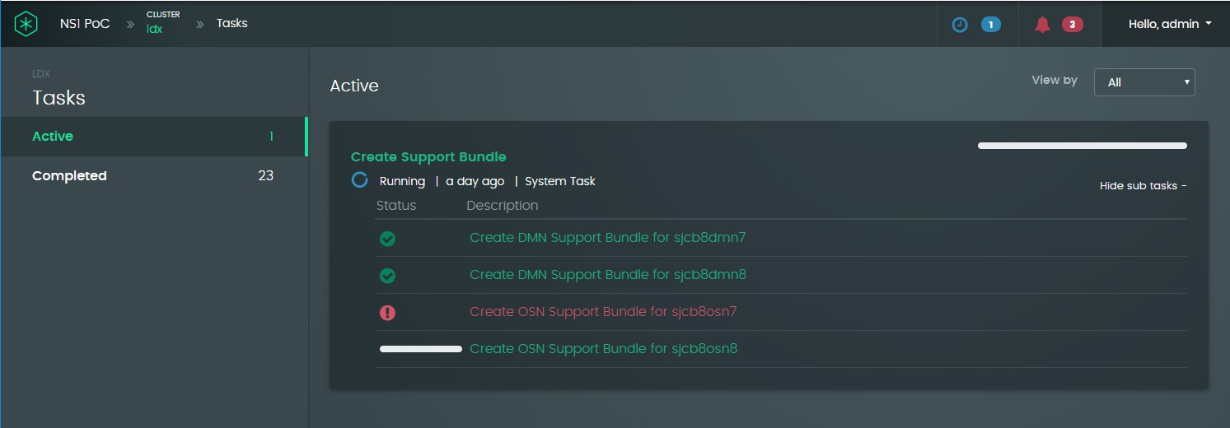

* + - * 1. The example above shows that the system is creating a support bundle, initiated as described in Section 6.2.4.4, “Create a support bundle”.

To view the list of completed tasks performed on the Samsung Data Platform cluster:

1. With the **Tasks** panel open as shown above, click the on the **Completed** line displayed at the left of the panel

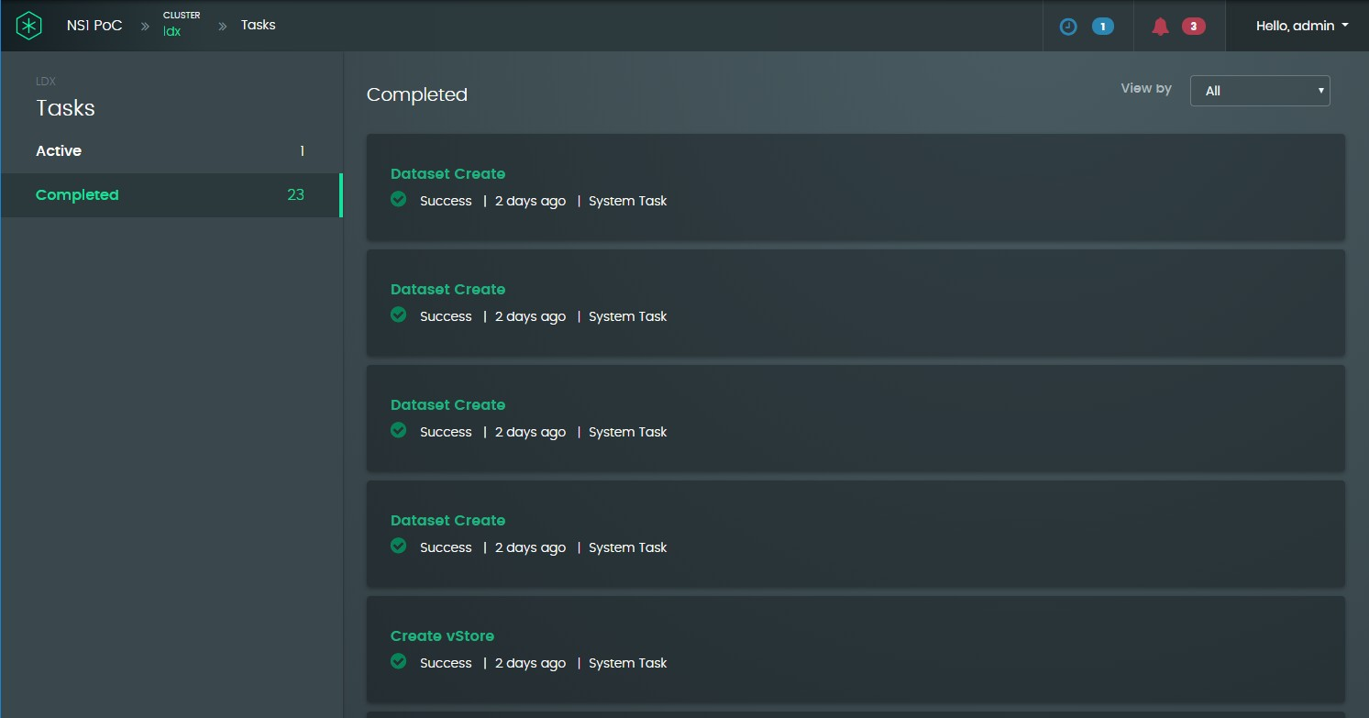

1. Clicking on an entry shows when the tasks was started and ended, and the time that the task took to complete in seconds.
2. If the task has subtasks, **Show sub tasks +** or **Hide sub tasks -** is displayed at the right of the entry where you can click to view or hide the subtasks. For example, the **Create Support Bundle** task has a subtask for each node in the cluster:

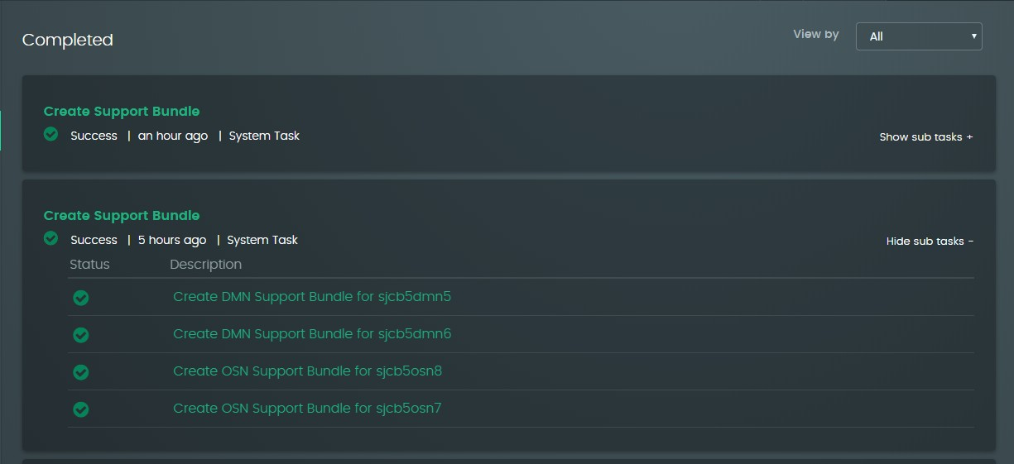

### Using the CLI to view task status

To view tasks from the CLI, use the **task show** command:

**task show [ --state=<state> ] [WAITING, INITIALIZING, RUNNING, PAUSING, PAUSED, RESUMING, CANCELLING, MIGRATING, SUCCESS, PARTIAL_SUCCESS, FAILED, CANCELLED]**

**[ --id=<id> ]**

For example, to show a summary of all tasks created on the cluster, run the task show command without options:

**ns1> task show**

+---------+-------------------------------+---------------------+---------------------+-----------+

| Id | Description | Resource | State | Progress |

+---------+-------------------------------+---------------------+---------------------+-----------+

+---------+-------------------------------+---------------------+---------------------+-----------+

Hit [enter] to retrieve more items. [Ctrl-C] to exit

+---------+-------------------------------+---------------------+---------------------+-----------+

| Id | Description | Resource | State | Progress |

+---------+-------------------------------+---------------------+---------------------+-----------+

+---------+-------------------------------+---------------------+---------------------+-----------+

|  |  |  |  |  |  |  |  |  |  |  |  |
| --- | --- | --- | --- | --- | --- | --- | --- | --- | --- | --- | --- |
| | | 1 | | | Creating | a support bundle | | | b8mpcl8x8 | | | SUCCESS | | | 100 | | |
| | | 2 | | | Creating | dataset file_dist | | | vs5 | | | SUCCESS | | | 100 | | |
| | | 3 | | | Creating | a support bundle | | | b8mpcl8x8 | | | SUCCESS | | | 100 | | |
| | | 4 | | | Creating | a support bundle | | | b8mpcl8x8 | | | SUCCESS | | | 100 | | |
| | | 5 | | | Creating | a support bundle | | | b8mpcl8x8 | | | SUCCESS | | | 100 | | |
| | | 6 | | | Creating | a support bundle | | | b8mpcl8x8 | | | SUCCESS | | | 100 | | |
| | | 7 | | | Creating | a support bundle | | | b8mpcl8x8 | | | SUCCESS | | | 100 | | |
| | | 8 | | | Creating | a support bundle | | | b8mpcl8x8 | | | SUCCESS | | | 100 | | |
| | | 9 | | | Creating | a support bundle | | | b8mpcl8x8 | | | SUCCESS | | | 100 | | |
| | | 10 | | | Creating | a support bundle | | | b8mpcl8x8 | | | SUCCESS | | | 100 | | |

|  |  |  |  |  |  |  |  |  |  |  |  |
| --- | --- | --- | --- | --- | --- | --- | --- | --- | --- | --- | --- |
| | | 11 | | | Updating | time settings | | | b8mpcl8x8 | | | SUCCESS | | | 100 | | |
| | | 12 | | | Updating | time settings | | | b8mpcl8x8 | | | SUCCESS | | | 100 | | |
| | | 13 | | | Creating | a support bundle | | | b8mpcl8x8 | | | SUCCESS | | | 100 | | |
| | | 14 | | | Creating | a support bundle | | | b8mpcl8x8 | | | SUCCESS | | | 100 | | |
| | | 15 | | | Creating | a support bundle | | | b8mpcl8x8 | | | SUCCESS | | | 100 | | |
| | | 16 | | | Creating | a support bundle | | | b8mpcl8x8 | | | SUCCESS | | | 100 | | |
| | | 17 | | | Creating | a support bundle | | | b8mpcl8x8 | | | SUCCESS | | | 100 | | |
| | | 18 | | | Creating | a support bundle | | | b8mpcl8x8 | | | SUCCESS | | | 100 | | |
| | | 19 | | | Creating | a support bundle | | | b8mpcl8x8 | | | SUCCESS | | | 100 | | |
| | | 20 | | | Creating | a support bundle | | | b8mpcl8x8 | | | SUCCESS | | | 100 | | |

Specifying a task ID displays details such as the list of subtasks, when the task was started and ended, and the time that the task took to complete in seconds.

**ns1> task show --id=1**

Id : 1

Description : Creating a support bundle Resource Type : CLUSTER

Resource : b8mpcl8x8

State : SUCCESS

Progress : 100

Start Time : Mon Dec 23 12:52:56 PST 2019

End Time : Mon Dec 23 12:57:46 PST 2019

Subtasks

+---------+-------------------------------+---------------------+---------------------+-----------+

| Id | Description | Resource | State | Progress |

+---------+-------------------------------+---------------------+---------------------+-----------+

|  |  |  |  |  |  |  |  |  |  |  |  |  |  |
| --- | --- | --- | --- | --- | --- | --- | --- | --- | --- | --- | --- | --- | --- |
| | | 1.1 | | | Create | DMN | Support | Bundle | f...| | sjcb8dmn7 | | | SUCCESS | | | 100 | | |
| | | 1.2 | | | Create | DMN | Support | Bundle | f...| | sjcb8dmn8 | | | SUCCESS | | | 100 | | |
| | | 1.3 | | | Create | DMN | Support | Bundle | f...| | sjcb8dmn5 | | | SUCCESS | | | 100 | | |
| | | 1.4 | | | Create | DMN | Support | Bundle | f...| | sjcb8dmn9 | | | SUCCESS | | | 100 | | |
| | | 1.5 | | | Create | DMN | Support | Bundle | f...| | sjcb8dmn10 | | | SUCCESS | | | 100 | | |
| | | 1.6 | | | Create | DMN | Support | Bundle | f...| | sjcb8dmn6 | | | SUCCESS | | | 100 | | |
| | | 1.7 | | | Create | DMN | Support | Bundle | f...| | sjcb8dmn11 | | | SUCCESS | | | 100 | | |
| | | 1.8 | | | Create | DMN | Support | Bundle | f...| | sjcb8dmn12 | | | SUCCESS | | | 100 | | |
| | | 1.9 | | | Create | OSN | Support | Bundle | f...| | sjcb8osn4 | | | SUCCESS | | | 100 | | |
| | | 1.10 | | | Create | OSN | Support | Bundle | f...| | sjcb8osn1 | | | SUCCESS | | | 100 | | |

+---------+-------------------------------+---------------------+---------------------+-----------+

Hit [enter] to retrieve more items. [Ctrl-C] to exit

+---------+-------------------------------+---------------------+---------------------+-----------+

| Id | Description | Resource | State | Progress |

+---------+-------------------------------+---------------------+---------------------+-----------+

| 1.11 | Create OSN Support Bundle f...| sjcb8osn7 | SUCCESS | 100 |

| 1.12 | Create OSN Support Bundle f...| sjcb8osn5 | SUCCESS | 100 |

| 1.13 | Create OSN Support Bundle f...| sjcb8osn3 | SUCCESS | 100 |

| 1.14 | Create OSN Support Bundle f...| sjcb8osn6 | SUCCESS | 100 |

| 1.15 | Create OSN Support Bundle f...| sjcb8osn2 | SUCCESS | 100 |

| 1.16 | Create OSN Support Bundle f...| sjcb8osn8 | SUCCESS | 100 |

+---------+-------------------------------+---------------------+---------------------+-----------+

**ns1>**

### Selecting the time period for running maintenance background tasks

The application allows you to set the days in the week and the time of day when background tasks can be run to avoid running these tasks during peak traffic periods.

To view or change the maintenance window:

* + - * 1. Select **Settings** from the user drop-down menu and click the **Policy** tab.
        2. Click the **Maintenance** button to make it active (green).

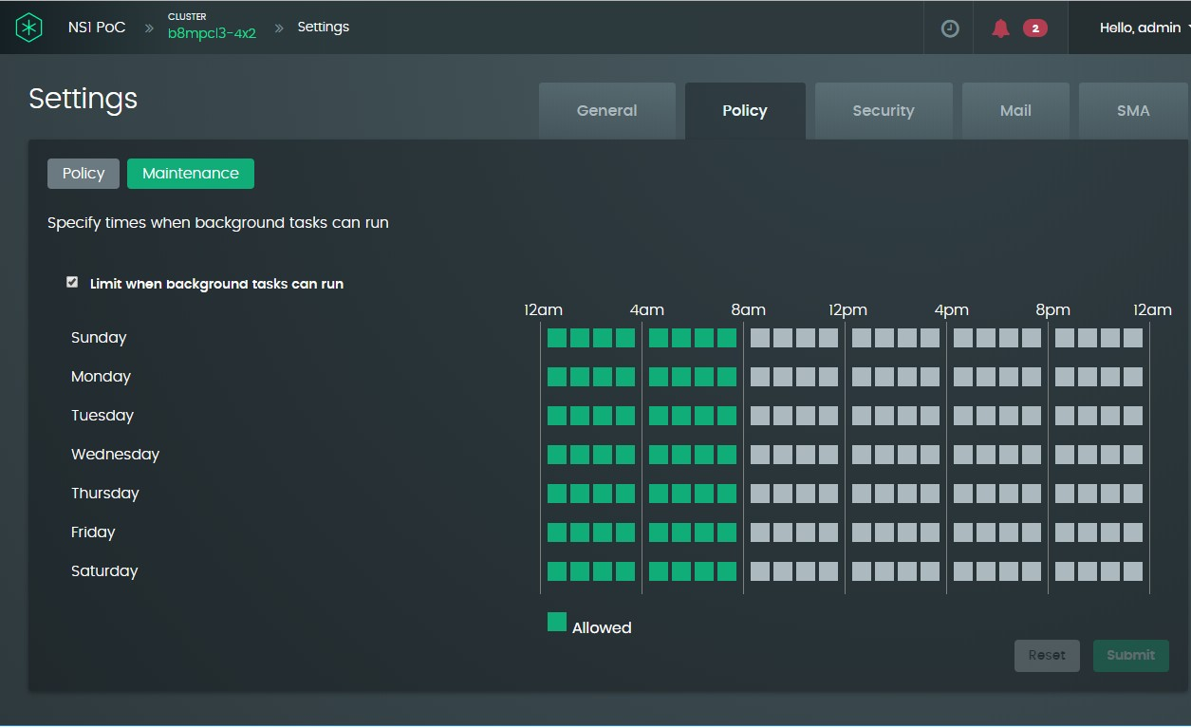

* + - * 1. Each green or gray square corresponds to a one-hour period in which maintenance tasks can or cannot run. Clicking on a square will toggle the status between allowed (green) and not allowed (gray). If you do not need to limit when background tasks need to be run, clear the checkmark in the **Limit when background tasks can run** checkbox near the top-left of the panel. This removes the squares for enabling/ disabling background tasks for each hour in every day of the week.
        2. If you made any changes in step 3, click the **Submit** button to complete the operation.

Clicking the **Reset** button instead of **Submit**, resets the maintenance window to the factory-defined default, enabling background tasks to be performed between midnight and 8 am.

### Configuring the email server for sending system event notifications

*Procedure using the GUI:*

* + - * 1. Select **Settings** from the user drop-down menu at the top-right of the Samsung Data Plat- form cluster dashboard window.
        2. On the **Settings** page, select the **Security** tab and the **Mail** sub-tab.

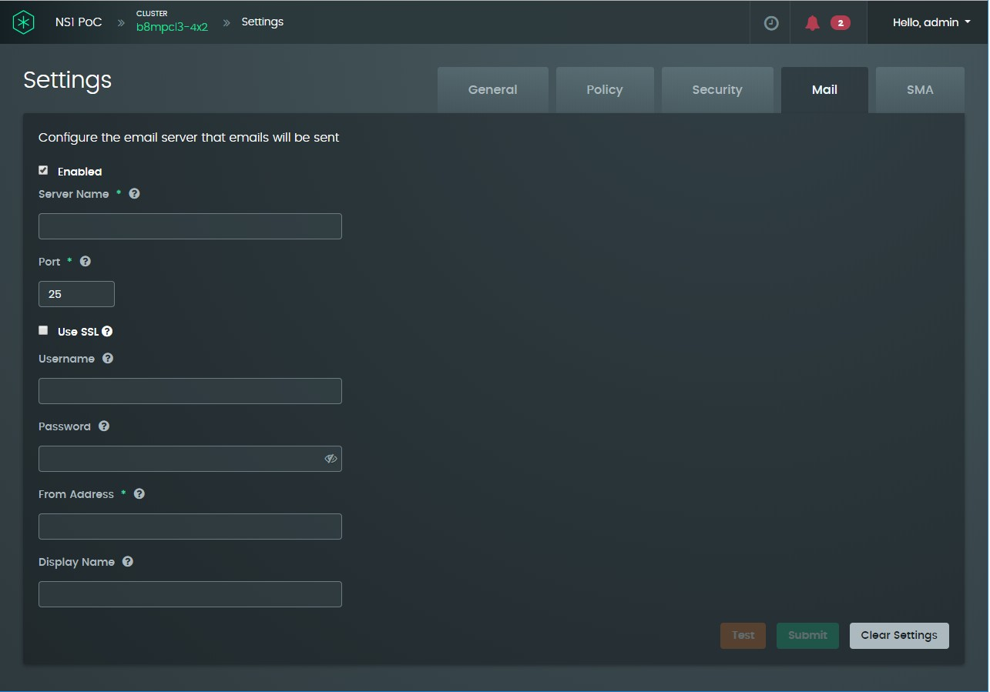

* + - * 1. For the server name, enter the host name, such as *mail.company_name.com* or

*smtp.company_name.com*, or the IP address of the email server.

* + - * 1. Port 25 is the most widely used SMTP port, but port 587 is the best choice for STARTTLS.
        2. Enable the **SSL** radio button if encryption is being used.
        3. If the SMTP server needs administrator credentials to send emails, enter the required information in the **Username** and **Password** fields.
        4. In the **From Address** field, enter the address that emails from this cluster will appear to come from.
        5. In the **Display Name** field, enter an informal name for the email address that emails from this cluster will appear to come from.

### Using the CLI to configure the email server for sending system event notifications

**mail update [ --server=<server> ] [ --port=<port> ]**

**[ --ssl=<ssl> ]**

**[ --username=<username> ] [ --password=<password> ] [ --from=<from> ] [ --display=<display> ]**

**[ --enabled=<enabled> ]**

In the aforementioned command, valid values for <ssl> and <enabled> are **true** and **false**.

### Enabling remote monitoring of the Samsung Data Platform cluster

To be able to configure and manage the system from the cloud, you must enable remote management.

*Procedure using the GUI*

* + - * 1. Select **Settings** from the user drop-down menu and click the **SMA** tab.

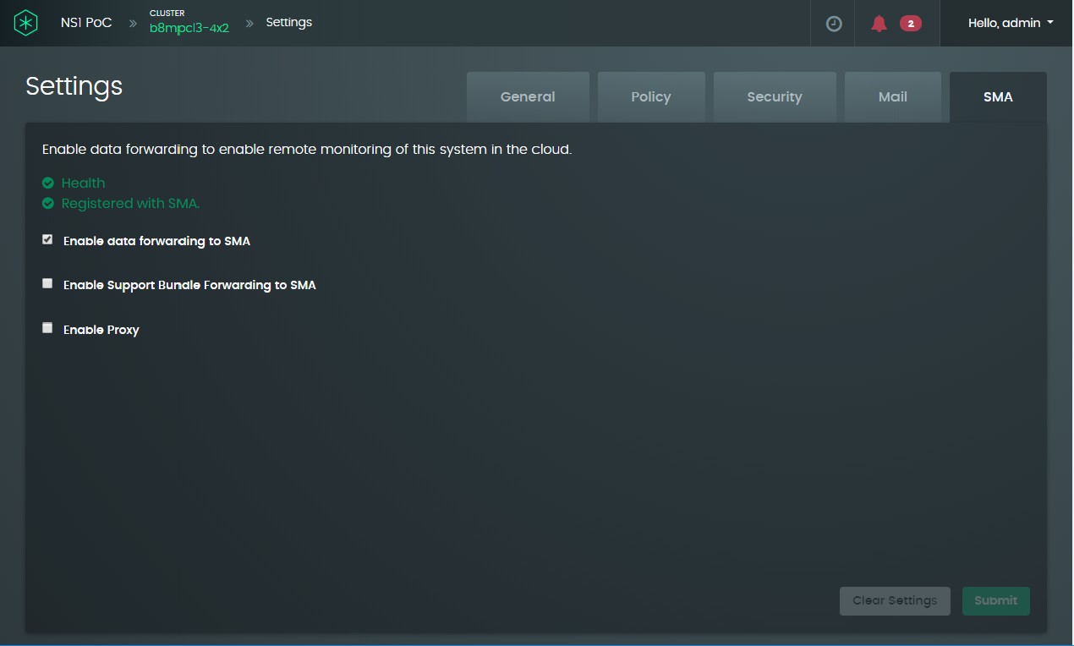

* + - * 1. As a minimum, set the **Enable data forwarding to SMA** checkbox. This will enable you to monitor your cluster from the internet as well as send diagnostic information about the cluster to Samsung Support. If you want support bundles, created as described in Section 6.2.4.4, “Create a support bundle”, to be sent to the Cloud, set the **Enable Support Bundle Forwarding to SMA** checkbox.
        2. If the internal network requires proxy settings to access the Internet, set the **Enable Proxy** checkbox. The software will display text boxes for you to define the proxy URL, a proxy user name, and proxy password.
        3. Click the **Submit** button to complete the operation.

### Using the CLI to Enable remote monitoring of the Samsung Data Platform cluster

To view current SMA settings, enter the **sma show** command. For example:

**ns1> sma show**

Enable Data Forwarding : false Enable Support Bundle Forwarding : false Enable Proxy : false

Health : OK

Registered : true

To update the SMA settings:

**sma update [ --enableDataForwarding=<enableDataForwarding> ]**

**[ --enableSupportBundleForwarding=<enableSupportBundleForwarding> ] [ --enableProxy=<enableProxy> ]**

**[ --proxyURI=<proxyURI> ]**

**[ --proxyUser=<proxyUser> ] [ --proxyPassword=<proxyPassword> ] [ --registered=<registered> ]**

In the above command, valid values for <enableDataForwarding>,

<enableSupportBundleForwarding>, <enableProxy>, and <registered> are **true** and **false**. Option switches **--proxyURI**, **--proxyUser**, and **--proxyPassword** are required if **-- enableProxy=true**.

### Viewing the audit trail of events on the Samsung Data Platform cluster

The Samsung Data Platform cluster software maintains a history of notifiable events.

*View procedure using the GUI*

* + - * 1. Select **Settings** from the user drop-down menu, click on the **Security** tab and the **Audit** sub-tab. The software displays the list of notifiable events, with the most recent event appearing first.

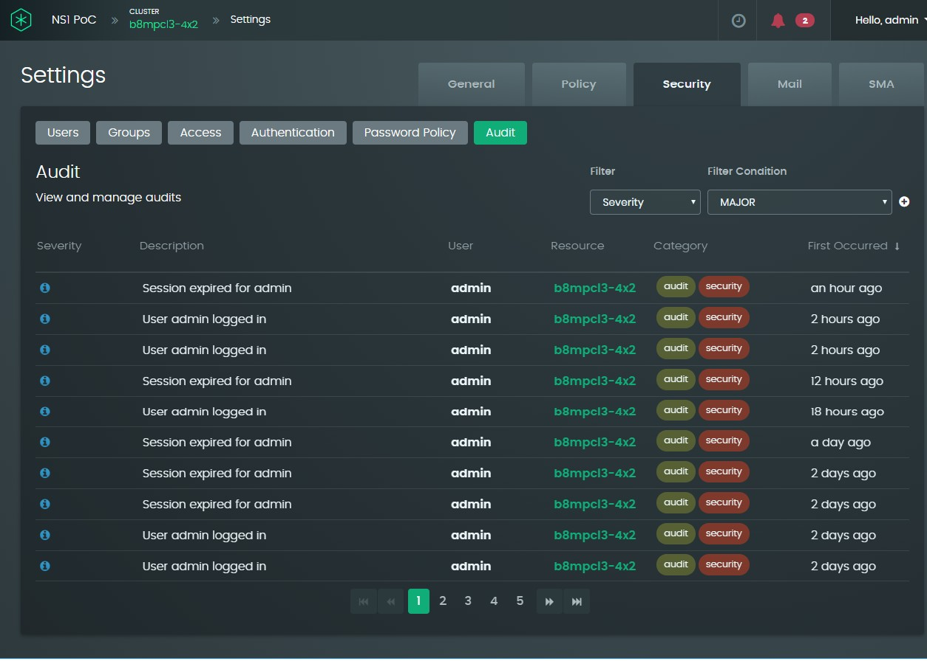

* + - * 1. If you click on an event, you can see the exact time of day that the event occurred.

### Using the CLI to View the audit trail of events on the Samsung Data Platform cluster

**audit show [ --id=<id> ] [ --before=<before> ] [ --after=<after> ]**

In the above command, the date-time values for <before> and <after> must be in the format yyyy-MM-dd HH:mm:ss. For example:

**ns1> audit show --after=2019-12-26 12:00:00**

To display details about a specific audit entry, use the **--id** switch. For example:

**ns1> audit show --id=1**

ID : 1

Description : Session expired for admin User : admin

Resource Type : CLUSTER Resource : b8mpcl8x8

Time : Thu Dec 26 14:14:01 PST 2019

Username : admin

Running the command with the --id option is only possible after running the audit show command without the switch, to load the audit events into memory.

## Managing your user profile

Your user profile includes

* + - the email address for receiving automated notifications from the Samsung Data Platform cluster
    - the type and severity of notifications that you opt to receive
    - your password for logging in to the Samsung Data Platform cluster software application

### Changing the email address for receiving automated notifications from an SDP cluster

* + - 1. Select **Profile** from the user drop-down menu at the top-right of the Samsung Data Plat- form cluster dashboard window.

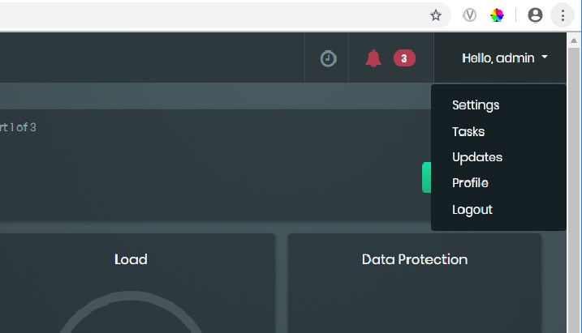

The application displays a Profile window with three tabs: **Notification, User Details**, and **Password**.

* + - 1. On the **User Details** panel, you can set the email address where system event notification can be sent. The **Notification** tab allows you to specify the type and severity of the notifications that you want to receive.

You can only change the email address if the SMTP mail server that the sys- tem uses to send automated notifications has been set up; see Section 6.2.5, “Configure the email server for sending system event notifications”.

### Selecting the type and severity of system email notifications

*Procedure using the GUI*

* + - * 1. Select **Profile** from the user drop-down menu at the top-right of the Samsung Data Plat- form cluster dashboard window and then click on the **Notification** tab. The application displays the following window:

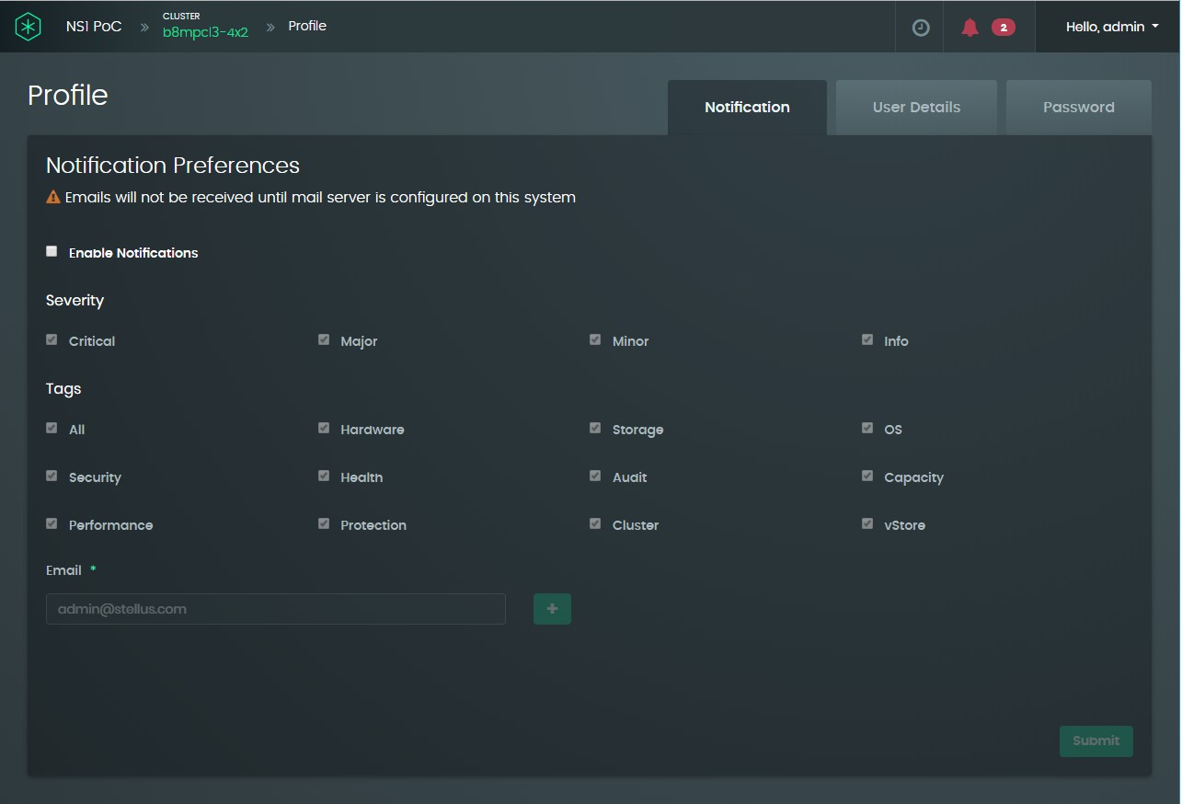

* + - * 1. Select the checkboxes for the notification that you want to receive, set the **Enable Notifications** checkbox, and click submit.
        2. If needed, add other email addresses for receiving the notifications.

Notifications require the mail server to be set up; see Section 6.2.5, “Config- ure the email server for sending system event notifications”

### Using the CLI to identify types and severities of system notification emails

**notification update [ --severities=<severities> ] [Info, Minor, Major, Critical] [ --tags=<tags> ] [Hardware, Storage, OS, Security, Health, Audit, Capacity, Performance, Protection, Cluster, vStore]**

**[ --email=<email> ]**

**[ --enabled=<enabled> ] [ --allSeverities ] [ --allTags ]**

For the above command, valid values for <enabled> are **true** and **false**. To specify specific severities, use the **--severities** option switch; otherwise use **--allSeverities** to receive notifications for all of them. Similarly, use the **--tags** option to specify specific notification tags or **--allTags** to receive notifications for all of them.

### Changing your Samsung Data Platform cluster login password

*Procedure using the GUI*

* + - * 1. Select **Profile** from the user drop-down menu at the top-right of the Samsung Data Plat- form cluster dashboard window and then click on the **Password** tab.

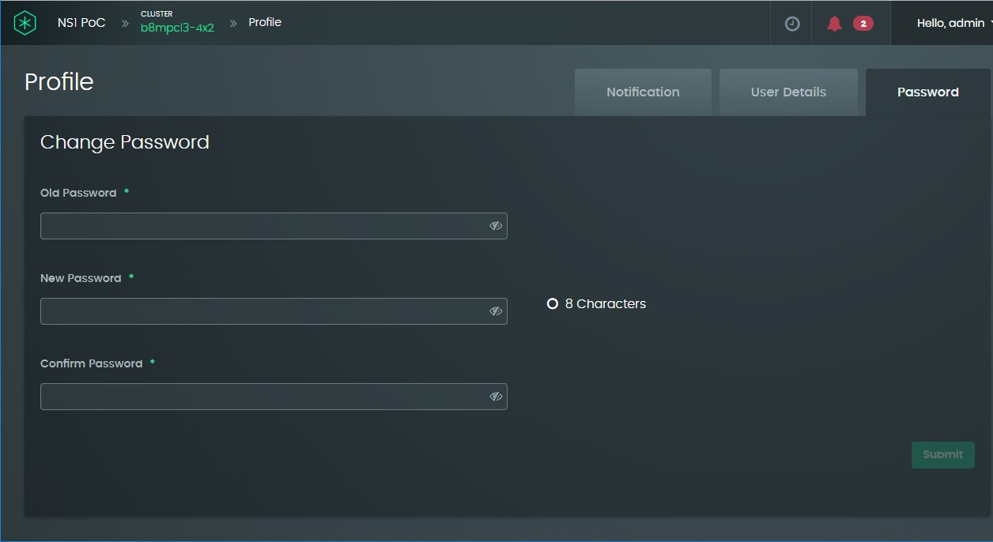

* + - * 1. In the appropriate text boxes, type in your current password, and new password (twice). The new password must conform to the password policy set up by the system administrator; see Section 6.1.2, “Set up the password policy”.
        2. Click the **Submit** button to complete the operation.

### Using the CLI to change your Samsung Data Platform cluster login password

**user update --level=<level> [CLUSTER, VSTORE] --username=<username> [ --newusername=<newusername> ]**

**[ --password=<password> ] [ --emailAddress=<emailAddress> ] [ --changepw=<changepw> ] [ --locked=<locked> ]**

**[ --vStore=<vStore> ]**

**[ --primaryUserGroup=<primaryUserGroup> ] [ --userGroups=<userGroups> ] [ --uid=<uid> ]**

To change the password, only the option switches **--username** and **--password** need to be provided.

# Managing vStores

## Creating an additional data set

*Procedure using the GUI*

* + 1. Click on the **Create Data Set** button in the upper right of the screen shown in Step 9 on page 54.
    2. When creating the new data set, a name must be provided. In this example, the name **dataset-1** is used. Also at creation time, the protection policy must be created. As noted above, the choice of **Performance Optimized** means that there are two copies of the data. If compression or encryption are desired for the data set, they can be chosen as well.

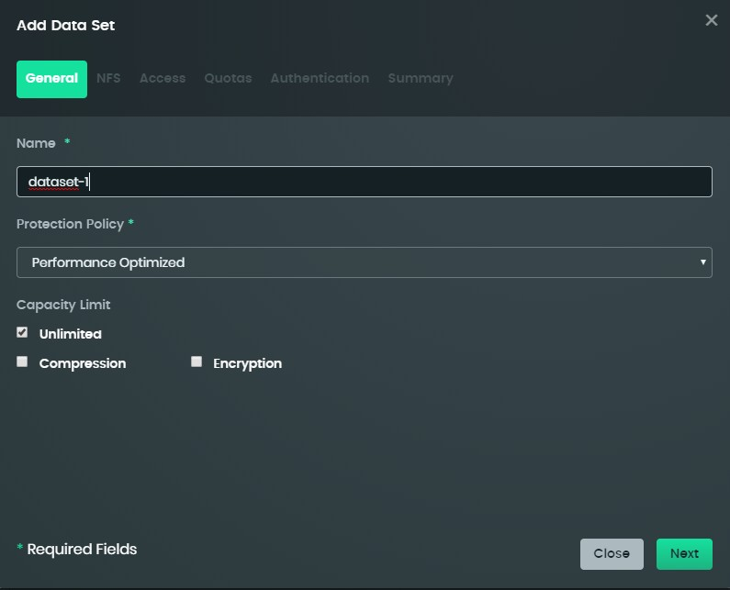

* + 1. Click **Next** to display a dialog to set up NFS-related information for the data set, such as the mount point and the access to the data set.

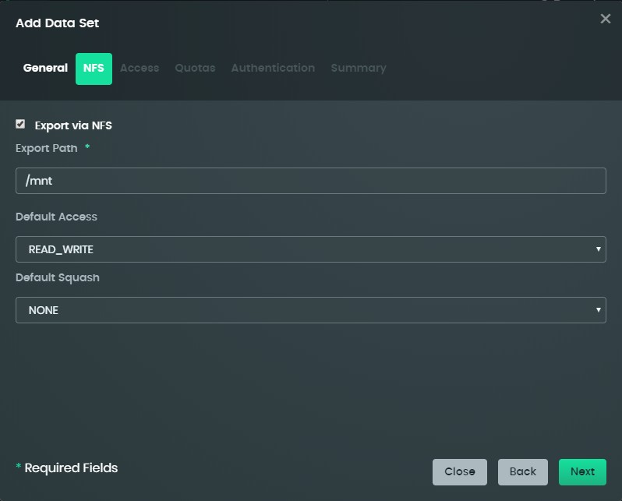

* + 1. Click **Next** to view the **Access** dialog.

If specific host access information is desired, then it can be added by clicking the **Add Host Access** button highlighted in the screen shown below.

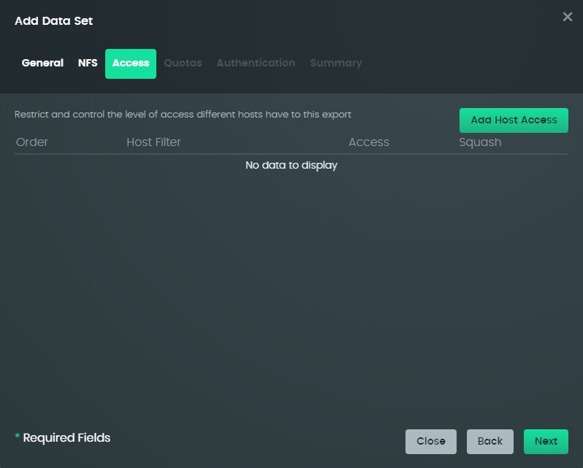

* + 1. Click **Next** to set up quotas, if required, for the data set.

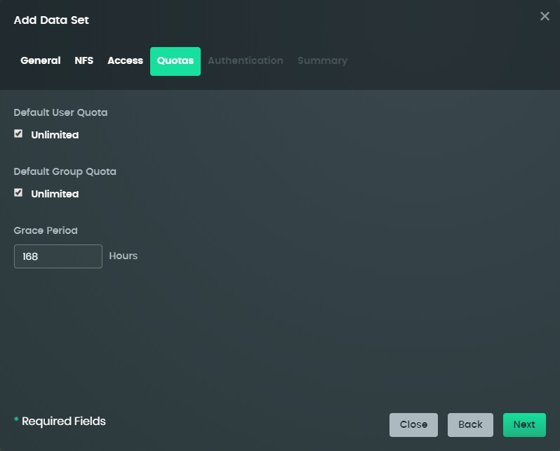

* + 1. Click Next to view the Authentication options as shown below. Select one or both of the options. By default, both are enabled.

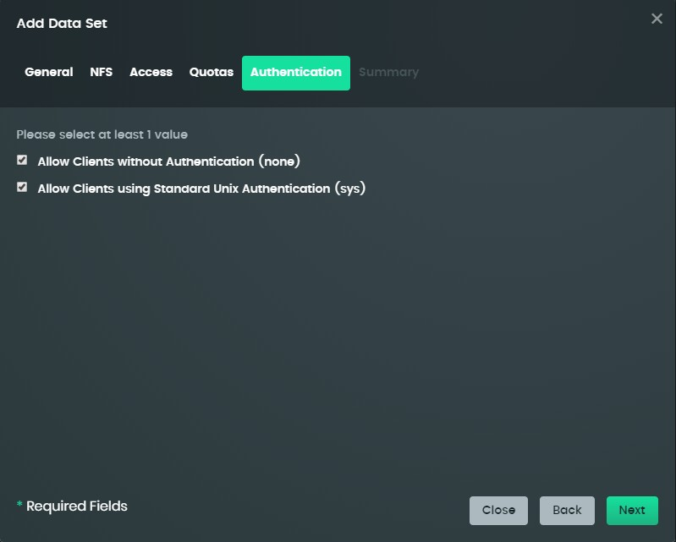

* + 1. Click **Next** to view a summary screen, as shown below, before clicking on the **Submit**

button to create the data set.

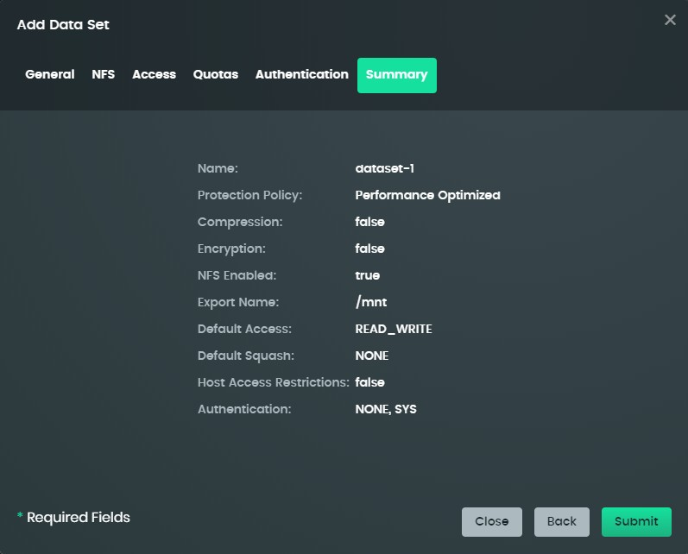

* + 1. The **Data Sets** screen for the vStore lists the new data set. Click the **?** icon, the mount point is shown for that Data Set, for an NFS client to mount to. Additional data sets can be created by following these steps again.

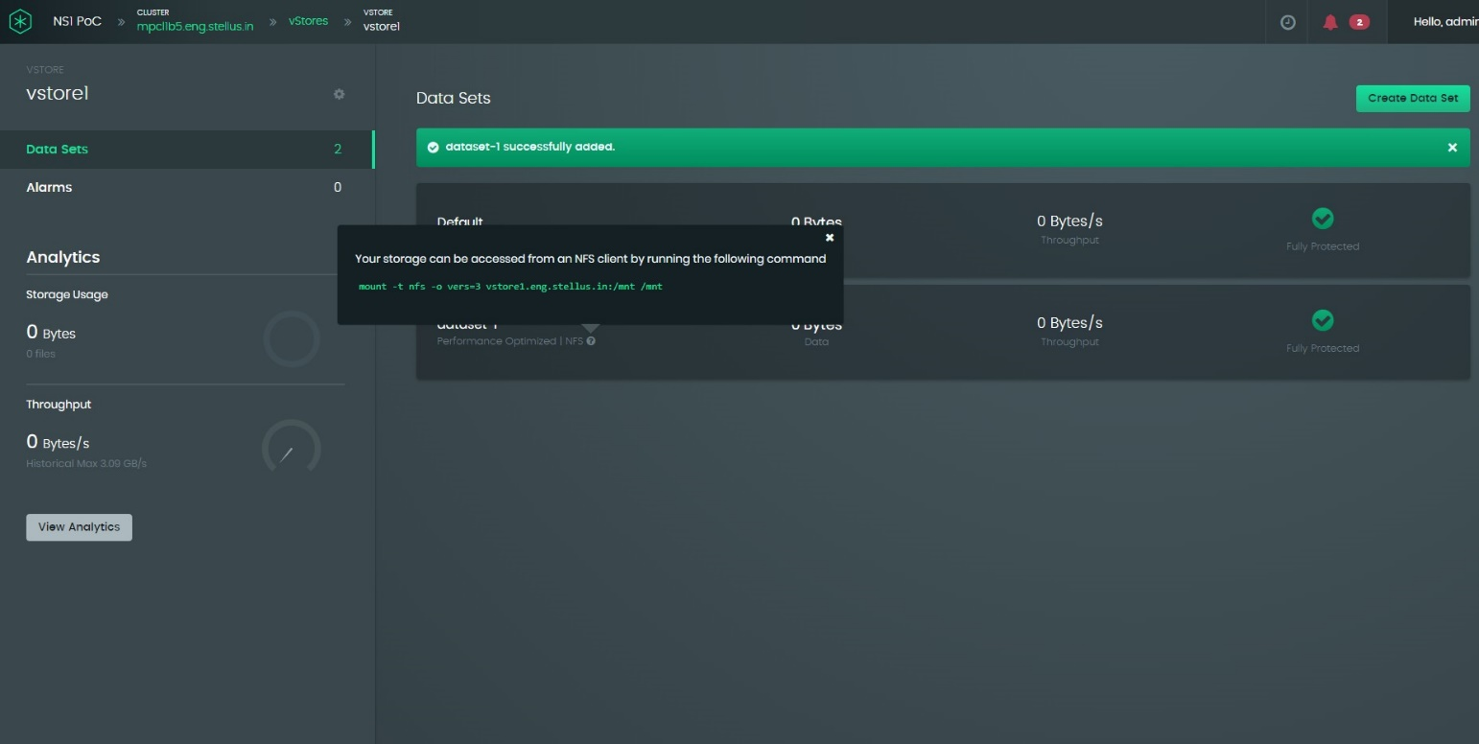

Click here to view the NFS

mount information

### Using the CLI to create additional data sets

To create the dataset:

**dataset create --vStore=<vStore> --name=<name> --protectionPolicy=<protectionPolicy> [ --nfsEnabled=<nfsEnabled> ] [ --exportPath=<exportPath> ]**

**[ --compression=<compression> ] [ --encryption=<encryption> ] [ --access=<access> ] [READ_ONLY, READ_WRITE, NONE]**

**[ --squash=<squash> ] [ALL, ROOT, NONE]**

**[ --gracePeriodHours=<gracePeriodHours> ]**

**[ --capacity=<capacity> ] [ --defaultUserQuota=<defaultUserQuota> ] [ --defaultGroupQuota=<defaultGroupQuota> ]**

In the above command, the valid values for <nfsEnabled>, <compression>, and <encryption> are **true** and **false**. If <nfsEnabled> is set to true, a value for **--exportPath** must be provided. which is appended to the vStore domain name when creating an NFS mount. The value for

<exportPath> does not require a leading “/” character. Values for <capacity>,

<defaultUserQuota>, and <defaultGroupQuota> must be expressed by an integer indicating capacity or quota in GB.

To view the protection policies that can be applied to datasets in a vStore when they are created, use the dataset protectionPolicy show command:

**dataset protectionPolicy show --vStore=<vStore>**

To add host access, use the **dataset hostAccess add** command:

**dataset hostAccess add --name=<name> --vStore=<vStore> --filter=<filter>**

**--access=<access> [READ_ONLY, READ_WRITE, NONE]**

**--squash=<squash> [ALL, ROOT, NONE]**

## Changing or viewing vStore configuration settings

This subsection describes how to set up, change, or view the following vStore configuration settings:

* General settings comprising the vStore name, capacity limit, and capacity-warning threshold.
* Network settings first set up when the vStore was created: vStore domain name, IP address subnet, gateway, number of associated VLANs, and the range or ranges of DM IP addresses.
* NFS settings: port, default maximum read size, and default maximum write size.
* vStore-specific security settings (similar in scope to the cluster security settings).

### Accessing the vStore Configuration

*Procedure using the GUI*

1. Click in the Virtual Store panel of the Samsung Data Platform cluster main dashboard:

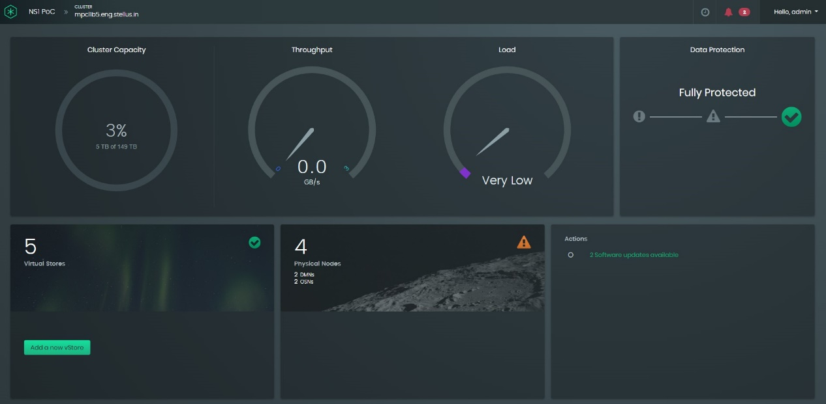

3

1. Click in the subpanel for the vStore that you want to access:

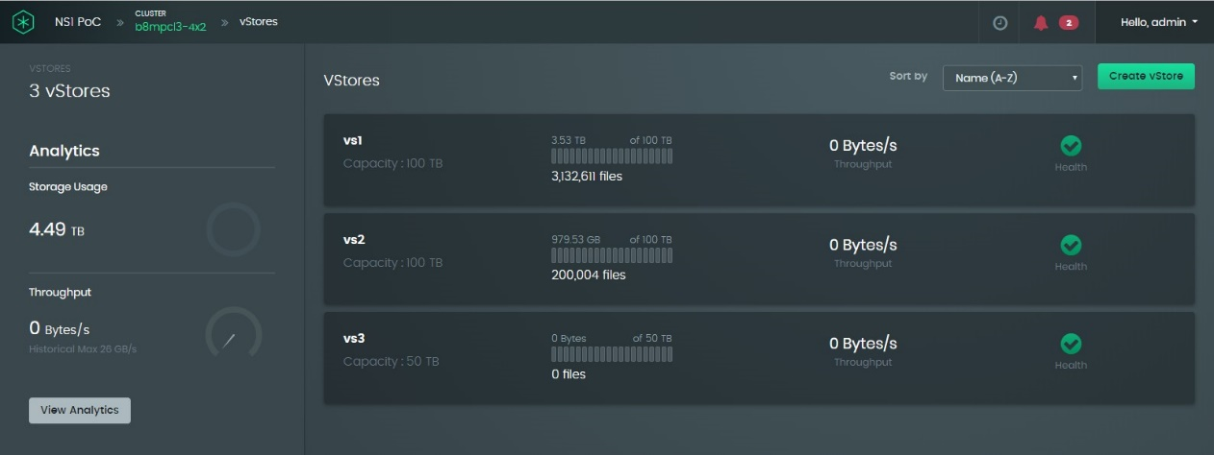

1. On the vStore information screen, click the gear-cog icon towards the top right of the left panel:

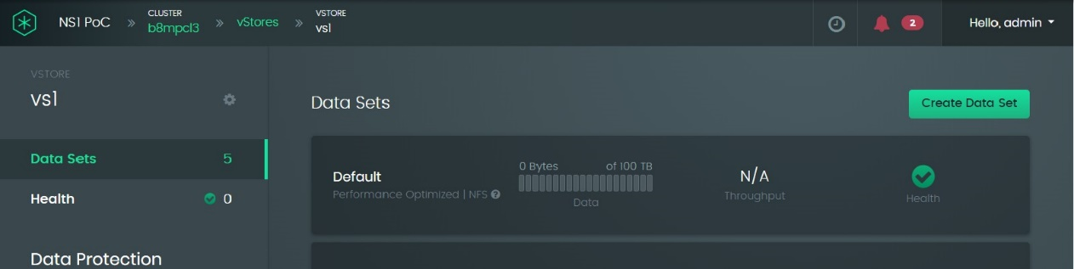

vStore configuration settings icon

The software displays a general settings screen.

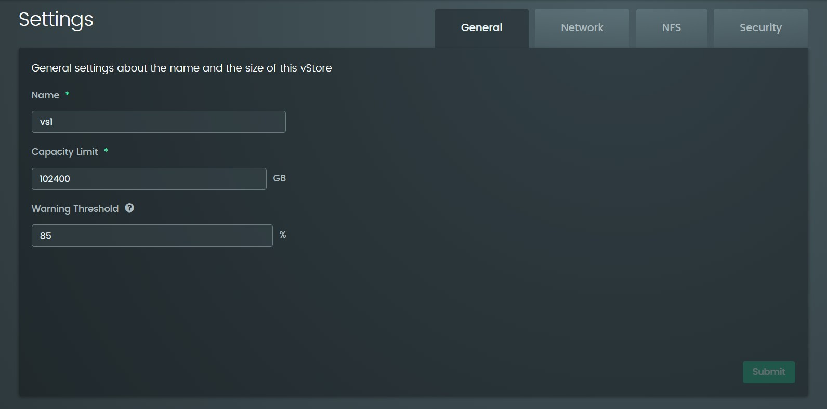

When viewing this vStore-specific information screen for the first time, the name and capacity fields are as specified when the vStore was created. The capacity warning threshold is initially set to the same threshold as for the entire Samsung Data Platform cluster, but this screen allows the threshold for the vStore to be set independently. If you change any of these settings, click the **Submit** button to put the changes into effect.

Click the **Network** tab to view the network settings. All the fields on this panel were initially defined when the vStore was created. If you modify any of these settings, click the **Submit** button to put the changes into effect.

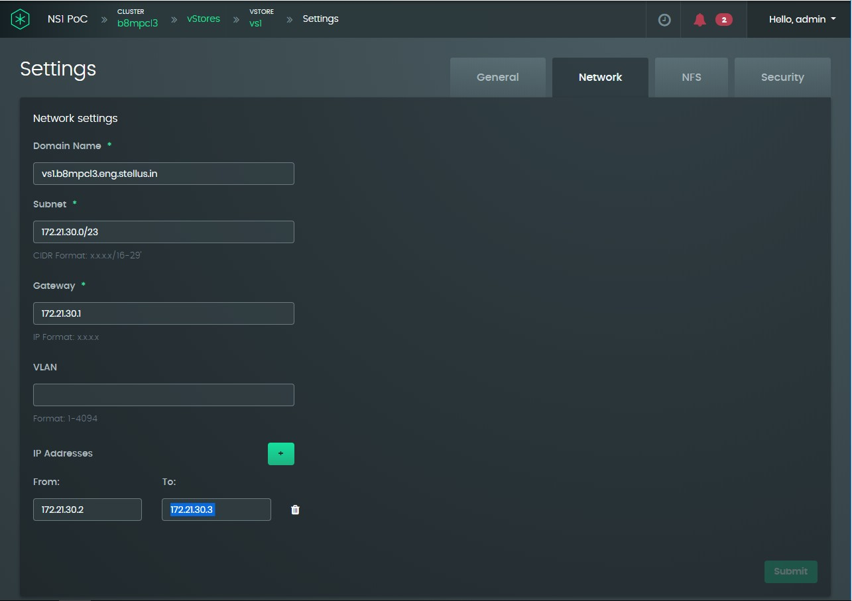

The NFS tab allows you to view or modify the NFS port, the default maximum read size, and the default maximum write size.

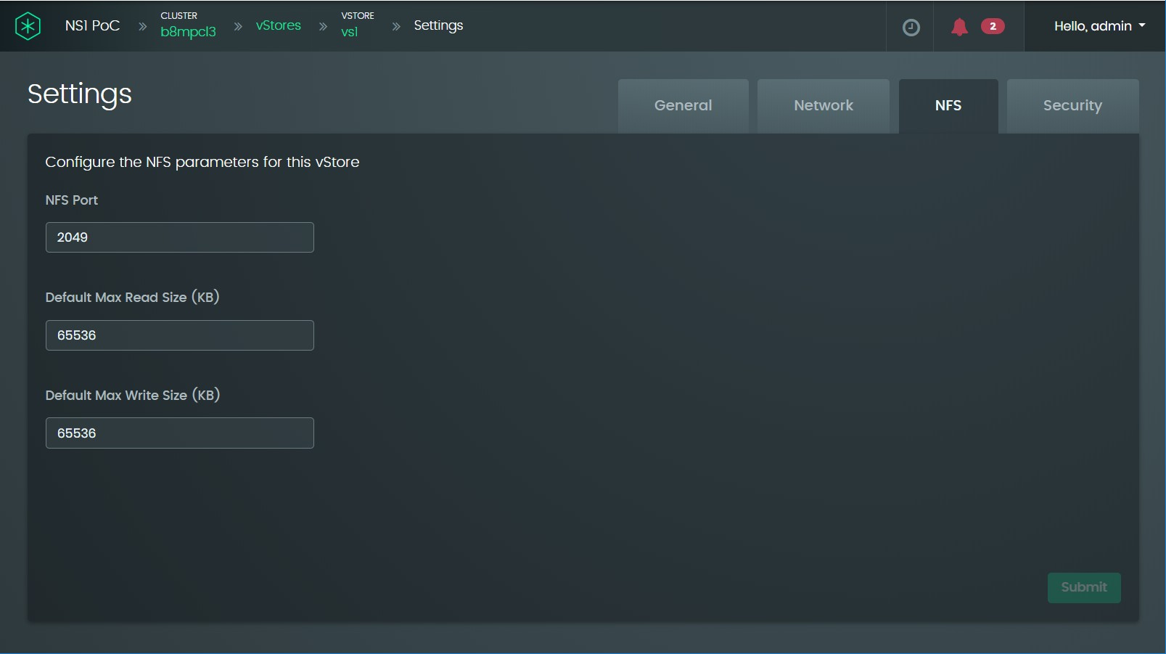

When the vStore is initially created, the NFS port number is 2049 by default, and the maximum read and writes sizes are 64 MB. If you modify any of these settings, click the **Submit** button to put the changes into effect.

The option buttons on the security panel are similar to those for the Samsung Data Platform cluster (see Section 6.1, “Samsung Data Platform cluster security administration”), except that the vStore security panel has an additional Kerberos authentication subtab.

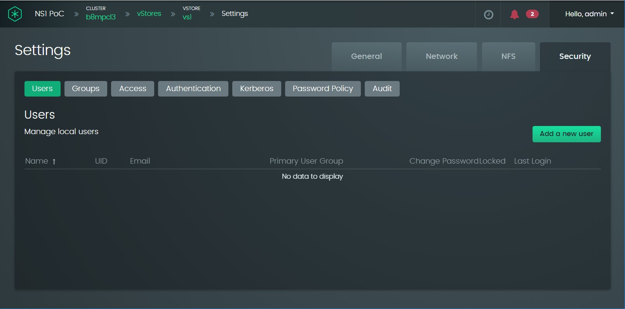

The security settings for the Samsung Data Platform cluster and each of the vStores can be entirely independent of one another. The vStore groups screen lists vStore-specific groups; Samsung Data Platform cluster groups do not need to be included because access can be granted or withheld from either set of groups under the **Access** tab. By default, the vStore groups include **vstore_administrators** and **vstore_operators**, as shown below.

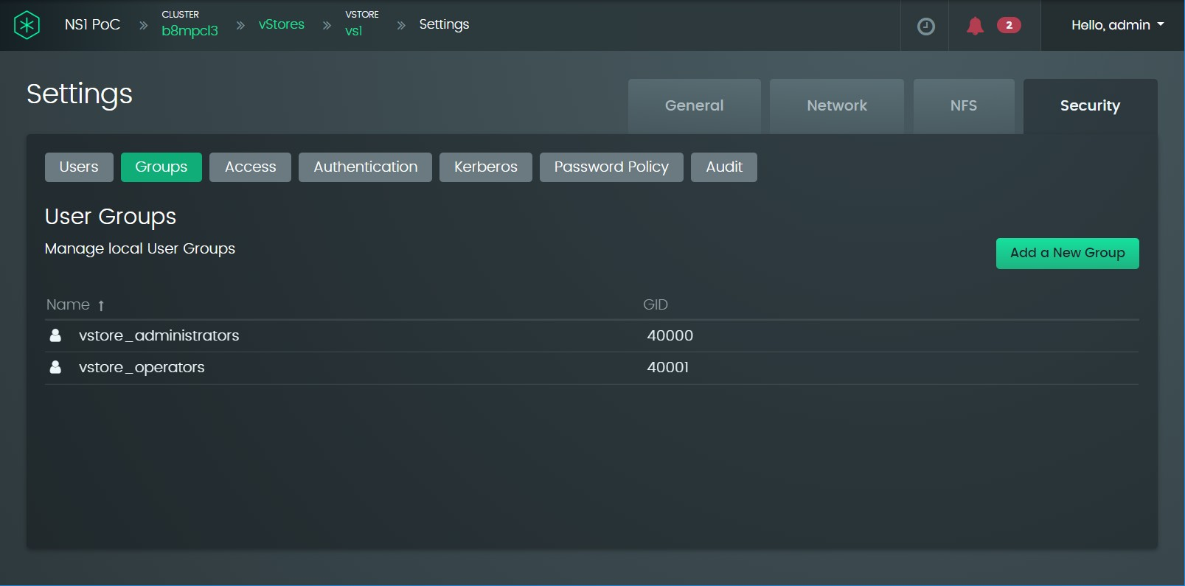

If required, you can define groups that are specific to the vStore and the default

**vstore_administrator** and **vstore_operators** groups can be deleted.

For the **Users**, **Groups**, **Access**, **Authentication**, **Password Policy**, and **Audit** panels, usage is the same as for the equivalent panels under the Samsung Data Platform cluster Security tab except that the scope is specific to the selected vStore. For usage instructions, see Section 6.1, “Samsung Data Platform cluster security administration”.

Using Kerberos for third-party computer network authentication is optional and, by default, is not enabled.

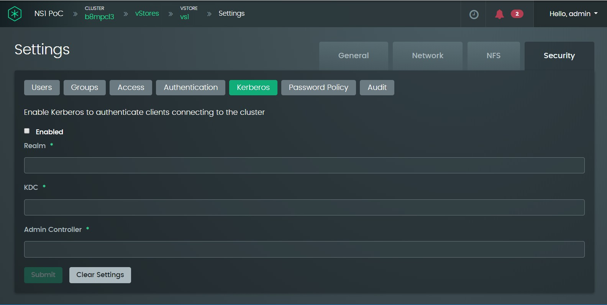

To enable Kerberos authentication, you must provide three parameters:

* + - * 1. **Realm**: This is synonymous with the domain name. For example, if you have set up an AD server under the **Authentication** tab, the realm name will be the same as the Active Directory domain name formatted in uppercase letters.
        2. **KDC**: The domain name of the third-party key distribution center; for example, kerberos.mit.edu. Roland: I suspect this isn’t a good example.
        3. **Admin Controller**: The local Kerberos domain controller that recognizes tickets issued by the KDC.

After the above parameters have been provided, enable Kerberos authentication by activating the **Enabled** checkbox and clicking the **Submit** button.

### Using the CLI to access the vStore Configuration

To view vStore general settings:

**vStore show [ --name=<name> ]**

Without the --name option, the command shows each vStore name, domain name, capacity in GB, used capacity, and health status. For example:

**ns1> vStore show**

+---------------+--------------------------------------+---------------------+------------------+------------+

| Name | Domain Name | Capacity (GB) | Usage (GB) | Health |

+---------------+--------------------------------------+---------------------+------------------+------------+

+---------------+--------------------------------------+---------------------+------------------+------------+

|  |  |  |  |  |  |
| --- | --- | --- | --- | --- | --- |
| | vs1 | | vs1.b8mpcl8x8.eng.stellus.in | | 102400.0 | | 12199.9 | | OK | | |
| | vs2 | | vs2.b8mpcl8x8.eng.stellus.in | | 102400.0 | | 818.4 | | OK | | |
| | vs3 | | vs3.b8mpcl8x8.eng.stellus.in | | 102400.0 | | 15000.1 | | OK | | |
| | vs4 | | vs4.b8mpcl8x8.eng.stellus.in | | 102400.0 | | 15052.5 | | OK | | |
| | vs5 | | vs5.b8mpcl8x8.eng.stellus.in | | 102400.0 | | 53.4 | | OK | | |
| | vs6 | | vs6.b8mpcl8x8.eng.stellus.in | | 102400.0 | | 16562.6 | | OK | | |
| | vs7 | | vs7.b8mpcl8x8.eng.stellus.in | | 102400.0 | | 14423.1 | | OK | | |
| | vs8 | | vs8.b8mpcl8x8.eng.stellus.in | | 102400.0 | | 20152.3 | | OK | | |

Both general and network settings are displayed if a specific vStore is identified using the

**--name** switch option. For example:

**ns1> vStore show --name=vs1**

Name

Domain Name Subnet Gateway

called get addresses IP Addresses

Capacity (GB) Usage (GB)

Warning Threshold (%) Health

Protection Status Consistency Status

: vs1

: vs1.b8mpcl8x8.eng.stellus.in

: 172.21.30.0/16

: 172.21.0.1

: 172.21.30.2-172.21.30.9

: 102400.0 GB

: 12283.8 GB

: 85

: OK

: NOMINAL

: CONSISTENT

To modify the general or network settings, use the vStore update command:

**vStore update --name=<name> [ --newName=<newName> ] [ --capacity=<capacity> ] [ --capacityWarningThreshold=<capacityWarningThreshold> ]**

**[ --domainName=<domainName> ] [ --subnet=<subnet> ] [ --gateway=<gateway> ] [ --ipAddresses=<ipAddresses> ] [ --vlan=<vlan> ]**

To view NFS settings, use the **vStore nfs show** command:

**vStore nfs show [ --name=<name> ]**

For example:

**ns1> vStore nfs show**

+---------------------+-----------+---------------------+---------------------+

| Name | NFS Port | Max Read (KB) | Max Write (KB) |

+---------------------+-----------+---------------------+---------------------+

| vs1 | 2049 | 65536.0 | 65536.0 |

| vs2 | 2049 | 65536.0 | 65536.0 |

| vs3 | 2049 | 65536.0 | 65536.0 |

| vs4 | 2049 | 65536.0 | 65536.0 |

| vs5 | 2049 | 65536.0 | 65536.0 |

| vs6 | 2049 | 65536.0 | 65536.0 |

| vs7 | 2049 | 65536.0 | 65536.0 |

| vs8 | 2049 | 65536.0 | 65536.0 |

+---------------------+-----------+---------------------+---------------------+

To change one or more NFS settings on a specific vStore, use the **vStore update** command:

**vStore nfs update --name=<name>**

**[ --nfsPort=<nfsPort> ] [ --maxReadKB=<maxReadKB> ] [ --maxWriteKB=<maxWriteKB> ]**

To show Kerberos settings:

**vStore kerberos show --name=<name>**

To update Kerberos settings:

**vStore kerberos update --name=<name> --enabled=<enabled>**

**[ --realmName=<realmName> ] [ --kdc=<kdc> ] [ --adminServer=<adminServer> ] [ --username=<username> ] [ --password=<password> ]**

To clear Kerberos settings:

**vStore kerberos clear --name=<name>**

For other security settings, see Section 6.1, “Samsung Data Platform cluster security administration”.

## Changing or viewing data set settings

*Procedure using the GUI*

1. Click in the **Virtual Store** panel of the Samsung Data Platform cluster main dashboard:



3

1. Click in the subpanel for the vStore containing the data set that you want to access:



* + - 1. Click in the subpanel for the data set that you want to view or edit:

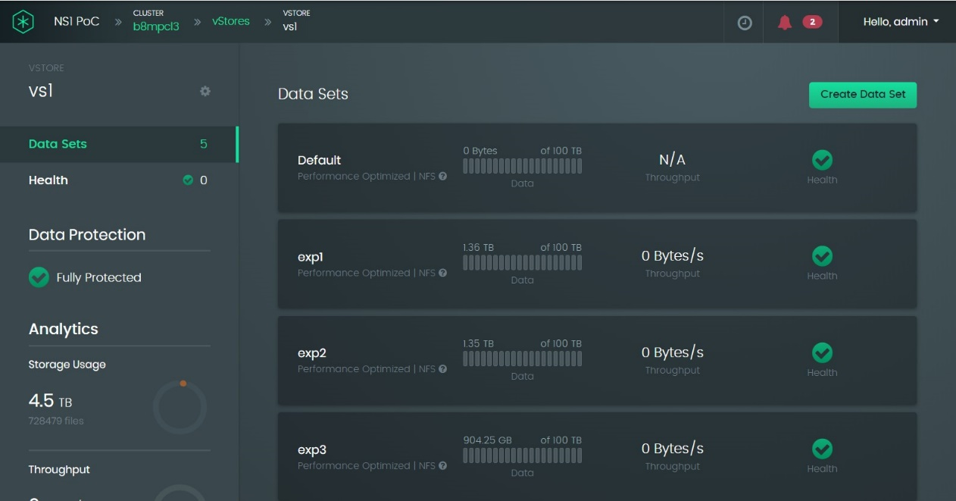

The data set panel provides direct options for setting the setting up the filesystem, user and group quotas, and viewing any alarms, such as reaching the capacity threshold.

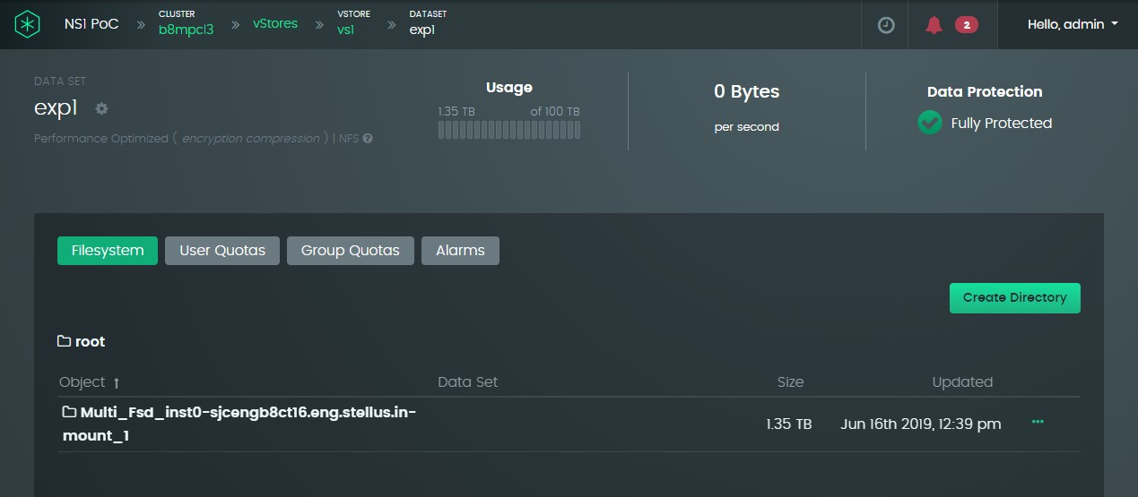

* + - 1. To view or edit the panels that were displayed when the data set was originally created, click the gear-cog icon near the top-left of the screen:

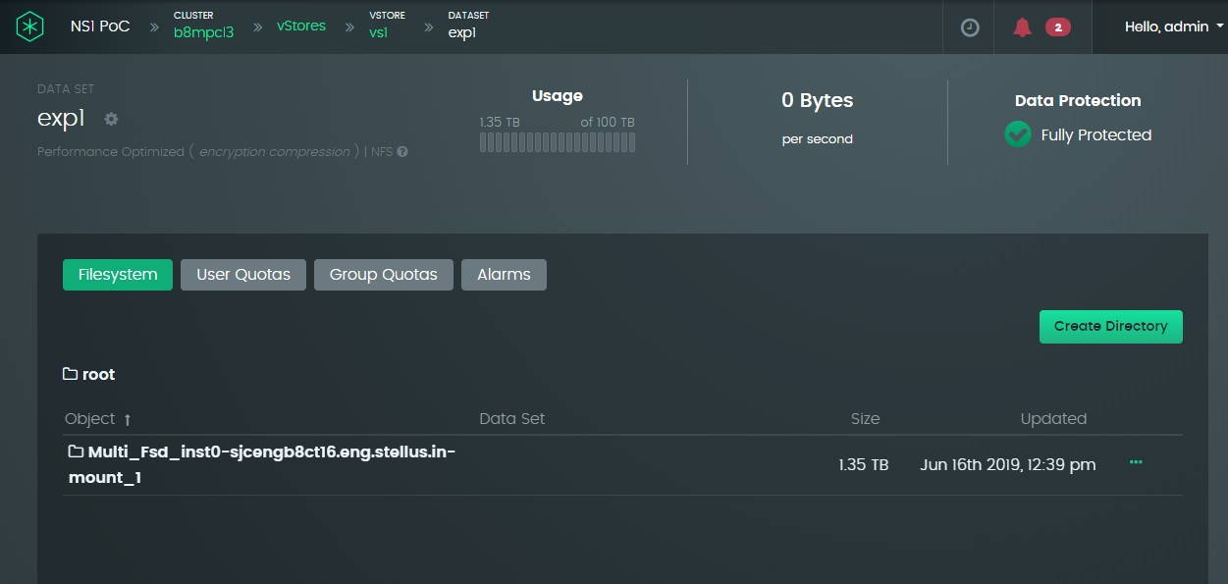

The options in the Edit Data Set panel are exactly the same as the configuration options presented when the dataset was originally created (see Section 7.2, “Creating an additional data set”).

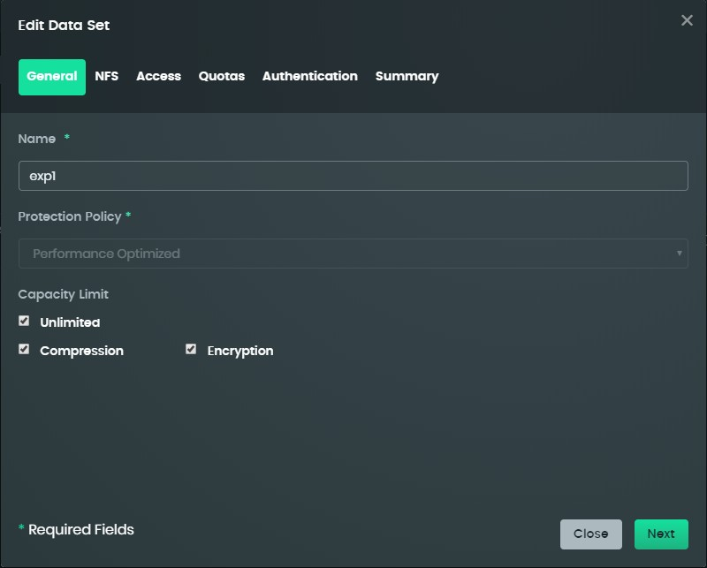

### Equivalent CLI commands

To view the settings for an existing dataset, use the **dataset show** command:

**dataset show --vStore=<vStore> [ --name=<name> ]**

If the **--name** switch option is omitted, the command displays the name, protection policy, NFS-enable status, export path, capacity, used capacity, and heath status for each dataset in the vStore. For example:

**ns1> dataset show --vStore=vs1**

+--------------+--------------------------+-----------+---------------+---------------------+--------------+-----------+

| Name | Protection Policy | NFS | Export Path | Capacity (GB) | Usage (GB) | Health |

+--------------+--------------------------+-----------+---------------+---------------------+--------------+-----------+

+--------------+--------------------------+-----------+---------------+---------------------+--------------+-----------+

|  |  |  |  |  |  |  |
| --- | --- | --- | --- | --- | --- | --- |
| | Default | | Performance Optimized | | enabled | | /default | | Unlimited (102400...| 0.0 GB | | OK | | |
| | exp1 | | Performance Optimized | | enabled | | /exp1 | | Unlimited (102400...| 6460.5 GB | | OK | | |
| | exp2 | | Performance Optimized | | enabled | | /exp2 | | Unlimited (102400...| 982.3 GB | | OK | | |
| | exp3 | | Performance Optimized | | enabled | | /exp3 | | Unlimited (102400...| 856.1 GB | | OK | | |
| | exp4 | | Performance Optimized | | enabled | | /exp4 | | Unlimited (102400...| 918.1 GB | | OK | | |
| | exp5 | | Capacity Optimized | | enabled | | /exp5 | | Unlimited (102400...| 850.4 GB | | OK | | |
| | exp6 | | Capacity Optimized | | enabled | | /exp6 | | Unlimited (102400...| 853.1 GB | | OK | | |
| | exp7 | | Capacity Optimized | | enabled | | /exp7 | | Unlimited (102400...| 873.3 GB | | OK | | |
| | exp8 | | Capacity Optimized | | enabled | | /exp8 | | Unlimited (102400...| 864.1 GB | | OK | | |

If the **--name** switch is included, the command output displays all the attributes set up when the dataset was originally created. For example:

**ns1> dataset show --vStore=vs1 --name=exp1**

Name : exp1

Protection Policy : Performance Optimized NFS : enabled

Export Path : /exp1

Mount Path : vs1.b8mpcl8x8.eng.stellus.in:/exp1

Compression : true

Encryption : true

Access : READ_WRITE

Squash : NONE

Grace Period (hr) : 168

Capacity (GB) : Unlimited (102400.0 GB) Usage (GB) : 6468.2 GB

Default User Quota : Unlimited (102400.0 GB) Default Group Quota : Unlimited (102400.0 GB) Health : OK

Protection Status : NOMINAL Consistency Status : CONSISTENT

To modify general settings of an existing dataset, use the **dataset update** command:

**dataset update --vStore=<vStore> --name=<name>**

**[ --newName=<newName> ] [ --compression=<compression> ] [ --encryption=<encryption> ]**

**[ --access=<access> ] [READ_ONLY, READ_WRITE, NONE] [ --squash=<squash> ] [ALL, ROOT, NONE]**

**[ --gracePeriodHours=<gracePeriodHours> ]**

**[ --capacityUnlimited ] [ --capacity=<capacity> ]**

**[ --defaultUserQuotaUnlimited ] [ --defaultUserQuota=<defaultUserQuota> ]**

**[ --defaultGroupQuotaUnlimited ] [ --defaultGroupQuota=<defaultGroupQuota> ]**

To view the NFS settings applied to a dataset, use the **dataset nfs show** command:

**dataset nfs show --name=<name> --vStore=<vStore>**

To update the NFS settings applied to a dataset, use the **dataset nfs update** command:

**dataset nfs update --name=<name> --vStore=<vStore>**

**[ --nfsEnabled=<nfsEnabled> ] [ --exportPath=<exportPath> ] [ --maxReadKB=<maxReadKB> ] [ --maxWriteKB=<maxWriteKB> ]**

**[ --security=<security> ] [NONE, SYS, KRB5, KRB5I, KRB5P]**

To show the current host access settings, use the **dataset hostAccess show** command:

**dataset hostAccess show --name=<name> --vStore=<vStore>**

To modify an existing host access setting, use the **dataset hostAccess update** command:

**dataset hostAccess update --name=<name> --vStore=<vStore> --order=<order>**

**--filter=<filter>**

**--access=<access> [READ_ONLY, READ_WRITE, NONE]**

**--squash=<squash> [ALL, ROOT, NONE]**

To delete a host access setting, use the dataset hostAccess delete command:

**dataset hostAccess delete --name=<name> --vStore=<vStore> --order=<order>**

To delete a dataset, use the dataset delete command:

**dataset delete --vStore=<vStore> --name=<name>**

# Viewing Node Status

## Procedure using the GUI

* + 1. Click on the **Physical Nodes** panel on the dashboard.

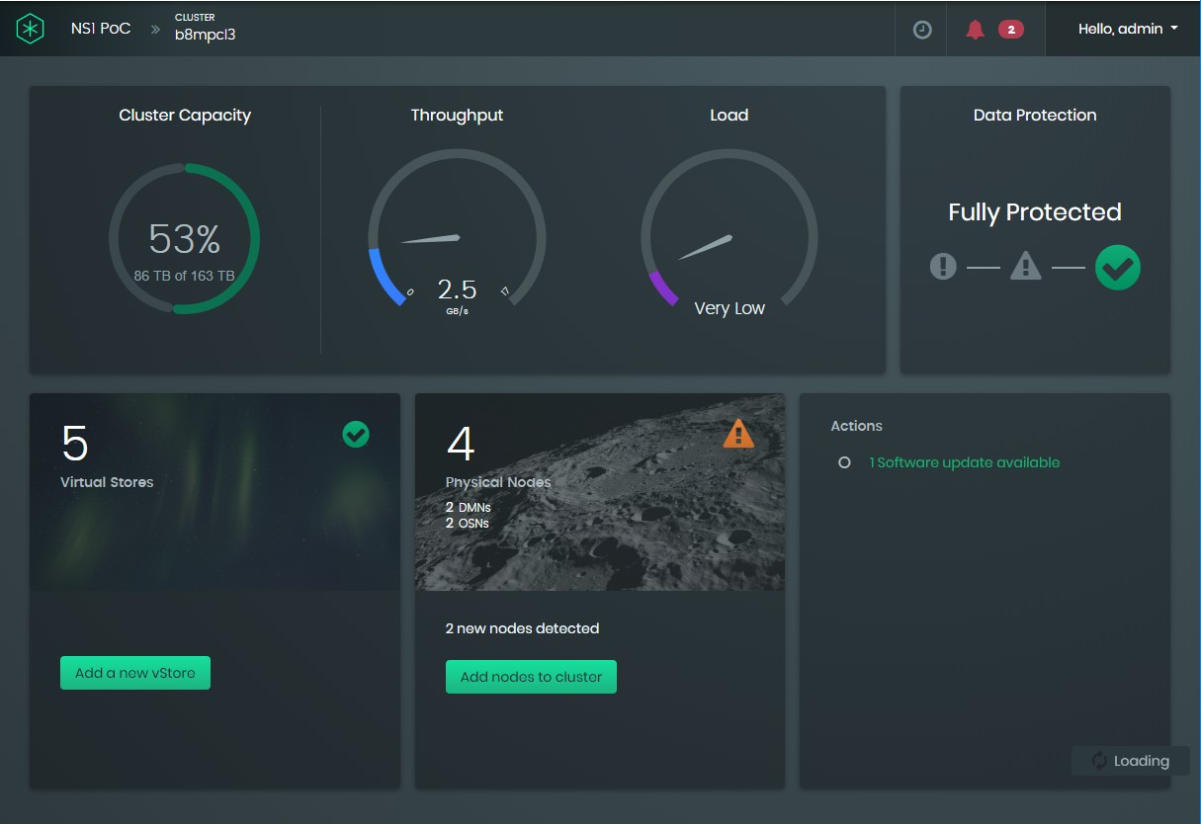

The screen displays two panels:

* + - * A Hardware panel on the left, with selectable lines listing all nodes, DMs, KVSs, drives, and switches.
      * A panel on the right listing the items selected in the **Hardware** panel. When first navigating to this screen, this panel displays the list of all nodes. In this example there are two DMs and two KVSs, not including the available additional nodes.

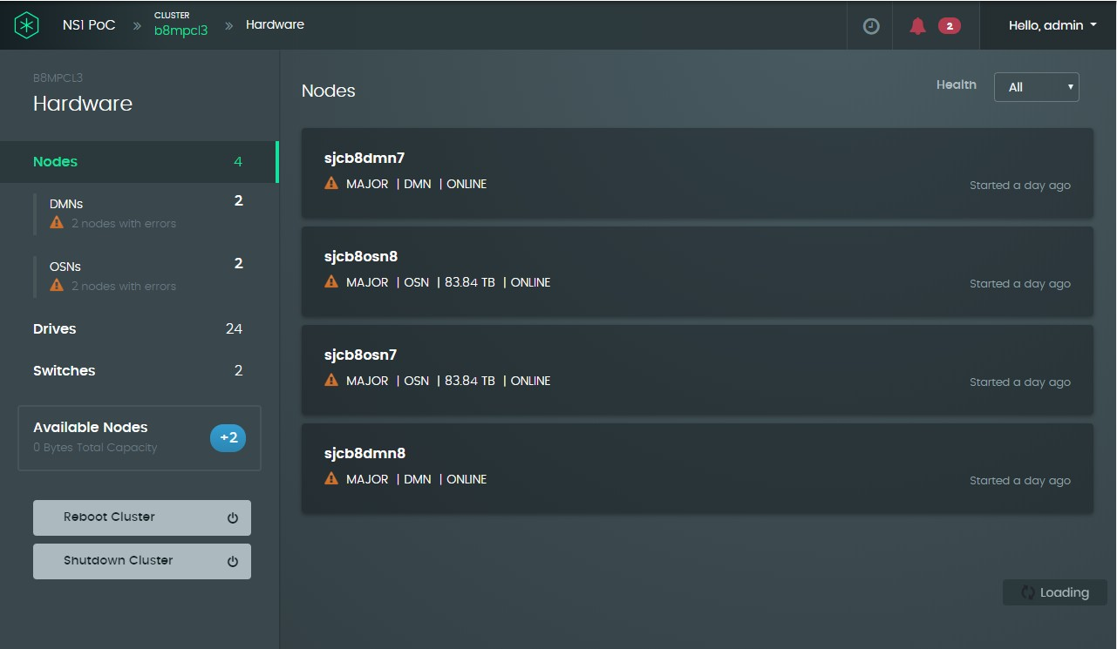

* + 1. To change what is listed in the right panel, click on an item in the **Hardware** panel. For example, clicking **Drives** displays the list of drives:

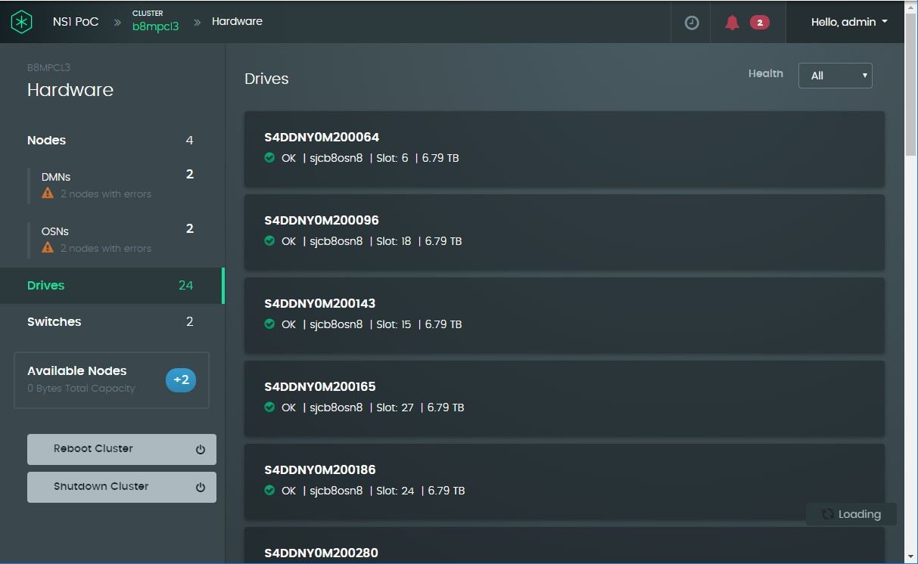

* + 1. Select **Nodes** in the **Hardware** panel and click on one of the nodes in the **Nodes** panel on the right.
    2. Selecting a DM shows a screen with a **Summary** tab selected, similar to the following:

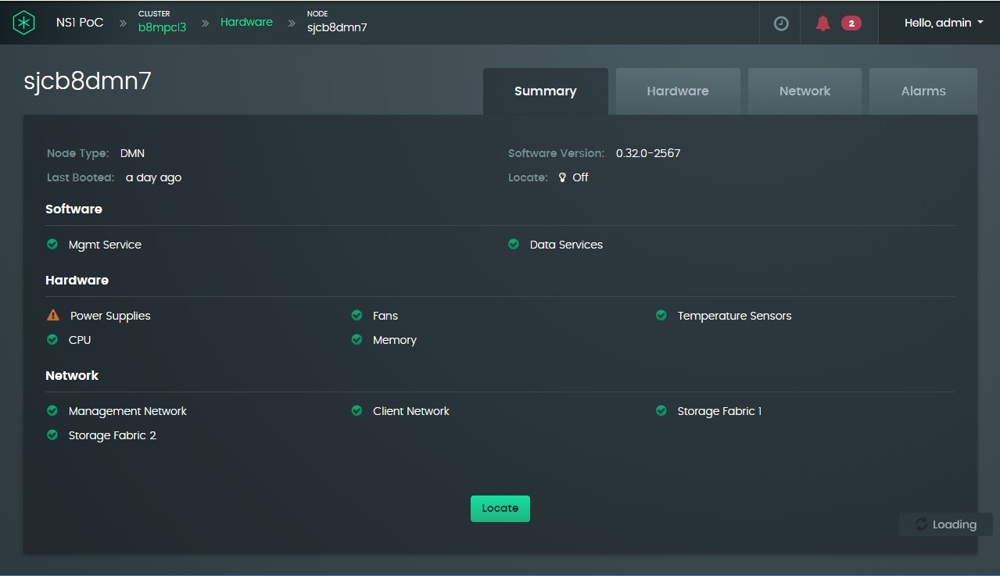

The screen for a KVS is similar to that of a DM, except that the interfaces displayed in the Network subpanel only list the storage fabrics. Items that are functioning normally are denoted by a green circle with a check mark in it. Items that require attention are denoted by an amber triangle with an exclamation mark in it. In the above example, a power-supply malfunction is simulated by leaving one of them disconnected.

* + 1. Click the **Hardware** tab. The screen lists the fans in the node, their health status, and their current speeds. In the example, the speed of the fan for PSU2 is at 0 because PSU2 is disconnected.

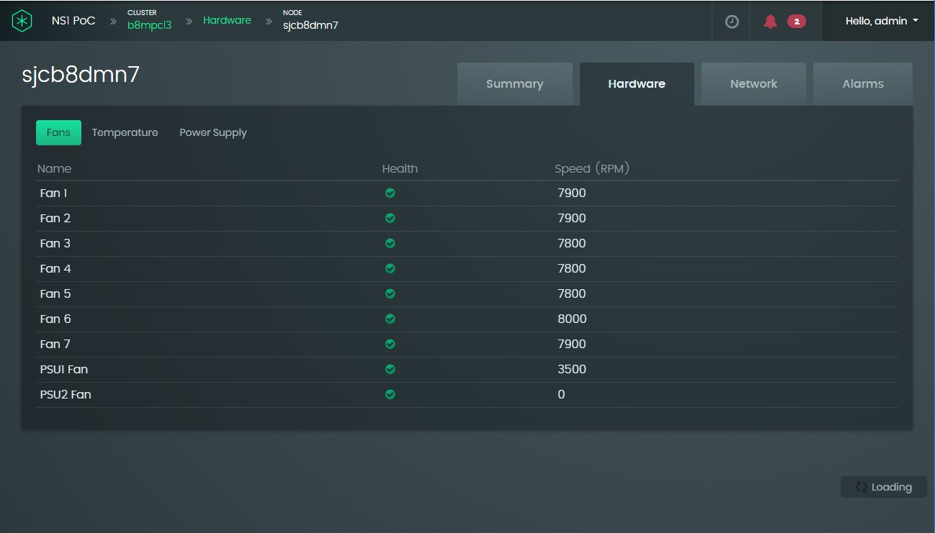

The screen for a KVS looks very similar except there is an extra sub-tab for the drives and the fan speeds are considerably higher:

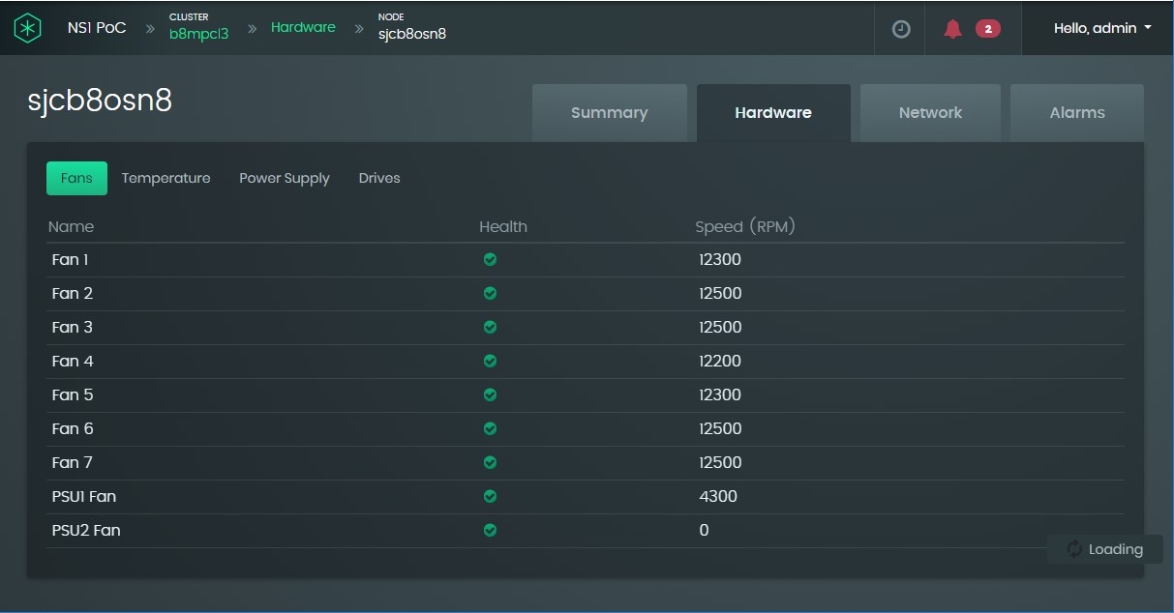

* + 1. Click the Temperature sub-tab. The screen for a DM will be similar to the following:

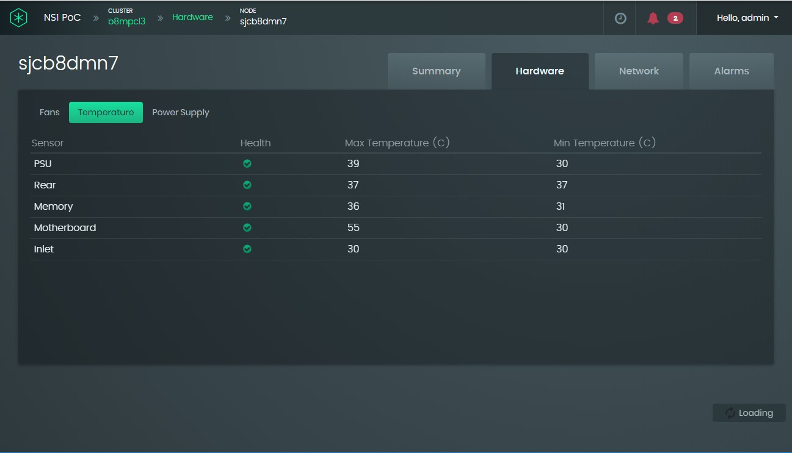

The maximum and minimum temperatures provide the temperature range over the last 24 hours.

The KVS sensors are similar to the DM except there are also sensors monitoring the drives.

* + 1. Click the **Power Supply** sub-tab to see the location and status of the PSUs. The following screen shows that the AC power to one of the PSUs is disconnected.

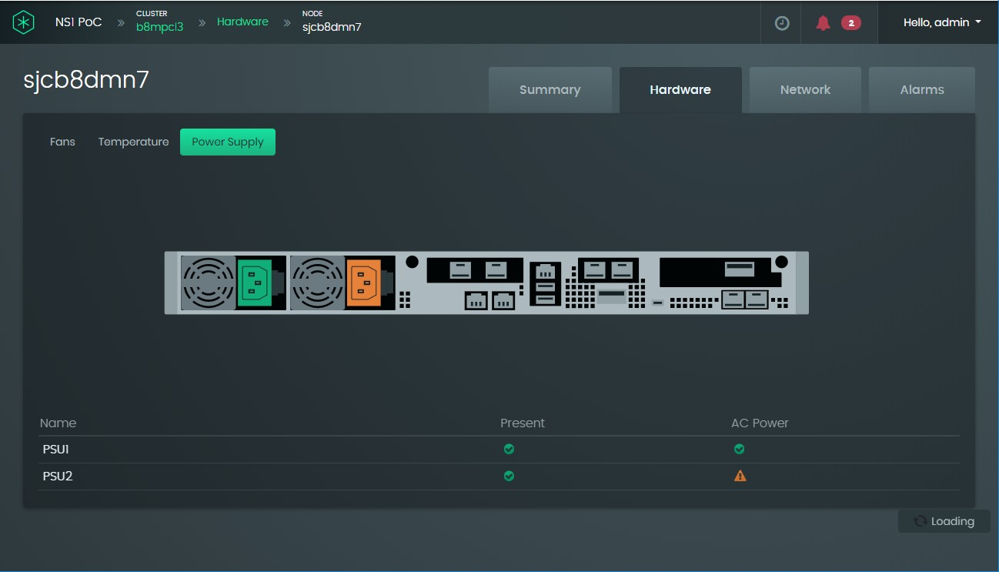

* + 1. If the node is a KVS, click the Drives tab. The screen shows the location, status, and capacity of each of the 12 drives in the KVS:

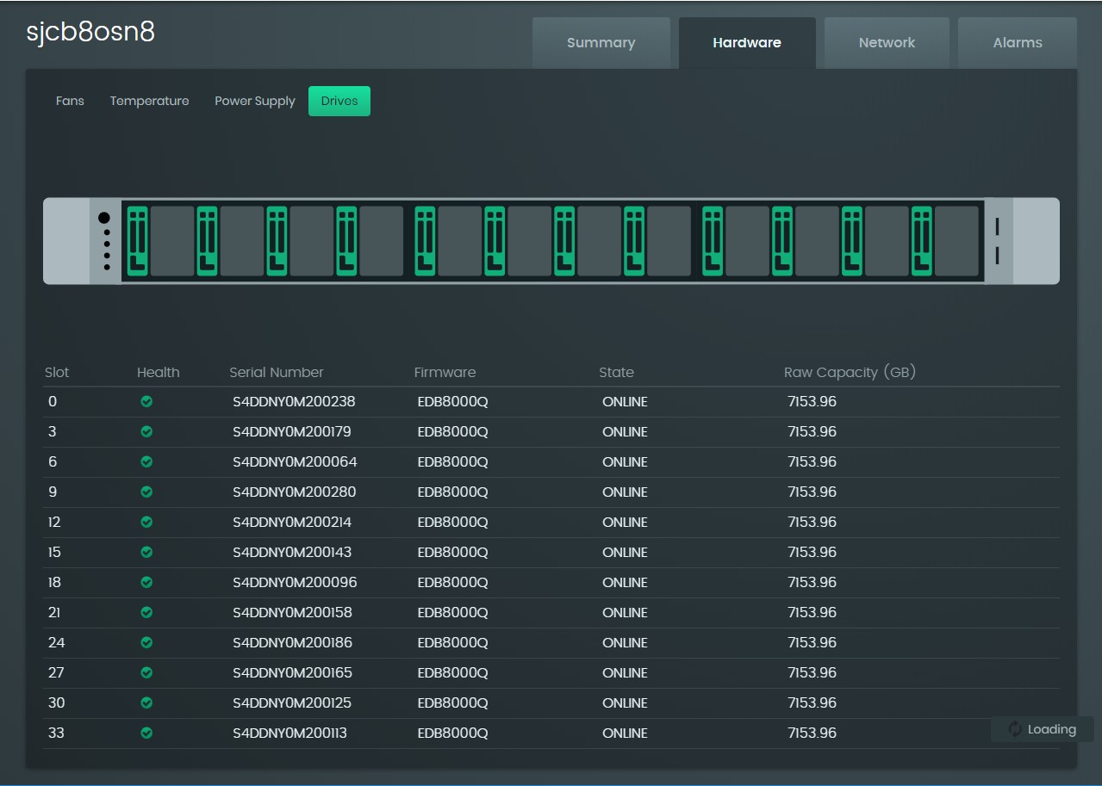

* + 1. Click the **Network** tab to see the locations of all the node interfaces. For a DM, this includes four client interfaces and two fabrics:

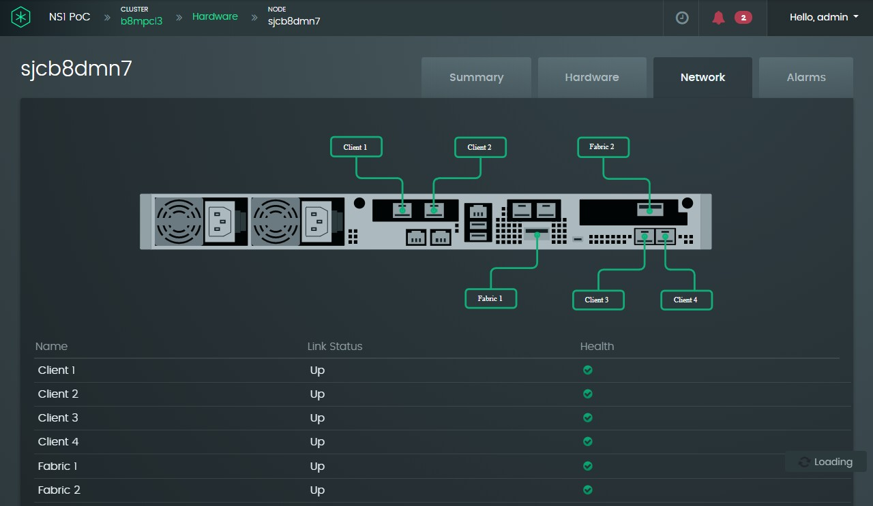

A KVS connects to the two fabrics only:

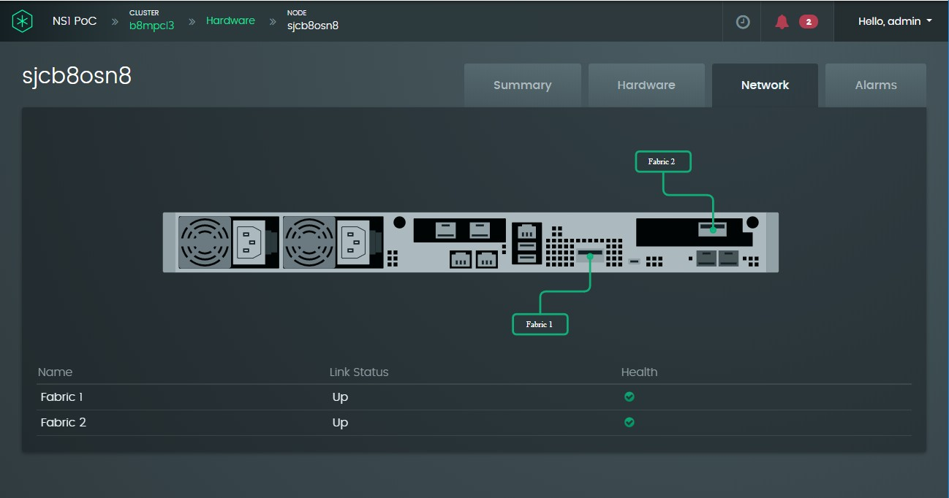

* + 1. Click the Alarms tab to view node-related alarms:

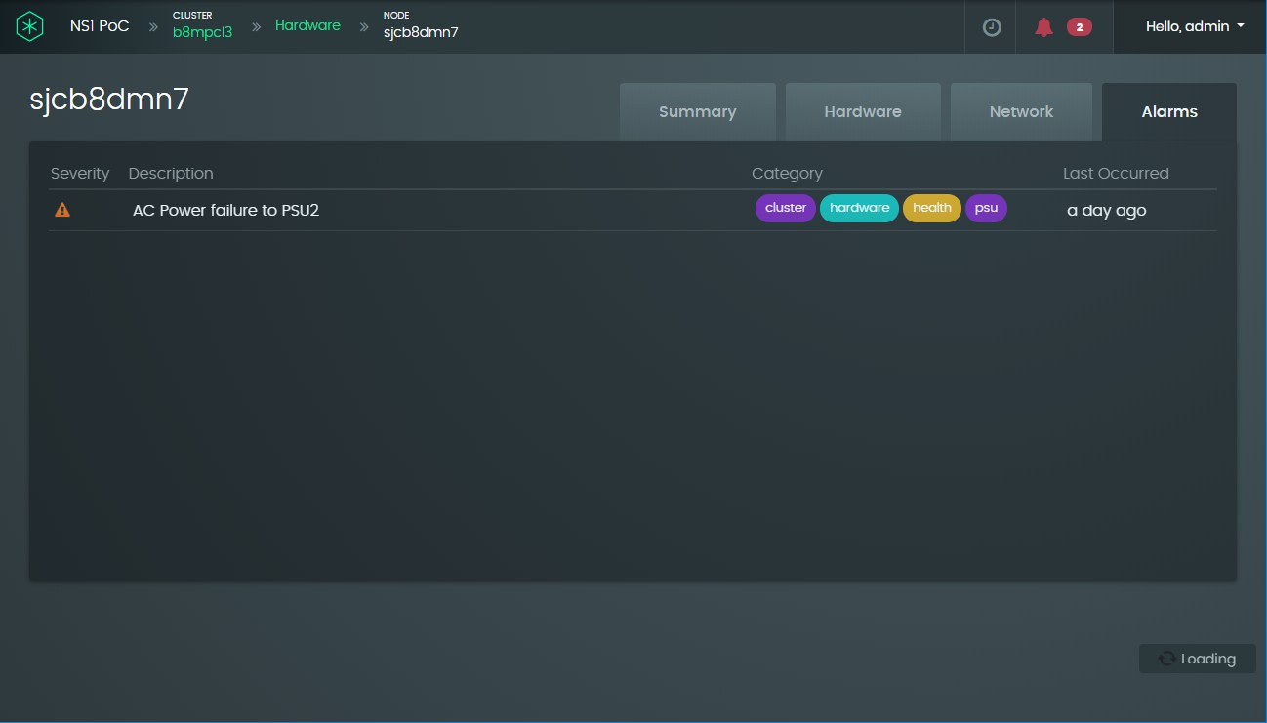

## Equivalent CLI commands

### Viewing node status and network summaries

Use the **node show** command displays the node status summary:

**node show [ --hostname=<hostname> ]**

For example, to view the general summary of all nodes in the cluster, run the command without the option switch:

**ns1> node show**

+---------------------+-----------+----------------+----------------+

| Hostname | Type | State | Health |

+---------------------+-----------+----------------+----------------+

| sjcb5dmn5 | DMN | ONLINE | MAJOR |

| sjcb5dmn6 | DMN | ONLINE | MAJOR |

| sjcb5osn8 | OSN | ONLINE | MAJOR |

| sjcb5osn7 | OSN | ONLINE | MAJOR |

+---------------------+-----------+----------------+----------------+

To view a more detailed summary for a specific node, including network and time zone information, specify the node using the **--hostname** switch. The following is a DM example:

**ns1> node show --hostname=sjcb5dmn5**

Hostname : sjcb5dmn5

Type : DMN

State : ONLINE

Health : MAJOR

Version : 1.0.1-2811

IP Address : 105.133.24.50

Gateway : 105.133.24.1

Time Zone : America/Los_Angeles Time Synchronized : true

Identify LED : false Storage Services : ONLINE CPU Utilization : 3 %

Memory Usage : 338.69 / 768 GB

Mgmt Network : OK

Client Network : OK Fabric Network 1 : OK Fabric Network 2 : OK Power Supplies : MAJOR

Fans : OK

Temperature : OK

Details show for a KVS are similar, except that the status includes the number of drives in the KVS and their combined capacity, and management network and client network status is not applicable. For example:

**ns1> node show --hostname=sjcb5osn7**

Hostname : sjcb5osn7

Type : OSN

State : ONLINE

Health : MAJOR

Version : 1.0.1-2811

Identify LED : false Storage Services : ONLINE Num Drives : 12

Capacity : 83.84 TB CPU Utilization : 42 %

Memory Usage : 35.17 / 448 GB Fabric Network 1 : OK

Fabric Network 2 : OK Power Supplies : MAJOR

Fans : OK

Temperature : OK

### View KVS drive status

To view details about all the drives in a cluster or a KVS, use the drive show command without option switches (for all drives in a cluster) or with the --hostname option switch (for all drives in a KVS):

**drive show [ --hostname=<hostname> ] [ --slot=<slot> ]**

The following example shows the status summary for all drives on a specific KVS:

**ns1> drive show --hostname=sjcb5osn7**

+-------------+------------------+------+--------+--------+-------------+---------------+

| Hostname | Serial Number | Slot | Health | State | Drive Light | Capacity (GB) |

+-------------+------------------+------+--------+--------+-------------+---------------+

+-------------+------------------+------+--------+--------+-------------+---------------+

|  |  |  |  |  |  |  |  |  |  |  |  |  |  |  |
| --- | --- | --- | --- | --- | --- | --- | --- | --- | --- | --- | --- | --- | --- | --- |
| | | sjcb5osn7 | | | S4DDNY0M200193 | | | 27 | | | OK | | | ONLINE | | | false | | | 7153 | | |
| | | sjcb5osn7 | | | S4DDNY0K900159 | | | 3 | | | OK | | | ONLINE | | | false | | | 7153 | | |
| | | sjcb5osn7 | | | S4DDNY0M600905 | | | 12 | | | OK | | | ONLINE | | | false | | | 7153 | | |
| | | sjcb5osn7 | | | S4DDNY0M200104 | | | 18 | | | OK | | | ONLINE | | | false | | | 7153 | | |
| | | sjcb5osn7 | | | S4DDNY0M200139 | | | 21 | | | OK | | | ONLINE | | | false | | | 7153 | | |
| | | sjcb5osn7 | | | S4DDNY0M200255 | | | 24 | | | OK | | | ONLINE | | | false | | | 7153 | | |
| | | sjcb5osn7 | | | S4DDNY0M600930 | | | 30 | | | OK | | | ONLINE | | | false | | | 7153 | | |
| | | sjcb5osn7 | | | S4DDNY0M600934 | | | 15 | | | OK | | | ONLINE | | | false | | | 7153 | | |
| | | sjcb5osn7 | | | S4DDNY0K900154 | | | 9 | | | OK | | | ONLINE | | | false | | | 7153 | | |
| | | sjcb5osn7 | | | S4DDNY0K900165 | | | 0 | | | OK | | | ONLINE | | | false | | | 7153 | | |
| | | sjcb5osn7 | | | S4DDNY0K900152 | | | 6 | | | OK | | | ONLINE | | | false | | | 7153 | | |
| | | sjcb5osn7 | | | S4DDNY0M600946 | | | 33 | | | OK | | | ONLINE | | | false | | | 7153 | | |

To view details about the drive model and firmware version, use both the --hostname and

--slot option switches. For example:

**ns1> drive show --hostname=sjcb5osn7 --slot=12**

Hostname : sjcb5osn7

Slot : 12

Health : OK

State : ONLINE

Drive Light : false Capacity (GB) : 7681501126656

Model : SAMSUNGMZ4LB7T6HMLA00003

Firmware Version : EDB8000Q

Serial Number : S4DDNY0M600905

# Reboot or shut down the Samsung Data Platform cluster

## Procedure using the GUI

* + 1. Click on the **Physical Nodes** panel on the dashboard.

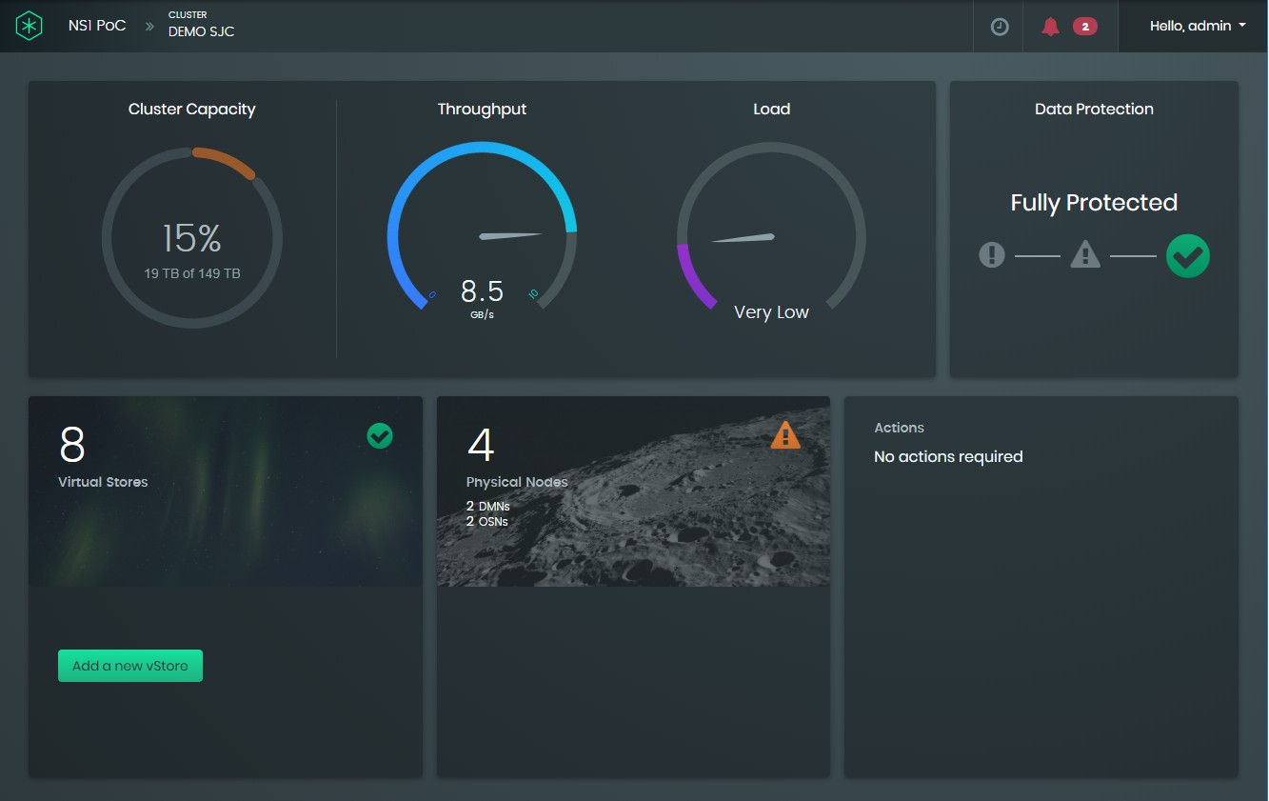

* + 1. Click on one of the buttons at the bottom of the **Hardware** panel.

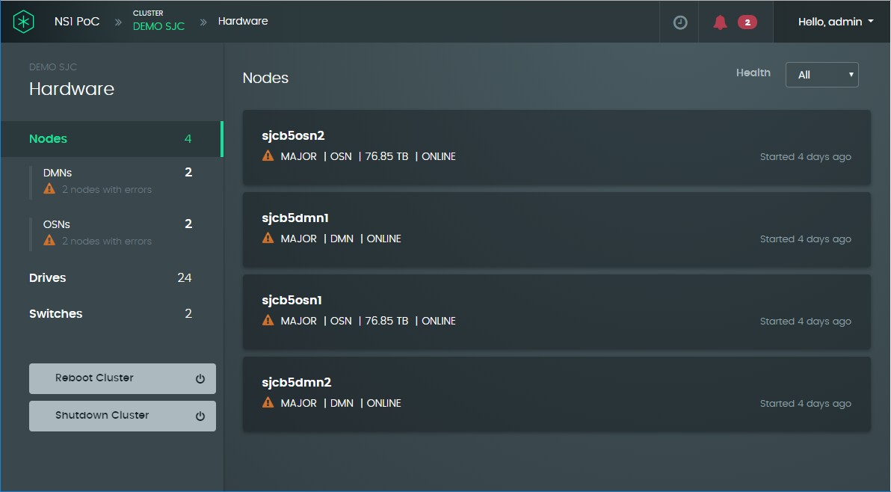

## Equivalent CLI commands

To reboot the cluster:

**cluster reboot**

To shut down the cluster:

**cluster shutdown**

# Monitor the Samsung Data Platform cluster capacity, performance, and health

## View the cluster capacity using the GUI

The overall cluster capacity can be seen at a glance from the dashboard displayed when you initially log in:

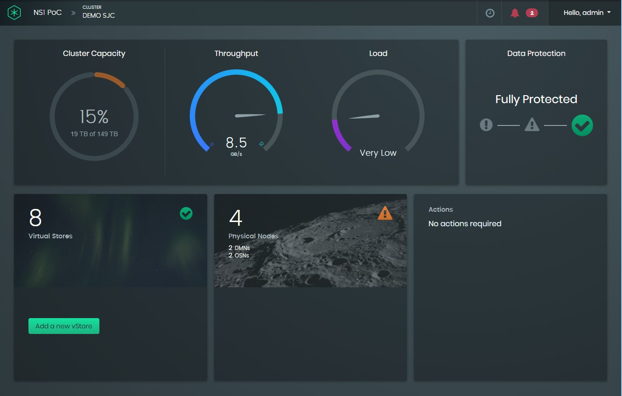

### View changes in used capacity and percentage utilization

To view changes in used capacity over the last hour, click in the **Cluster Capacity** pie chart on the dashboard. An example is shown below, where the used capacity had not changed.

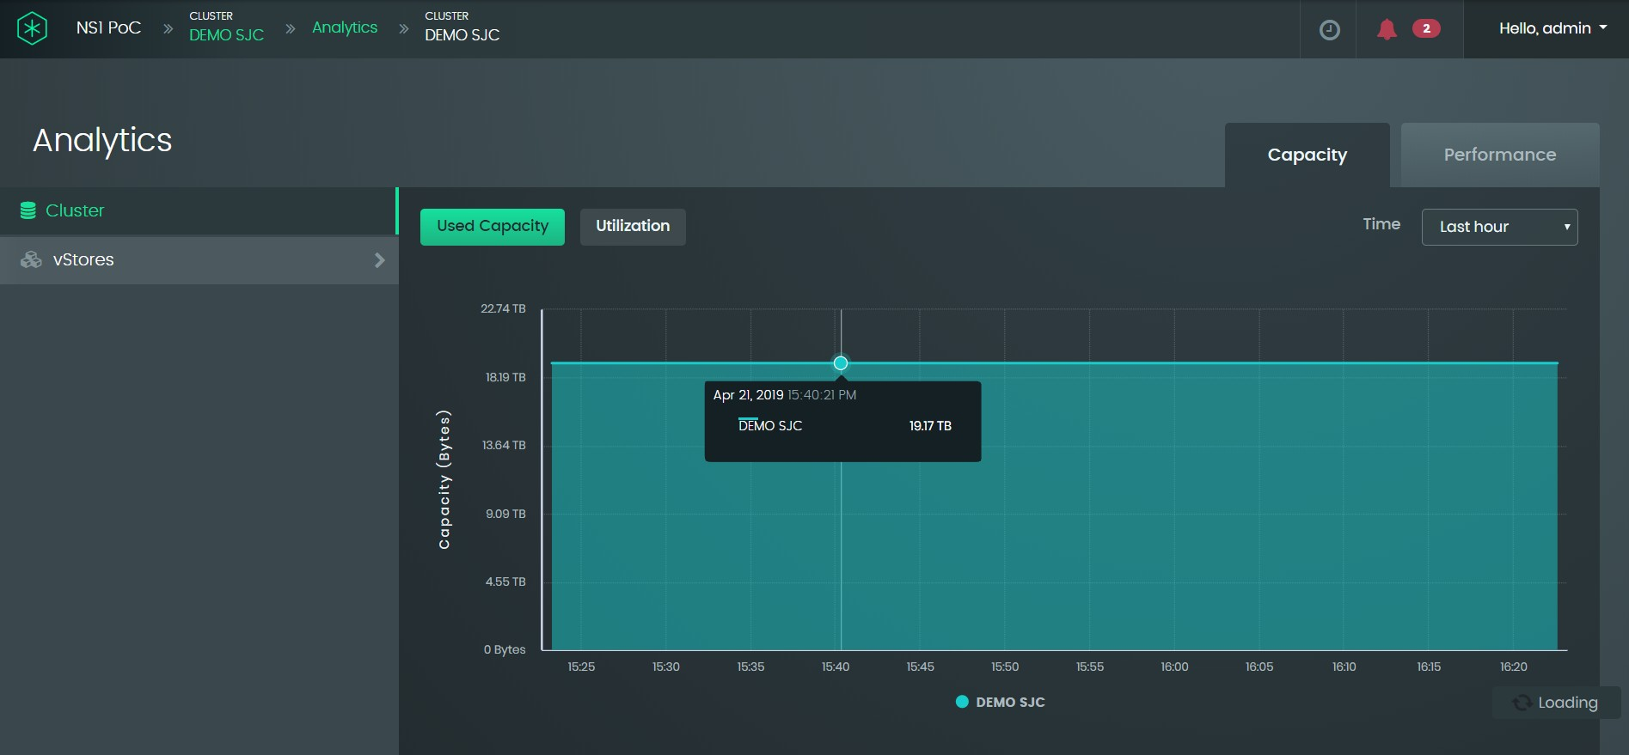

To view details about the used capacity at a particular point in time, place the cursor in the colored area denoting used capacity. In the example above, the used capacity of the Samsung Data Platform cluster named “DEMO SJC” was 19.17TB.

The metric shown is for used capacity, not total capacity. As can be seen from the dashboard screenshot, the total capacity of this particular cluster was 149TB.

To change the timeline over which you want to see the used capacity, change the entry in the **Time** drop-down list located at the top-right of the **Capacity** panel. You can select from any of the following options:

* + - * Now (this just reproduces the pie chart shown on the dashboard)
      * Last hour (the default)
      * Last 24 hours
      * Last week
      * Last month
      * Last 6 months
      * Last year

Clicking on the **Utilization** button displays the same information as for **Used Capacity**, except that the y-axis shows percentage utilization instead of capacity in TB. The graphs will only deviate if the total capacity of the system is changed at some point.

## View vStore and dataset capacity

### Procedure using the GUI

After clicking on the **Cluster Capacity** pie chart, capacity information is available for vStores and datasets in those vStores by clicking on the **vStores** menu entry and, if desired, expanding

the menu to select a particular vStore or dataset within a vStore. The following graphic shows an example of used capacity across all vStores:

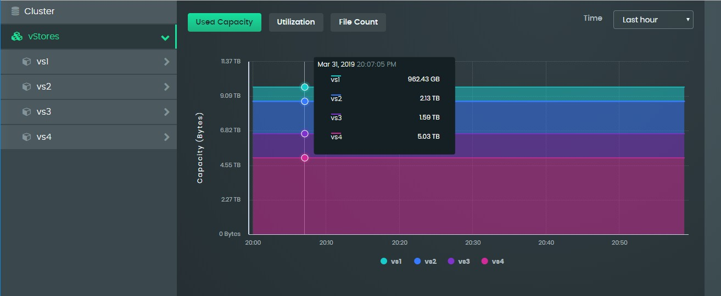

In addition to providing information about used capacity and percentage utilization, a **File Count** button allows you to see the number of files across vStores, in a particular vStore or in datasets within a vStore. An example of the file counts across all vStores is shown below.

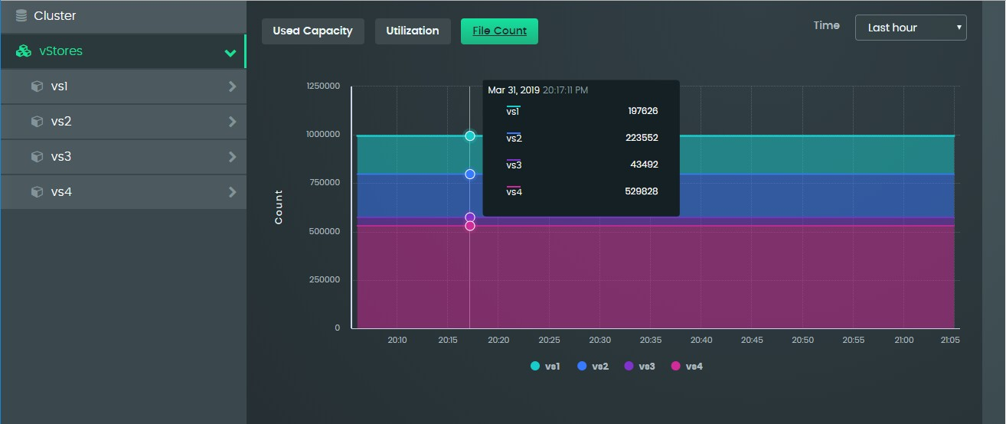

If you drill down to a dataset, the capacity information is displayed in the form of a pie chart, displaying the size and name of each file in the dataset.

### CLI commands

To view total and used capacity at the vStore level, use the **vStore show** command:

**vStore show [ --name=<name> ]**

For example:

**ns1> vStore show --name=ns1filer**

Name

Domain Name Subnet Gateway

called get addresses IP Addresses

Capacity (GB) Usage (GB)

Warning Threshold (%) Health

Protection Status Consistency Status

: ns1filer

: ns1filer.dogfood.eng.stellus.in

: 172.24.30.0/16

: 172.24.0.1

: 172.24.30.2-172.24.30.3

: 51200.0 GB

: 19663.4 GB

: 85

: OK

: NOMINAL

: CONSISTENT

To view total and used capacity at the dataset level, use the **dataset show** command:

**dataset show --vStore=<vStore> [ --name=<name> ]**

For example:

**ns1> dataset show --vStore=ns1filer --name=export**

Name : export

Protection Policy : Performance Optimized NFS : enabled

Export Path : /export

Mount Path : ns1filer.dogfood.eng.stellus.in:/export Compression : false

Encryption : false

Access : READ_WRITE

Squash : NONE

Grace Period (hr) : 168

Capacity (GB) : Unlimited (51200.0 GB) Usage (GB) : 19663.4 GB

Default User Quota : Unlimited (51200.0 GB) Default Group Quota : Unlimited (51200.0 GB) Health : OK

Protection Status : NOMINAL Consistency Status : CONSISTENT

There are no CLI commands that provide file-count metrics.

## Monitor cluster performance

Overall Samsung Data Platform cluster throughput and load are displayed in the form of tachometer-like dials on the dashboard:

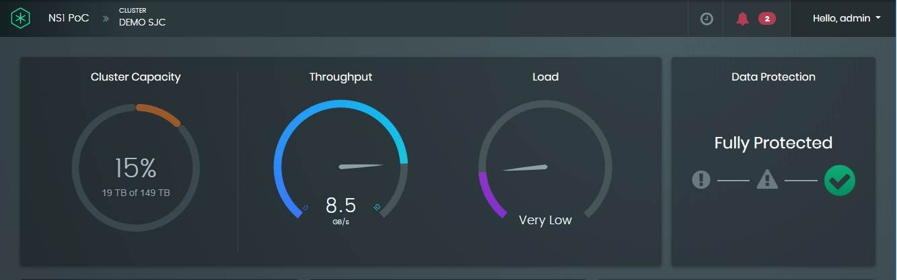

Clicking on either of these dials will display the display just the cluster throughput metric for the last hour by default, but other metrics (NFS operations, latency, client count, and load) can also be added, as shown below:

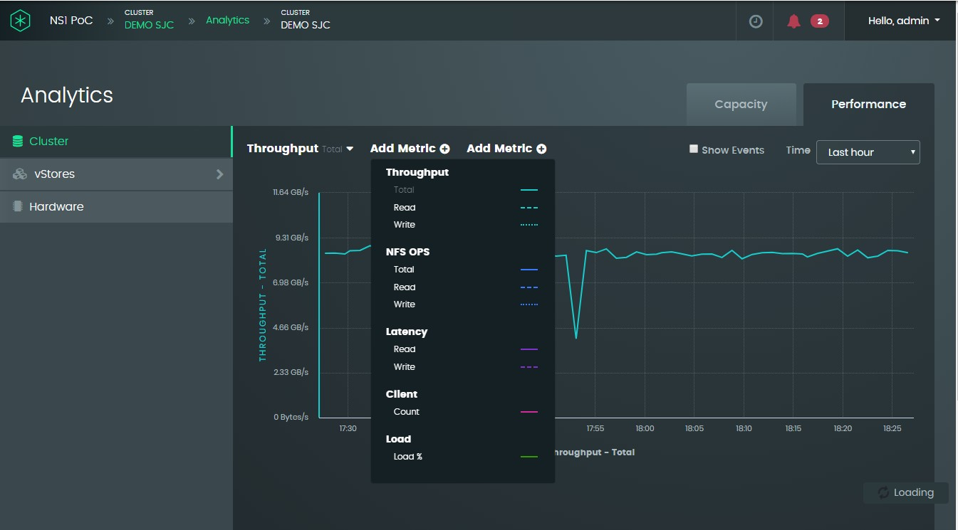

As with the capacity analytics, you can view vStore performance at various levels of detail:

* Across vStores
* Within a vStore
* Across datasets in a vStore
* Within a specific vStore
* Client-specific performance per vStore

In addition, selecting the **Hardware** menu entry displays metrics for each DM. By default, total throughput is displayed as shown in the following example:

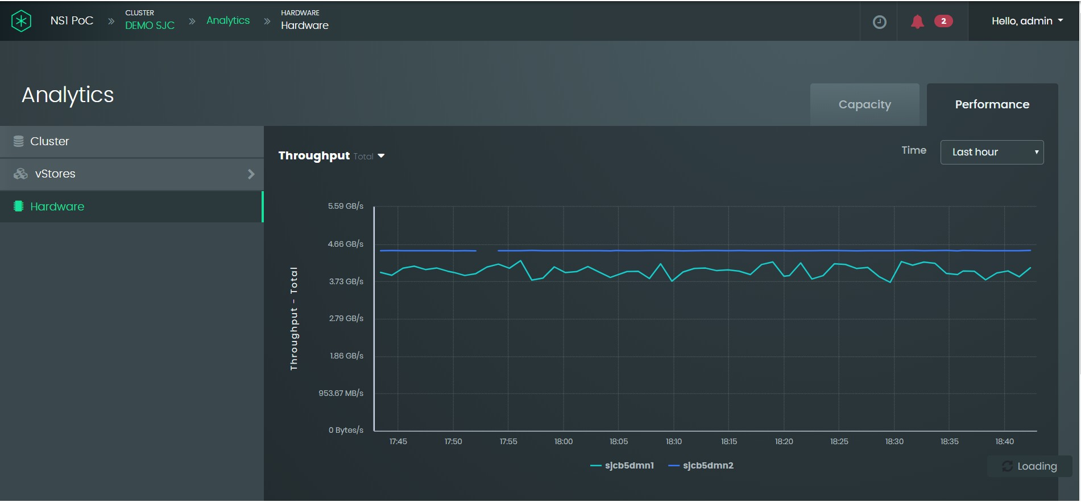

The metric can be changed by clicking on the drop-down list as shown below:

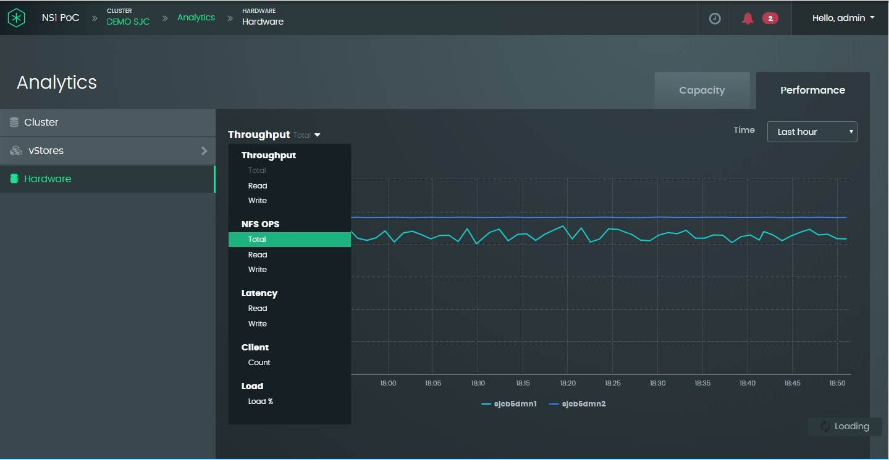

## Data protection status

Data protection is shown on the dashboard. SDP uses EC 9+3 for data protection.

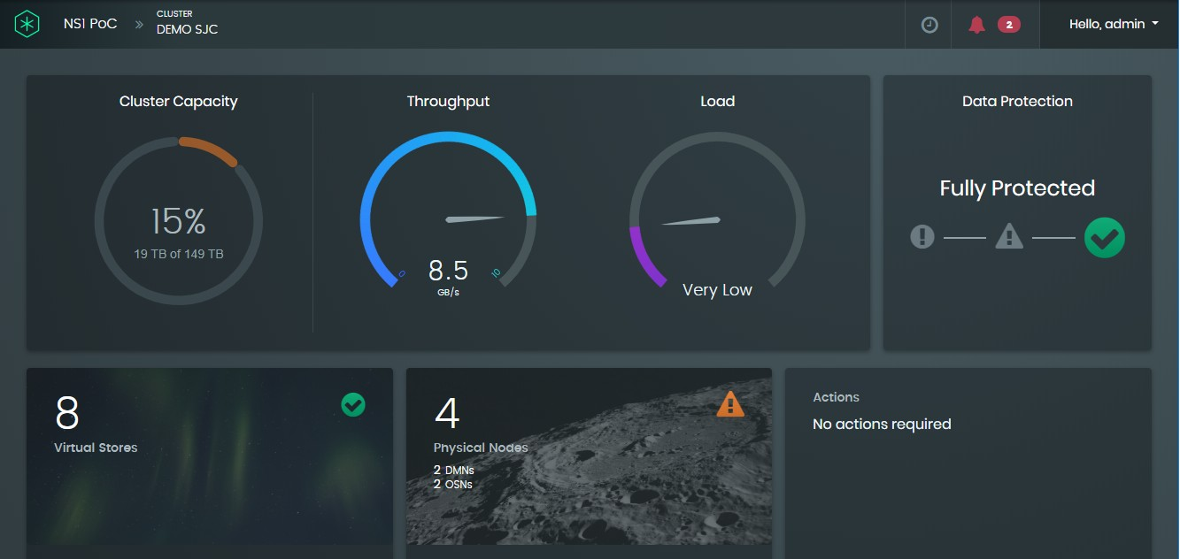

## View system-health alarms

### Procedure using the GUI

Alarm status is shown next to the user drop-down list at the top-right of the dashboard. The following example shows two critical alarms:

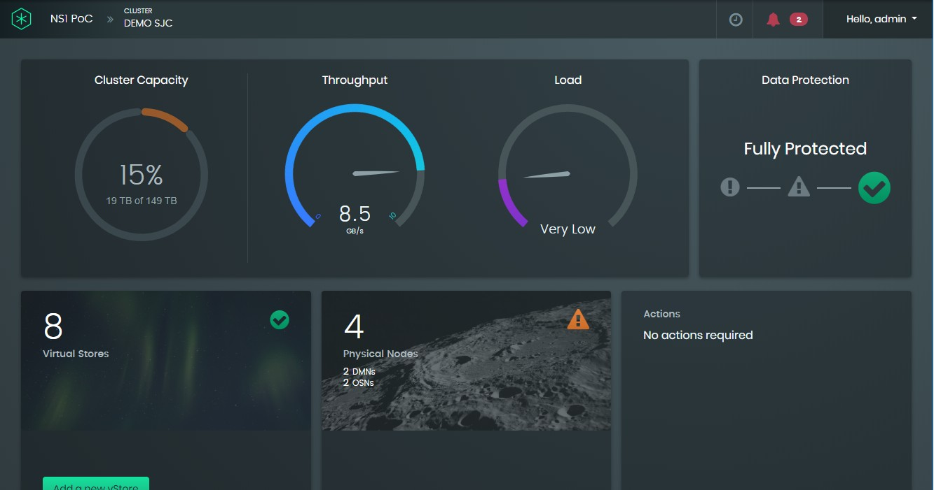

If there are no critical alarms but there are major health alarms, the color of the alarm icons will be orange. If there are no critical or major health alarms, the alarm icon will be gray.

Clicking on the dashboard alarm icons displays details about the alarm status:

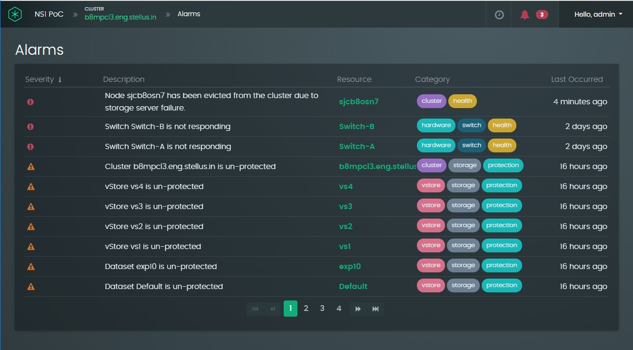

Clicking on an alarm entry will indicate exactly when the health event occurred.

### Equivalent CLI command

To view the status of active alarms in a cluster, use the alarm show command:

**alarm show [ --id=<id> ]**

For example:

**ns1> alarm show**

+-----------+-----------+-------------------------------------+----------------+----------------+

| ID | Severity | Description | Resource Type | Resource |

+-----------+-----------+-------------------------------------+----------------+----------------+

| 1

| 2

| 3

| 4

| 5

| 6

| CRITICAL

| CRITICAL

| MAJOR

| MAJOR

| MAJOR

| MAJOR

| Switch Switch-A is not responding

| Switch Switch-B is not responding

| AC Power

| AC Power

| AC Power

| AC Power

failure to PSU2

failure to PSU2 failure to PSU2 failure to PSU2

| SWITCH

| SWITCH

| NODE

| NODE

| NODE

| NODE

| Switch-A

| Switch-B

| sjcb5osn8

| sjcb5osn7

| sjcb5dmn6

| sjcb5dmn5

|

|

|

|

|

|

+-----------+-----------+-------------------------------------+----------------+----------------+

The resource or node where an alarm is active is displayed in the last column of the table shown in the command output. To view details about a specific alarm, specify the ID, shown

in the first column of the table using the **--id** option switch. The following example, retrieves details about the critical alarm for Switch-B (alarm ID 2):

**ns1> alarm show --id=2**

ID : 2

Severity : CRITICAL

Description : Switch Switch-B is not responding Details : Unable to connect to switch Switch-B

Resource Type : SWITCH

Resource : Switch-B

First Occurrence : Sat Dec 07 12:16:02 PST 2019

Last Occurrence : Sat Dec 07 15:46:04 PST 2019 name : Switch-B

ipAddress : 172.16.26.1

# 11 Opening an SSH remote-access gateway

To aid customer support by, the Samsung Data Platform system can be set up to allow Samsung Technologies Support to remotely connect to the system for a limited period of time using SSH.

Two steps are required to initiate remote-access support:

1. The customer who controls the Samsung Data Platform cluster, initiates a tunnel, which effectively grants Samsung Support remote-access capability for a strictly limited period of time. When the customer initiates the tunnel, the Samsung Data Platform cluster creates an outbound SSH connection to the Samsung Remote Access Gateway, which opens the tunnel back into the system.
2. Samsung Support uses SSH to access the remote-access gateway and then initiates a second SSH connection to the TCP port associated with the tunnel. After authentication, Samsung Support will be connected to the customer’s Samsung Data Platform system.

## Initiating the tunnel

A customer can initiate the tunnel to the remote-access gateway from either the Graphical User Interface (GUI) or Command Line Interface (CLI).

Enabling remote access requires that the cluster is already registered with the SMA. An error message will be displayed if this is not the case advising the user that they must first register the cluster with SMA. For details about registering with the SMA, see Section 6.2.6, “Enable remote monitoring of the Samsung Data Platform cluster”

### Using the GUI

* + - 1. Select **Support** from the user drop-down menu and select the Remote Access tab.

The Remote Access panel will display the current state of any connection to the Remote Access Gateway.

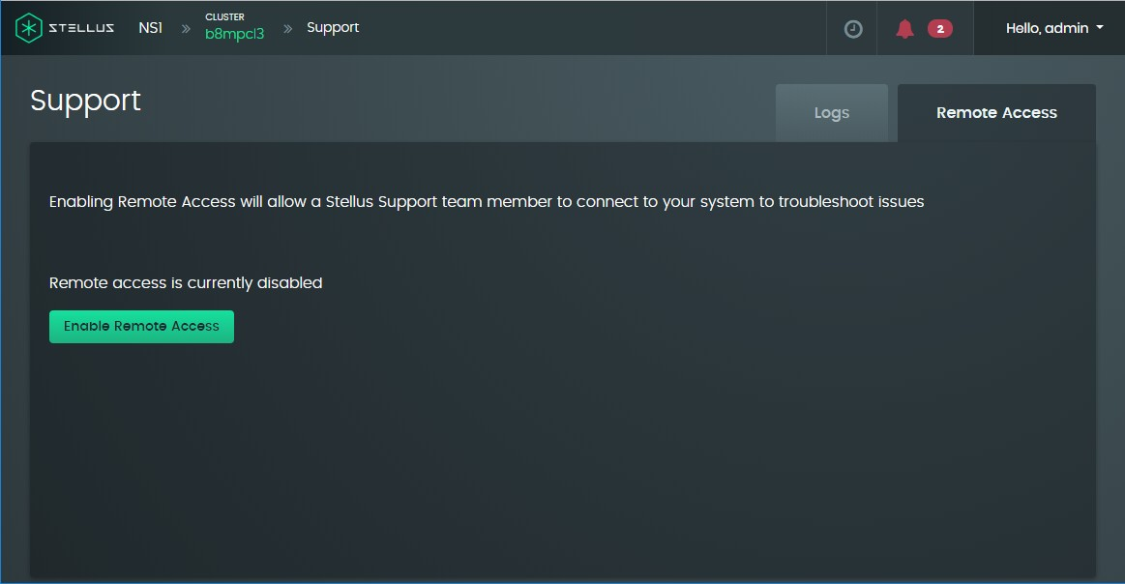

* + - 1. To enable a connection, click the **Enable Remote Access** button.

A dialog prompts you to specify how long you want to allow Samsung Support to con- nect to the system. For security purposes, you should always limit the length of time that someone from outside of your company can connect into the system.

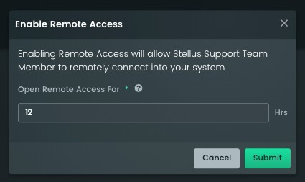

* + - 1. Specify an upper limit to the amount of time, that you will grant Samsung Support remote access the system and click **Submit**.

This sets an upper limit to the tunnel’s time to live. When Samsung Support no longer needs access, remote access can be disabled as detailed in Section 11.2, “Disabling the tunnel”.

### Using the CLI

* + - 1. Enable remote access from the CLI using the following command:

**NS1> support remoteAccess enable**

Remote access enabled until 2019-10-16T06:12:52.491Z.

If, as in the above command, you do not specify a time for the tunnel to remain open, the time will default to the value configured in the SMA. You can specify the a time to live, in minutes, using the --**ttlminutes** switch. For example, the following command gives the tunnel 12 hours to live:

**NS1> support remoteAccess enable --ttlMinutes 720**

* + - 1. To view the current state of the tunnel, run the following command:

**NS1> support remoteAccess show**

Remote access state : CONNECTED

Remote access expiration : Tue Oct 15 23:07:12 PDT 2019

## Disabling the tunnel

An enabled tunnel can be disabled at any time.

### Using the GUI:

* + - 1. Select **Support** from the user drop-down menu and select the Remote Access tab.

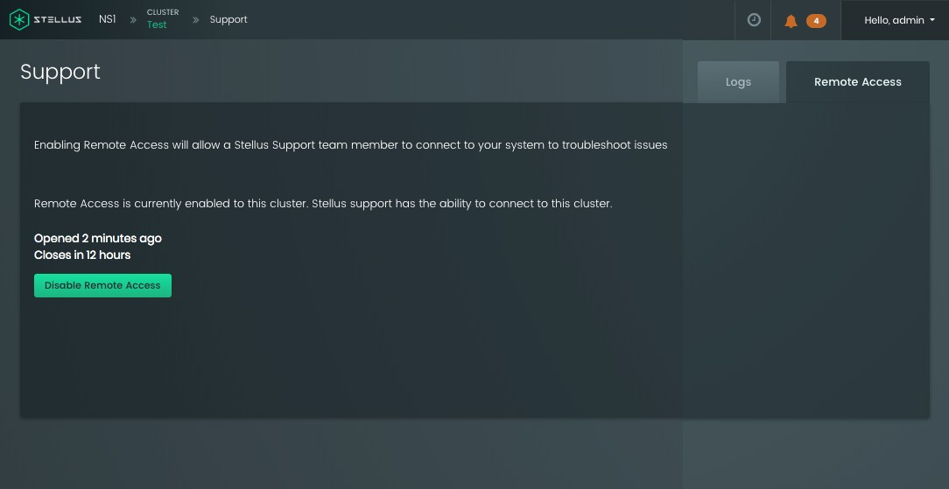

* + - 1. Click the **Disable Remote Access** button.

### Using the CLI:

* Enter the following command:

**NS1> support remoteAccess disable**

Remote access is disabled.

## Connecting to the tunnel as Samsung Support

### View customer clusters with a remote-access tunnel enabled

An SMA support person can see the details of all the clusters that have a remote-access tun- nel enabled by going to SMA and clicking on the 'Support' menu option. Only users that have the VIEW_SMA privilege can view this screen.

The screen allows the Samsung support person to easily see which clusters currently have tunnels open and, importantly, the port that the cluster is connected to on the remote-access server.

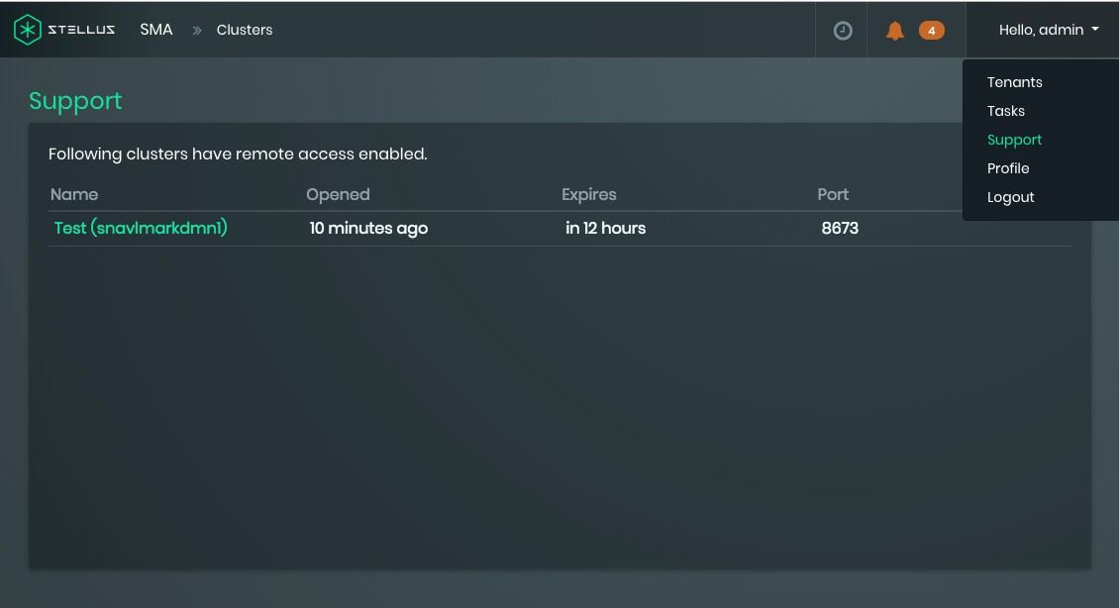

To connect to the SSH tunnel, you must be an authorized user that has had an account set up on the remote access gateway. If you need an account set up, notify a Samsung Support man- ager or supervisor.

For security reasons, access to the remote access gateway requires two-factor authentica- tion. When your account is set up, Samsung will configure your 2FA token, and send you an email, along with an initial password. When you have the required information, proceed as follows:

* + - 1. Install the Google-authenticator app on your smart phone and scan in the barcode sent in the email. This will generate a time-based token that you can then use to log in to the gateway as follows:



**$ ssh *<your_user_name>*@sma-remote.stellus.com**

Verification code: Password:

Last login: Thu Sep 19 17:26:36 2019 from 207.140.43.116

| |_ )

_| ( / Amazon Linux AMI

|\ | |

**[*<your_user_name>*@pdx-dev-remote01 ~]$**

* + - 1. After the initial login, change your password from the initial value that was assigned to you.
      2. Optionally, set up SSH keys to log in to the gateway without requiring use of the 2FA token if you find that more convenient.
      3. Use the following commands to generate SSH private and public keys for your account.



**$ mkdir -m 700 .ssh**

**$ ssh-keygen -t rsa -C "" -N "" -f .ssh/smagw_key**

Generating public/private rsa key pair.

Your identification has been saved in .ssh/smagw_key. Your public key has been saved in .ssh/smagw_key.pub. The key fingerprint is: SHA256:zSFZbb5VASW0tPYCVqZn6IbeyJdqRUHl22wviBbx8PQ

The key's randomart image is:

+---[RSA 2048]----+

| oooOoo.|

| o .X + .|

| o +BoB . |

| ++O*.* |

| S.=oo=E= |

| o ++o.o .|

| +++. . .|

| oo . |

| .. |

+----[SHA256]-----+

**$ mv .ssh/smagw_key.pub .ssh/authorized_keys**

The above commands create a secured folder (.ssh), generate a pair of private and public keys named **smagw_key** and **smagw_key.pub**, and enable SSH key authentica- tion on the gateway.

* + - 1. Copy the private key to a machine from which the gateway is to be connected. The following example commands shows connection from a standard Samsung VM.



**installer@sjcvlplatbuild1:~$ mkdir -m 700 .ssh** (IF.ssh already exists, skip this step) **installer@sjcvlplatbuild1:~$ scp j.loo@sma-remote.stellus.com:/home/j.loo/ smagw_key .ssh/**

<<< The 2FA token authentication will be required for this step >>> **installer@sjcvlplatbuild1:~$ chmod 400 .ssh/smagw_key installer@sjcvlplatbuild1:~$ ls -l .ssh/smagw_key**

-r-------- 1 installer installer 1679 Oct 7 20:32 .ssh/smagw_key

* + - 1. Test the connection from Samsung on a standard VM:



**installer@sjcvlplatbuild1:~$ ssh -i ~/.ssh/smagw_key *<your_user_name>*@sma- remote.stellus.com**

Last login: Mon Oct 7 20:40:35 2019 from 207.140.43.33

| |_ )

_| ( / Amazon Linux AMI

|\ | |

https://aws.amazon.com/amazon-linux-ami/2018.03-release-notes/

3 package(s) needed for security, out of 7 available Run "sudo yum update" to apply all updates. **[*<your_user_name>*@pdx-dev-remote01 ~]$**

* + - 1. If connecting from MobaXterm, create an SSH session by providing information in the red highlighted areas as appropriate.

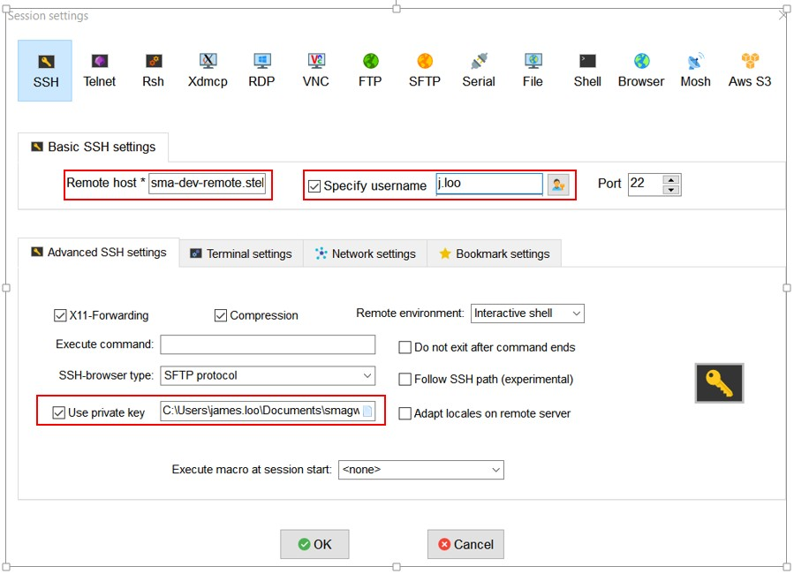

* + - 1. Connect to the customer cluster using one of the following methods.

### Connecting to the customer cluster via the CLI (1.0.2+)

* + - 1. After connecting to the gateway, to connect to the customer system, run the gate- way CLI. Note: support users may be automatically entered into the gateway CLI upon successful SSH connection (i.e. they will not have access to the shell).



**$ /opt/stellus/remote/bin/cli.sh**

* + - 1. Log in with your SMA credentials:



Username : ***<your_user_name>*@stellus.com**

Password : **\*\*\*\*\*\*\*\*\*\*\***

###########################################

# #

# SMA Support Remote Gateway #

# #

###########################################

**ns1>**

* + - 1. Use the **remoteAccess** command to list the clusters that have remote access enabled. Remember the index of the cluster. Note that there is a lag time of up to one minute between when a customer enables remote access and when it is listed on this page.



**ns1> remoteAccess show**

+------+---------------------+---------------------+-----------+------------------------------+

| Index| Cluster | Node | State | Expiration |

+------+---------------------+---------------------+-----------+------------------------------+

| 1 | sjcvldaryecl1 | sjcvldarye1 | CONNECTED | Tue Nov 12 22:27:20 PST 2019 |

+------+---------------------+---------------------+-----------+------------------------------+

* + - 1. Use the **remoteAccess connect** command to initiate an SSH connection to the cus- tomer cluster. Use the index displayed by the **remoteAccess show** command in the preceding step. You will have to provide the stadmin password to complete the SSH authentication.



**ns1> remoteAccess connect --index=1**

Connecting to sjcvldaryecl1 as user stadmin

To exit remote access session press Ctrl-D or type `exit`

============= Remote access session starting... ============= stadmin@localhost's password:

STOS-1.0.0-11-internal PXE Kernel: 4.4.1-stpxe PXE RootFS: 08152019

Installed Kernel: 4.4.0-97-generic Installed RootFS: 08152019

FW tool: N/A

Booted RootFS: Primary Platform Type: VM Platform Config: devqa

Platform S/N: 423b354e77516da3d6 Platform Creation Date: 09102019-132653 Last STOS Update: 10222019-101641

Hostname: sjcvldarye1 IP: 105.133.6.184

IP: 105.133.6.240

IP: 169.254.7.183

IP: 172.16.116.11

IP: 172.16.117.11

IP: 172.16.16.11

IP: 172.16.36.11

Last login: Mon Nov 11 15:14:25 2019 from 127.0.0.1

**stadmin@sjcvldarye1:~$** ls

bin stellus-dmn-deb_1.0.0+26_all.deb stellus-mgmtsrv-deb_1.0.0+16_all.deb

* + - 1. To exit from the SSH session and return to the gateway CLI, press **Ctrl-D** or type “**exit**”.



**stadmin@sjcvldarye1:~$ exit**

Connection to localhost closed.

============= Remote access process has exited ============= Returning to NS1 CLI.

**ns1>**

### Connecting to the customer cluster manually (1.0.1+)

After connecting to the gateway, connect to the customer system by opening an SSH con- nection to the customer-created tunnel as follows:

* + - 1. Use the procedure in Section 11.3.1, “View customer clusters with a remote-access tunnel enabled” to determine the port number assigned to the cluster when the cus- tomer enabled remote access.
      2. Open an SSH connection to the customer-created tunnel by specifying the assigned port number. In the following example, the port number is 8673. Authenticating with the “stadmin” password, will log you in directly to the DM.



**[*<your_user_name>*@pdx-prod-remote01 ~]$ ssh -p 8673 stadmin@localhost**

stadmin@localhost's password: STOS-1.0.0-11

PXE Kernel: 4.4.1-stpxe PXE RootFS: 08152019

Installed Kernel: 4.4.0-97-generic Installed RootFS: 08152019

FW tool: 1.0.0-2

Booted RootFS: Primary Platform Type: DMN Platform Config: customer

Platform S/N: 515-18083000400020

Platform Creation Date: 09092019-160736 Last STOS Update: N/A

Hostname: sjcb3dmn27 IP: 105.133.26.38

IP: 169.254.11.178

IP: 172.16.116.16

IP: 172.16.117.14

IP: 172.16.16.16

IP: 172.16.216.16

IP: 172.16.217.14

IP: 172.16.26.16

IP: 172.16.36.16

Last login: Thu Sep 19 17:52:04 2019 from 105.140.110.19

**stadmin@sjcb3dmn27:~$**

# Glossary

**AD/LDAP** Active Directory/Lightweight Directory-Access Protocol. AD is a directory services database and LDAP is one of the protocols that can be used to communicate with it. LDAP includes a user authentication capability.

**Atomic Data Store** A data store where an update operation updates the whole data store; this type of data store cannot be updated partially. This type of store is used for metadata elements sized from hundreds of bytes to 1MB.

#### Data Protection Pol- icy

The level of data protection available on a Samsung Data Platform cluster:

* Capacity Optimized: Erasure coding 9+3

**Data Set** A Data Set contains one or more collections. Collections contain meta- data information about directories and files such as exports for a given directory and capacity limits. Each data set is assigned a data-protection policy. Data sets are organized into volumes, where every data set in a volume has the same data-protection policy.

**DHCP** Dynamic Host Control Protocol. A network management protocol man- aged by a DHCP server. The DHCP server dynamically assigns an IP address and other network-configuration parameters to each device on a network.

**DM** Data Manager. One of the two types of node in a Samsung Data Platform cluster. For details, see Section 2.1.1, “Data Managers”.

**DMZ** Demilitarized Zone or perimeter network. A subnetwork that contains and exposes an organization’s external-facing services to an untrusted net- work such as the Internet, but leaves the rest of the organization’s network protected behind a firewall.

**DNS** Domain Name System. Translates human-readable Internet domain names, such as Samsung.com, to Internet Protocol (IP) addresses.

**Immutable Data Store** Also known simply as a Data Store. A read/write data store that cannot be removed. This type of store is tuned to 1MB chunks of data. 85% of SSD capacity is in this type of data store.

**LDAP** Lightweight Directory Access Protocol.

**Metadata Store** Used to store metadata information that is often updated.



**NFS** Network File System. A client/server application that lets a computer user access files on a remote computer as they would on their own computer. Although the most current version is version 4.2, the most common version in use today is NFSv3 because of its use on virtualized Windows servers.

**NTP** Network Time Protocol. Used for clock synchronization of computer sys- tems over the Internet.

**NVMe** Non-Volatile Memory Express. A host controller interface and storage pro- tocol specifically created to allow operation at the read/write speeds of modern SSDs.

**RDMA** Remote Direct Memory Access. A direct memory access (DMA) from one computer into another without involving the operating system of either one.

**SMA** Samsung Monitoring and Analytics.

**SMS** Samsung Management Server. Monitors user’s storage utilization and activity. The SMS contains a user interface that can be accessed using HTTP, the command line, or using the SMS REST API.

**SMTP** Simple Mail Transfer Protocol. The most common protocol used by servers to transmit email over the Internet.

**SSD** Solid-State Drive. Solid-state storage device that uses IC memory to store data persistently. The Samsung Data Platform cluster uses SSDs, which are much faster than traditional hard disk drives.

**SSL** Secure Sockets Layer. The standard security technology for establishing an encrypted link between computer systems, typically a web server and a client running a browser. Once established, all data shared between the browser and server is encrypted.

**Staging Store** Not to be confused with a store set up for test purposes, a Samsung Staging Store is a 1MB-aligned data store used for staging multiple small write operations to the SSD so that after a timeout, the storage is updated (de- staged) in one operation.

**KVS** Key-Value Store. One of the two types of node in an Samsung Data Platform cluster. For details, see Section 2.1.2, “Key-Value Stores”.

**PXE** Preboot Execution Environment. An industry-standard client/server inter- face that allows networked computers that are not yet loaded with an operating system to be configured and booted remotely by an adminis- trator. To initiate a PXE boot, the client transmits a DHCP broadcast stating that it needs to PXE boot. The DHCP server responds with a suggested IP address to use.

**ToR** Top-of-Rack. A network connectivity architecture commonly used in data centers. A ToR switch (as the name suggests) is typically located at or near the top of a rack. All the servers on the rack connect to this switch.

**VLAN** Virtual Local Area Network. A network of devices connected to each other in the same physical location is known as a LAN. A VLAN allows sev- eral LANs to function virtually as though they were one LAN.

**Volume** A volume contains one or more data sets with the same data protection policy. All four data policies are allowed per vStore. Volumes are not exposed in the user interface.

**vStore** Virtual Store where store means storage, *not* an eCommerce site. vStores enable multi-tenancy. Each vStore contains at least one and up to four volumes of data sets. They are created and managed through the SMS user interface.